Project DESCRIPTION
Desired Forest Conditions (DFCs) are a set of management guidelines proposed by the Lower Mississippi Valley Joint Venture for managing bottomland hardwood forests for priority wildlife species. DFC treatments have been shown to benefit songbirds, but the effect of increased vertical complexity on other forest fauna, including bats, has not been previously studied. To examine bat community response to DFC treatments, this project conducted acoustic surveys in treated bottomland hardwood forest stands and reference stands on 14 National Wildlife Refuges and Wildlife Management Areas within the Mississippi Alluvial Valley. 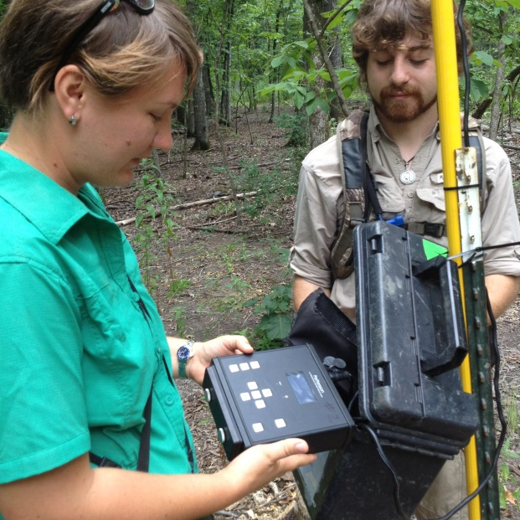

Objectives and Alternatives
Silvicultural treatments have been prescribed to promote Desired Forest Conditions for priority wildlife species such as Swainson’s warbler (Limnothylpis swainsonii). Variable-retention thinning and/or patch clearcuts have been used in closed canopy hardwood forests, and although the resultant conditions have been espoused as beneficial for bats, no research has directly studied bat response to DFCs. Rafinesque’s big-eared bats (Corynorhinus rafinesquii) and southeastern myotis (Myotis austroriparius) are both species of concern known to roost in interior cavities of large bottomland hardwood or swamp trees. Both species have poorly understood foraging ecologies and the potential effects of silvicultural treatments on them are virtually unknown.
This project proposes to survey for bat species occupancy in treated and reference stands in order to better understand how DFC treatments may affect bat species composition through the impact of treatments on prey species availability and/or the change in vegetation structural complexity. 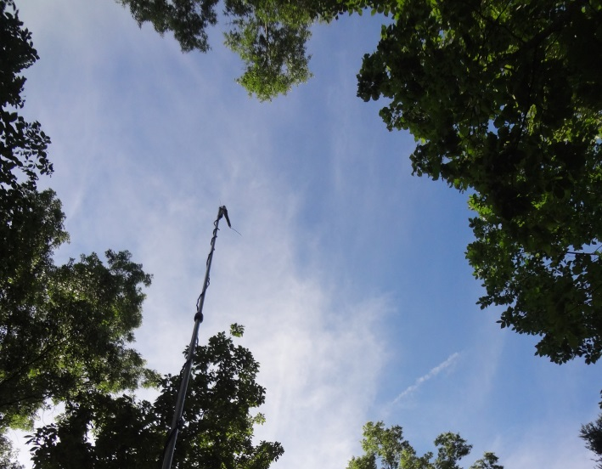

methods and protocols
Acoustic surveys were conducted using Petterson D500X acoustic recording devices to assess occupancy of bat species in treated and reference stands (Petterson, 2012). Twelve devices were deployed per NWR or WMA, with two devices per treatment or reference stand for six continuous survey nights. Insect prey availability was assessed using BioQuip® blacklight/bucket traps to capture nocturnal flying insects (Dodd et al., 2008). One trap was deployed per treatment or reference stand for four continuous trap nights, at two nights per survey point within each unit. Vegetation surveys were conducted to assess vegetative structure and DFC status within treated stands, and to compare treated stands with reference stands (Wilson et al., 2007). Two transects with 5 points each were surveyed per treatment or reference stand. At each point, a 0.01 ha plot was surveyed for plot-level characteristics as well as individual tree characteristics.

Data Management
Acoustic data were stored in a 3 TB external hard drive, and sorted by NWR or WMA. For each location, folders were designated to store call files that were collected in each treatment or reference stand. Each call file is named by date, location, and acoustic point. Insect specimen data were recorded in Microsoft Excel. Vegetation data were transcribed from paper datasheets into Microsoft Excel. All data are backed up and stored on external hard drives located at Stephen F. Austin State University.

Data ANALYSIS / MODels
Acoustic data were analyzed using SonoBat 3.1 Northeast™ to identify calls to species. Program PRESENCE was used to analyze acoustic data with insect and vegetation data as covariates within the program.

Accomplishments and Mangement Implications
Fourteen locations were surveyed from 15 April to 9 August, 2013. Over 3 TB of call files were recorded. At least eight species were detected on NWRs, including: evening bat (Nycticeius humeralis), eastern red bat and Seminole bat (Lasiurus borealis and L. seminolus), hoary bat (Lasiurus cinereus), tri-colored bat (Perimyotis subflavus), silver-haired bat (Lasionycteris noctivagans), big brown bat (Eptesicus fuscus), Rafinesque’s big-eared bat (Corynorhinus rafinesquii), and myotis spp. (Myotis austroriparius and others). More than 900 vegetation datasheets were transcribed. At least 336 jars of insects were sorted for identification and weighed for biomass.
This project will assist region-wide efforts to improve understand of the implications of DFC sivlicultrual treatments for bottomland hardwood bats.
This project is on-going. Data analysis is not yet complete and a second field season will begin in spring, 2014.

Partners

US Fish and Wildlife Service, Region 4 Inventory and Monitoring.
US Fish and Wildlife Service, Region 4 Refuges.
US Geological Survey.
Louisiana Dept. of Wildlife and Fisheries.
Mississippi Dept. of Wildlife, Fisheries, & Parks.

Literature Cited
Dodd, L. E., and M. J. Lacki, L. K. Rieske. 2008. Variation in moth occurrence and implications for foraging habitat of Ozark big-eared bats. Forest Ecology and Management 255:3866-3872.
Petterson, T. 2012. A new method for analyzing above canopy acoustic bat activity and wind speed. Page 7 in oral presentations abstracts for the Northeast Bat Working Group 2012 Annual Meeting, Carlisle, PA.
R. Wilson, K. Ribbeck, S. King and D. Twedt. 2007. Restoration, management and monitoring of forest resources in the Mississippi Alluvial Valley: Recommendations for enhancing wildlife habitat. Lower Mississippi Valley Joint Venture, Vicksburg, MS.

More information
Lorraine Ketzler, Arthur Temple College of Forestry and Agriculture, Stephen F. Austin State University, Nacogdoches, TX. ketzlerlp@titan.sfasu.edu

