**Prairie Reconstruction, Habitat Management and Monitoring within the Devils Lake Wetland Management District, North Dakota – 2004 to Present**

A White Paper and Slide Presentation – February 3, 2017

Mark R. Fisher

District Wildlife Biologist – Devils Lake Wetland Management District

Purpose Statement - Monitoring upland habitats restored with multi-species mixtures of native forbs and grasses (prairie reconstruction - PR) and their response to specific management treatments has been ongoing within the DLWMD for many years (Table 1). The PR restoration technique is new (circa. 2005) for the Devils Lake WMD and likewise for the mixed grassed physiographic region. Despite the enhanced waterfowl productivity provided by dense nesting cover (DNC) used from the 1980’s to present, the use of DNC has lost favor due to its non-native species composition, low species diversity (4 spp.), 10-15 year lifespan, homogenous structure, and eventual lack of defense against noxious weeds and invasive species. Theoretically, PR restorations should remain diverse, comprise native species, provide structural heterogeneity, are more resilient in the face of wild climatic oscillations and noxious weed encroachment, and provide season long nectar sources from June through September for pollinators. Nearly all new DLWMD upland restoration efforts include PR techniques, with only sites within saline soils receiving DNC restoration due to the propensity of this mix to persist at saline sites.

Monitoring Goals - Our primary monitoring goals for PR mixtures are to measure species resilience of these new PR habitats and what effects, positive or negative, can be gleaned utilizing different management treatments. Our primary monitoring questions are, "What happens both spatially and temporally to habitat structure, species composition, invasive species encroachment, and noxious weed densities while utilizing management regimes of prescribed fire, grazing, haying and rest”? Our vision is to utilize diverse upland habitat restoration techniques while simultaneously improving our knowledge of management methods which promote landscape biological integrity, diversity and environmental health. We are on the right path but need more time to claim success; we have a few stands now arriving at 12 years post restoration and monitoring and results are promising. We understand that 12 years may not be “temporally sufficient”, but it is a starting point where we feel we can begin to make solid claims regarding the utility of this restoration technique with properly timed management. Lastly, wildlife use within PR habitat types should be the ultimate measurement for continued implementation of this new upland restoration technique; several studies (waterfowl nesting, grassland songbird use) have been conducted in the DLWMD and results have shown these habitats can maintain wildlife populations while simultaneously providing landscape plant species richness and other complex grassland ecosystem services. More information needs to be accumulated for pollinators, but our “experience based” models indicate success.

Monitoring the PR stands is another matter altogether. There are many habitat monitoring techniques available, but proper vetting, analysis and management of data and understanding each monitoring technique is essential to provide useful data to managers with whom the ultimate decisions lay regarding implementation of management techniques. An adaptive management project has been proposed by Region 3 biologists (of which the DLWMD is a participant), but this is still in its infancy and may take many years of data collection to be useful. Therefore, the purpose of the following information and slideshow provides information currently used by the DLWMD to begin a series of pilot studies designed to monitor prescribed management and landscape outcomes. Many of the current results have triggered current on the ground management decisions, and further refinements and adaptability of existing techniques will occur as we progress into the future.

Table 1. Native restoration priority sites in the DLWMD selected for management and monitoring beginning in 2005 to the present day. Our goal is to provide predictability with respect to species composition and habitat structure in response to management treatments. 

**Results to Date – What we’re learning**

The following narrative and graphic representations are intended to inform what is working, what needs improvement, and what has failed. It is not the purpose of this paper of describing details of habitat implementation, management, and monitoring protocols used, the reader must assume all methods have been vetted and are acceptable to answer our questions outlined within our purpose statement. Details of each will be provided upon request.

1. Issue – Loss of cool season natives and forbs and increased warm season native grasses and Kentucky bluegrass and smooth brome grass in PR mixes.

Sites – Vollrath and Register WPA’s restored in 2009 and 2005, respectively.

An observed trend is a temporal and spatial decrease of cool season native grasses and forbs at many PR sites. This is somewhat concerning since the cool season grass and forb component tends to be a driver with respects towards waterfowl productivity in the DLWMD. Also, the financial resources dedicated to these PR mixtures can be high, and the long term loss or poor resilience of some species may dissuade management of using PR techniques in future upland restorations. We are seeing and major increase in warm season grass dominance, especially big bluestem and indiangrass, but a balance of both cool and warm season grasses thru time would be preferably expected. Replacement of this early season niche seems to be primarily from Kentucky blue grass and/or smooth bromegrass. This is a problem due to the dominance and con-generic species exclusion each of these species exhibit. Management treatments of haying, rest and prescribed fire have possibly exacerbated non-native cool season grass replacement. Grazing has not yet been evaluated. Figures 1 and 2 provides a graphical illustration of this trend at 2 monitoring sites; a decrease of cool season grasses and forb, but promotion of native big bluestem and non-native Kentucky bluegrass and smooth bromegrass (Figures 1 and 2).

Figure 1. The Vollrath WPA in Towner County, North Dakota; planted in the spring of 2008, hayed once in the summer 2009 to control absinth wormwood, prescribed rest in 2010, 2011, 2012 and 2013, burned in the fall of 2014, prescribed rest in 2015 and 2016.

Interpretation for Vollrath WPA – A noticeable drop in cool season native grasses such as green needlegrass and western wheatgrass (cool season natives) began immediately after 2008 - 2011 with prescribed rest as the dominant management (Figure 1). Forbs dropped from 20% to 1%, however, the amount of bluegrass/natives and native/bluegrass account for forbs present so in reality, forbs are relative stable and visibly present across the field. More troubling is the increase in Kentucky bluegrass which appears to increase “post fire” and will likely increase with time. On the positive side, the habitat structure is heterogeneous, and this is an important component for increased grassland bird diversity suggested by multiple literature citations. The increased warm season native species of big bluestem and indiangrass may simply be aggressive cultivars that were planted within the original mix, or a function of wetter than normal environmental conditions since 1994 which would favor these species. These points are speculative, yet are a starting point for future grassland discussions. More intensive monitoring (Daubenmire frames vs. belt transect method vs. Releve’ sampling) will be required to precisely confirm with certainty which species are increasing and decreasing; these Daubenmire monitoring polygons were established in 2009 and data will be collected at 5 year intervals.

Figure 2. The Register WPA in Towner County, North Dakota; planted in the spring of 2006, hayed in 2009, 2010, 2011, and 2012, prescribed rest in 2013, 2014, 2015 and 2016.

Interpretation for Register WPA – Again, a noticeable drop in cool season natives, but this time the cool season grass replacement of this niche was smooth bromegrass (Figure 2). The management of this site was exclusively haying; the site was hayed for multiple years consecutively from 2009 – 2012. A similar pattern has emerged with respect to warm season grasses and forbs as observed at the Vollrath site. Warm season grass has increased through time and is the most dominant feature of this site. Forbs have decreased, but they are present throughout the site and are present along with brome/natives and natives/brome areas. Noxious weeds have decreased over time which is a positive feature, also the habitat remains heterogeneous and somewhat structurally complex; pollinator opportunities exist but this must be monitored to confirm the species and densities present.

1. Haying and burning to inform management at Prairie Reconstruction tracts – The Neer WPA

The Neer WPA was planted in 2012 and is still in an early establishment period (Figure 3). This WPA has 2 unique soil types: the south side is higher and drier; the north side is flat, lower and more mesic. The WPA was hayed twice since and 2016 on either side – but the establishment initially was much better on the south-high/dry side of the WPA. What is interesting is the increase of dry cool season native grasses (CSN) on both sides of the WPA, and the persistence of slender wheatgrass, although slender wheatgrass is a decreaser and should drop out over time. Has haying in August of 2012 and 2015 improved the CSN component of this/these stands? A burn on the westside in 2015 certainly caused a major increase of warm season native grasses as expected. Haying will continue and we will continue to monitor. Also note the loss of forbs at both sites; this is another troubling trend across many PR sites and we will continue to explore. Currently, other stations are using higher levels of forbs in initial mixes, 50-75% forb, 50-25% grass at initial restoration, but we have no idea what their monitoring results are indicating. The belt transect method was used to monitor vegetation at Neer WPA.

Figure 3. An early established, intensely monitored prairie reconstruction site with haying and burning as the primary management treatments located in Benson County, Devils Lake WMD. 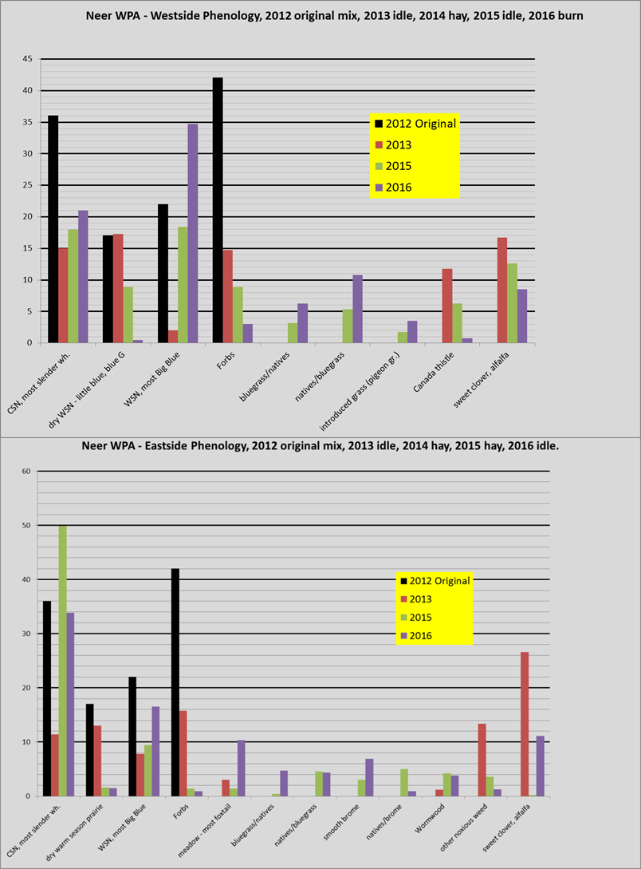

3. Our oldest PR site – Field 101, Nikolaisen WPA (a.k.a. Cami’s Field)

Our first “true” prairie reconstruction site was a 101 acres site located at the Nikolaisen WPA and seeded in spring of 2005 (Figure 4). Funding to initiate this restoration occurred from “Ruddy Duck Mitigation” funds from an oil spill occurring in the Potomac River drainage in Maryland. The blue bars represent what the field would have looked like initially (25 species mix) at restoration, the green bars show what the field looks like today. It is dominated by little bluestem, gramas, big bluestem and indiangrass and a variety of forbs; stiff goldenrod, yellow coneflower, Canada milk vetch, wild bergamot and leadplant. The field has been periodically managed throughout its 13 year lifespan as noted below. Note again the continued loss of cool season native grasses, but forbs have been maintained at roughly 25% during the 2016 evaluation. Kentucky bluegrass continues to increase and will likely be a problem into the future. Smooth bromegrass and Canada thistle continue to be minimal. What we’ve learned from this site and others like it is that a manger must have good management options and good cooperators to accomplish grassland management over red-meat production. Burning the site is a current option, but what we’ve learned to date is a spring or fall burn will likely spur KBG growth (and other beneficial species) KBG management is where most of our response uncertainty lays as KBG is a tough competitor and our management methods to decrease this species to date have been futile. The good news, the habitat is heterogeneous and species richness across the landscape remains high providing opportunities for a rich diversity of faunal biota from May through October, twelve years after restoration. Monitoring is ongoing.

Figure 4. Field 101 (Cami’s Field) management and vegetation monitoring results over 12 growing seasons at the Nikolaisen WPA, Towner County, Devils Lake WMD.

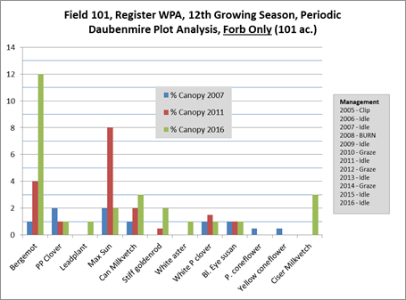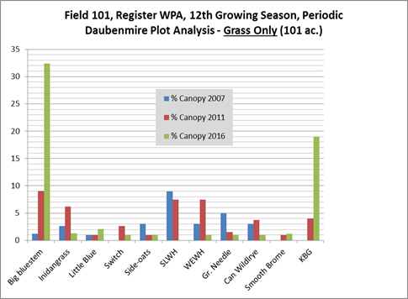

1. FIELD 38 – Nikolaisen WPA – Interseeding forbs at an established PR site.

Field 38 was restored with native grasses and forbs in the spring of 2005. The site was not a traditional diverse mixture; we used 7 species of native grasses and only 4 species of forbs at restoration. The grasses (green needlegrass, western and slender wheatgrass, needle and thread, little and big bluestem, switchgrass) and forbs (Maximillian sunflower, yellow coneflower, rough blazingstar, purple prairie clover) were planted at approximately 7.5 lbs. per acre, with grasses comprising 75% of the mix and forbs 25%. The site was hayed once in the fall of 2005, and was idle from 2006 to the fall of 2009.

In the spring of 2010 and after our monitoring revealed a drop in forb abundance yet excellent grass coverage, a decision was made to interseed 10 species of forbs into this existing grass stand. The site was hayed in the fall of 2009, and interseeded with a Truax grass drill in the spring of 2010. The forbs selected were; western yarrow, purple coneflower, black-eyed susan, yellow coneflower, Canada milkvetch, wild bergamot, golden alexander, blue vervain, purple prairie clover, Maximillian sunflower and Lewis flax. The seed cost for this effort was $58.00 per acre.

Results: We monitored 75 - 1m x 1m blocks across the field beginning in late summer of 2011, and again in 2013, 2014 and 2016. The following chart shows the results of each planted forb species and their individual probability of detection within a square meter test plot.

Figure 5. Results of interseeding at Field 38 within the Register WPA in Towner County, North Dakota. The percent detection chance is a species chance of being detected within a 1m x1m monitoring plot located within the field. Note – this field was interseeded in .5 acre blocks and totaled about 7 acres interseeded within a 38 acre field.

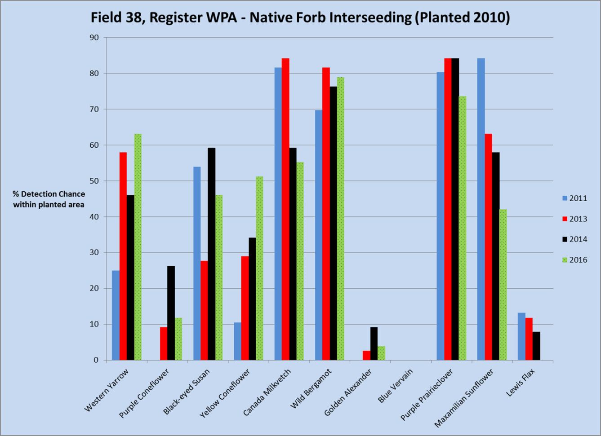

Interpretation: Of 11 interseeded forb species, only golden alexander, blue vervain and Lewis flax remained at very low detection levels. All other planted forbs exceeded a 20% detection probability, and 5 species exhibited a greater than 50% detection probability.

In the fall of 2013, a fence was installed around Field 38, and cattle were allowed to graze the site during the fall of 2014. It is expected that cattle will likely disperse seeds from many of these abundant forb species across the site, effectively causing a “seed rain” effect across the entire field which is ideal for promoting plant diversity here. In 2016, we established and monitored random sites across Field 38 designed to monitor the rates at which interseeded species spread.

What we’ve learned – interseeding forbs within an existing grass stand can be an effective tool for increasing plant species richness at a particular site, and these results indicate positively that many of these species can increase and remain abundant thru time. Also, the presence and persistence of these forb species would indicate an improved site for invertebrates’ dependent upon nectar sources and it would be expected to see increased pollinator diversity.

1. A slideshow presentation and accelerated level of monitoring of new PR stands with a management focus.

From this point forward in this document, please see the accompanying slideshow document which captures more details of further PR monitoring with a strong management focus. Also, we describe 3 monitoring methods used and designed to elucidate habitat management prescriptions and the plant species responses thru time. The 3 methods include the Belt Transect Method, the Daubenmire Method and Braun-Blanquet “Releve” sampling. Each technique are easy to analyze, and provides managers specific trends related to individual species or landscape level responses to management.