|  |  |
| --- | --- |
|  | |
| U.S. Fish and Wildlife Service  U.S. Department of the Interior  National Wildlife Refuge System |  |

Regional Protocol Framework for the Inventory and Effectiveness Monitoring of Invasive Plants in Forests

*Eastern Broadleaf Forest Biology Network – Midwest Region*

Stiltgrass (*Microstegium vimineum*) invasion

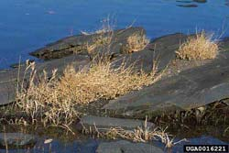

James Miller

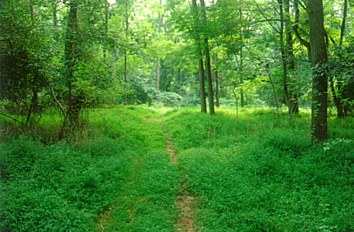

Chicago Botanic Garden

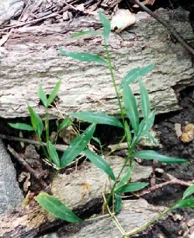

Marc Imlay

**Version 1.0 April 2017**

ON THE COVER

States of infestation illustrated with stiltgrass

Photographs by: Mark Imlay, James Miller, and the Chicago Botanic Garden

NWRS Survey Protocol Signature Page

|  |  |  |  |  |  |  |
| --- | --- | --- | --- | --- | --- | --- |
| **Protocol Title:** Regional Protocol Framework for the Inventory and Effectiveness Monitoring of Invasive Plants in Forests  **Version1 :** 1.0 | | | | | | |
| **Station Names:**  Big Oaks, Crab Orchard, Cypress Creek, Mingo, and Muscatatuck National Wildlife Refuges | | | | **Authors and Affiliations:**  Joshua Booker (USFWS), Sean M. Blomquist (USFWS), Daniel D. Wood (USFWS), Amanda C. McColpin (USFWS Contractor), Victoria M. Hunt (Chicago Botanic Garden), Damon B. Lesmeister (U.S. Forest Service), Eric V. Lonsdorf (Univ. of Minnesota), Karen Mangan (USFWS), Brad Pendley (USFWS), Benjamin A. Walker (USFWS) | | |
| **Approvals** | | | | | | |
| **Action** | | **Appropriate Signature/Name** | | | | **Date** |
| **Survey Coordinator2**  **Submitted by:** | | Joshua Booker, Zone Biologist, R3, and Amanda McColpin, I&M Contractor | | | | 4/20/17 |
| **Zone I&M3 or equivalent Approval:** | |  | | | |  |
| **Regional I&M4 Approval:** | | Melinda Knutson, I&M Coordinator, R3 | | | |  |
| **National I&M5 Approval:** | |  | | | |  |
|  | | | | | | |
| **Version1** | **Date** | | **Author** | **Change Made** | **Reason for Change** | |
|  |  | |  |  |  | |
|  |  | |  |  |  | |
|  |  | |  |  |  | |
|  |  | |  |  |  | |
|  |  | |  |  |  | |

1 Version is a decimal number with the number left of decimal place indicating the number of times this protocol has been approved (e.g., first approved version is 1.0.; prior to first approval all versions are 0.*x*; after first approval, all minor changes are indicated as version 1. *x* until the second approval and signature, which establishes version 2.0, and so on).

2 Signature of station representative designated lead in development of a site-specific survey protocol.

**3** Signature signifies approval of a site-specific survey protocol.

**4** Signature by Regional I&M Coordinator signifies approval of a protocol framework to be used at multiple stations within a Region.

**5** Signature by National I&M Coordinator signifies approval of a protocol used at multiple stations from two or more

Regions.

Survey Protocol Summary

In 2003, invasive[1] species were the top threat listed in the National Wildlife Refuge System Threats and Conflicts Database (U.S. Fish and Wildlife Service [USFWS] 2003). By fiscal year 2012, approximately 2.5 million acres of national wildlife refuge lands were impacted by invasive plants (USFWS 2013b). In response to this problem, six refuges within the Eastern Broadleaf Forest Biology Network of USFWS Midwest Region began developing an invasive plant adaptive management project in southern Indiana, Illinois, and Missouri during 2009‒2010. Project participants developed a structured, iterative process for managing invasive plants in forested habitats to target our two primary areas of uncertainty: the distribution of invasives and the effectiveness of management actions. This process, the Forest Invasives Adaptive Management project (FIAM; Lesmeister et al. 2014; USFWS 2016b), addresses the problem of invasive species management at two scales corresponding to the two areas of uncertainty: the refuge scale and a management scale (i.e., a smaller area targeted for a particular management action). This protocol framework[2] consists of two distinct components, which may be used together or separately: 1) a forest inventory of invasive plants at the refuge scale, along with a formalized process for using the inventory data to prioritize actions at the refuge scale, and 2) effectiveness monitoring at the management scale with a corresponding adaptive management model. Both components use an accompanying database on the FIAM project SharePoint site: <https://connect.doi.gov/fws/Portal/fip/SitePages/Home.aspx>.

This protocol framework was developed based on ideas and insights from data collected in 2009‒2010 during a forest inventory conducted following the U.S. Forest Service’s Forest Inventory and Analysis field methods (USFS 2012). The FIAM inventory underwent pilot testing in 2011. The FIAM inventory evaluates the spatial distribution of invasive plant species as well as the state (i.e., magnitude) of the infestation based on a sample of points on a grid system across the entire refuge. This systematic, grid-based approach samples points across the refuge to assess two categorical variables: state of infestation for each species and invasive species aggressiveness. The result is a quick assessment of the complete invasion problem throughout a refuge. The inventory data are used in a site prioritization model, which ranks infested areas based on GIS-derived metrics on distance to critical areas, the proportion of nearby (within 250 meters[m]) cells that are uninvaded, and distance to potential vectors for spread. The inventory approach described here is best suited to refuges with known and widespread invasive species problems and not for stations with a primary interest in detecting new invaders at low densities.

The FIAM effectiveness monitoring was pilot tested from 2012‒2016 and evaluates effectiveness of management actions at a management scale, providing a feedback loop to the corresponding adaptive management model. The FIAM effectiveness monitoring also uses a systematic grid of points (at a smaller scale) to quickly sample points in a target management area pre- and post-treatment to assess three state-based metrics: state of infestation for each species, invasive species aggressiveness, and native species richness and cover. More details on this project are available from the FIAM project SharePoint site.

**Suggested citation:**

Booker J, Blomquist SM, Wood DD, McColpin AC, Hunt VM, Lesmeister DB, Lonsdorf EV, Mangan K, Pendley B, Walker BA. 2017. Regional Protocol Framework for the Inventory and Effectiveness Monitoring of Invasive Plants in Forests, U.S. Fish and Wildlife Service, Midwest Region, National Wildlife Refuge System, Division of Natural Resources and Conservation Planning, Bloomington, MN.

This protocol is available from ServCat [[https://ecos.fws.gov/ServCat/ Reference/Profile/37544](https://ecos.fws.gov/ServCat/%20Reference/Profile/37544)]

Acknowledgments

We thank senior leadership of USFWS Midwest Region, Division of Natural Resources and Conservation Planning, especially Dr. Patricia Heglund and Dr. Melinda Knutson, for funding and science support during project development. National Wildlife Refuge System (NWRS) Seeds of Success, NWRS Invasives with Volunteers, and NWRS Inventory & Monitoring Initiative also provided funding for development of this inventory protocol framework. The Eastern Broadleaf Forest Biology Network in the Midwest Region developed and championed this project. We thank the Project Leaders and Refuge Biologists for their support, engagement, and perseverance.

In particular, we thank Alejandro Galvan, Project Leader at Muscatatuck NWR, for providing staff time and resources to support the pilot testing of all aspects of the project by former Refuge Biologist Daniel Wood and his team. We thank the dozens of field staff that assisted in collecting pilot data. Special thanks go to Dr. Joseph Robb, Project Leader at Big Oaks NWR, Perry Williams, former Refuge Biologist at Big Oaks, and Lindsey Landowski, former Assistant Manager at Patoka River NWR, for help developing the initial ideas that became FIAM. Giselle Block, Lindy Garner, Jenny Ericson, and Clinton Moore also provided useful advice and guidance. We thank Gabriel DeAlessio for developing the FIAM map within the Collector for ArcGIS mobile application. We thank the contractors that helped develop portions of the protocol framework. Karla Gauge, coordinator of the River to River Cooperative Weed Management Area in southern Illinois, helped to develop the training module. Eric Lonsdorf, Victoria Hunt, and Sarah Jacobi of the Chicago Botanic Garden helped structure and develop the prioritization and adaptive management decision models and SharePoint interface and provided invaluable guidance through this process. Finally, we thank the reviewers who provided helpful comments and critiques that resulted in improvements to the overall product.

*Disclaimer: References to commercial products are not endorsements.*

Contents

NWRS Survey Protocol Signature Page 1

Survey Protocol Summary 2

Acknowledgments 4

Narrative 7

Element 1: Introduction 7

Background 7

Objectives 10

Element 2a: Sampling Design – Inventory 14

Sample design – Inventory 14

Sampling units, sample frame, and target universe – Inventory 15

Sample selection and size – Inventory 15

Survey timing and schedule – Inventory 17

Sources of error – Inventory 17

Element 2b: Sampling Design – Effectiveness Monitoring 18

Sample design – Effectiveness Monitoring 18

Sampling units, sample frame, and target universe – Effectiveness Monitoring 19

Sample selection and size – Effectiveness Monitoring 19

Survey timing and schedule – Effectiveness Monitoring 20

Sources of error – Effectiveness Monitoring 20

Element 3: Field Methods and Processing of Collected Materials 21

Spread Prevention Techniques 21

Inventory 22

Effectiveness Monitoring 22

Documenting Management Actions 22

Element 4: Data Management and Analysis 22

Data entry, verification, and editing 22

Metadata 23

Data security and archiving 24

Analysis methods 24

Software 25

Element 5: Reporting 25

Report contents and reporting schedule 25

Report distribution 26

Archiving 27

Element 6: Personnel Requirements and Training 27

Roles and responsibilities 27

Qualifications 28

Training 28

Element 7: Operational Requirements 30

Budget 30

Staff time 33

Schedule 33

Coordination 34

Element 8: References 34

Standard Operating Procedures (SOPs) 38

SOP 1: Creating Grid Points – Inventory and Effectiveness Monitoring 38

Creating grid points 38

Creating subareas 40

Exporting grid points 41

SOP 2: Field Methods – Inventory 43

Pre-survey logistics and preparation – Inventory 43

Establishment of sampling units – Inventory 43

Data collection procedures (field, lab) – Inventory 44

Processing of collected materials – Inventory 50

End-of-season procedures – Inventory 50

Tips and hints from pilot testing, by Dan Wood 51

References – Inventory 51

SOP 3: Creating Species Distribution Maps and the Prioritization Model 52

Importing inventory data into ArcMap 52

Data manipulation and analysis to create species distribution maps 52

The prioritization model and GIS tool to implement the spread score 56

SOP 4: Field Methods – Effectiveness Monitoring 58

Pre-survey logistics and preparation – Effectiveness Monitoring 58

Establishment of sampling units – Effectiveness Monitoring 59

Data collection procedures (field, lab) – Effectiveness Monitoring 60

Processing of collected materials – Effectiveness Monitoring 64

End-of-season procedures – Effectiveness Monitoring 64

References – Effectiveness Monitoring 64

SOP 5: Documenting Management Actions 65

Conducting Management Action 65

Management Action Data Forms 65

Supplemental Materials (SM) 69

SM 1: Outline of FIAM Inventory and Effectiveness Monitoring Protocol Steps 69

Inventory 69

Effectiveness Monitoring 69

SM 2: Adaptive Management (AM) Model Documentation 71

References 72

SM 3: Summary Report Templates – Inventory 73

SM 4: Summary Report Templates – Effectiveness Monitoring 77

SM 5: Datasheets – Inventory and Effectiveness Monitoring 79

SM 6: Datasheets – Documenting Management Actions 83

SM7: Summary of All Data Fields 94

**Narrative**

Element 1: Introduction

***Background***

This protocol framework and the Forest Invasives Adaptive Management Project (FIAM) was designed for national wildlife refuges (NWR) in the Midwest Region. However, the project and the methods are appropriate for any forested lands managed with conservation and biological integrity objectives in mind. The project is open to federal, state, and Non-Government Organization agencies after consultation with the Project Coordinator. The terms “refuge” and “station” are both used to mean lands under the management of designated cooperators in the project. Each cooperator should confer with the Project Coordinator and the Data Manager to verify compatible management objectives, availability of the required resources, and to enroll the station in the project and determine naming conventions.

Invasive plant species, which affect approximately 2.5 million acres of U.S. Fish and Wildlife Service (USFWS) National Wildlife Refuge System (NWRS) lands (USFWS 2013b), are ecologically and economically costly (Leung et al. 2002). As mandated by the NWRS Improvement Act of 1997 and subsequent policy, the NWRS is administered to ensure the maintenance of the biological integrity, diversity, and environmental health (BIDEH) of the System. The BIDEH Policy states that where it is feasible and supports national wildlife refuge (NWR, refuge) purposes, the NWRS will be managed for historical conditions that were present prior to substantial human-related changes to the landscape. Most refuges report that invasive plants interfere with their wildlife management objectives (USFWS 2003), but control with cost-effective and publicly acceptable (e.g., results in better aesthetics, does not disrupt visitor experience) methods is a challenge. Refuge managers rank invasive plants the highest threat to the NWRS, scoring almost double that of any other threat (USFWS 2003). Costs for NWRS staff and resources to combat invasive species increased from $6 million in fiscal year 2004 to $15.8 million in fiscal year 2011 (USFWS 2013a). Further, many federally-listed threatened and endangered species may be impacted by invasive species. Although considered top priority for most NWR managers, there is limited funding and staff to control established infestations or prevent new infestations, and it is estimated that only about 10% of infested acres are treated annually (USFWS 2013b).

Mapping the distribution of plant invasions, or conducting an inventory, is an essential part of invasive plant management (DiTomaso 2000; Stohlgren and Schnase 2006). NWR managers, and most other land managers, have an established need for cost-effective informational tools to properly plan, prioritize, manage, and understand non-native invasive plant infestations. Often, in the face of temporal, budgetary and personnel constraints, managers plan their management strategies with little to no *a priori* information about the nature of the infestations they are managing. This paradoxical dilemma is difficult to overcome, as many managers feel the need to use limited resources to control invasive plants rather than “waste” those resources on invasive plant inventories. However, effective management is dependent upon reliable vegetation monitoring data, and area-wide invasive species inventories should be conducted before prioritizing and adopting specific management strategies (Dewey and Andersen 2004). Should a doctor treat a broken bone prior to taking an x-ray? Should firefighters leap into action on a wildland fire without aerial reconnaissance mapping? These analogies illuminate the error of well-meaning managers who conduct treatments prior to assessing the problem.

In addition to the logical reasoning for inventorying first, there are several legal reasons to do so as well. Department of Interior (DOI) and USFWS policies (517 DM1, 569 FW1, and 620 FW1) instruct refuges to adopt integrated pest management (IPM) as a strategy for managing invasive species. These policies also relate directly to the Biological Integrity Policy (601 FW 3), which mandates the use of IPM strategies. The USFWS IPM guidance for preparing and implementing IPM strategies states that monitoring and mapping are critical components of successful IPM programs and should be completed prior to any pest management action (USFWS 2004). Inventories should be conducted as a first step in an IPM strategy with the objective of creating accurate species distribution maps that will be used to set priorities and select management strategies.

The USFWS Midwest Region refuges that are primarily forested in the Central Hardwoods Region (Illinois, Indiana, and Missouri) include Big Oaks NWR (IN), Crab Orchard NWR (IL), Cypress Creek NWR (IL), Mingo NWR (MO), Muscatatuck NWR (IN), and Patoka River NWR (IN). In 2009, these refuges began investigating invasive plant infestations using the U.S. Forest Service (USFS) Forest Inventory and Analysis field methods (USFS 2012). However, the USFS inventory uses random points, and the detail required is time consuming at each data collection point. The refuge staff recognized that they needed a comprehensive, more efficient method of inventory in order to understand the overall distributions of invasive plant species across an entire refuge. There was a need to prioritize management actions across a refuge and a need for coordination to effectively control multiple forest-adapted invasive plant species. In 2011, staff from each refuge and from the Midwest Region Division of Natural Resources and Conservation Planning, as well as collaborators from the Chicago Botanic Garden, convened for a structured decision making workshop (USFWS 2011a). The goals of the workshop were to formulate and clarify the key components of an adaptive management framework, which included developing fundamental objectives (ultimate conservation objectives), means objectives (ways to achieve fundamental objectives), management alternatives, an appropriate model, and a monitoring approach (Keeney and Raiffa 1993; Hammond et al. 1999; Nichols and Williams 2006; Williams et al. 2007; Gregory and Long 2009). Through the structured decision making process, participants decided to focus on 1) developing a systematic refuge-wide invasive plant inventory, 2) reducing uncertainty in invasive plant management effectiveness at the management scale, and 3) linking invasive plant management decisions at the management scale to success at the refuge scale. Participants decided that a 1-hectare (ha) scale was the most appropriate scale to balance effort and resolution of inventories, as well as an effective scale for management actions and monitoring. Ultimately, FIAM was developed (Lesmeister et al. 2014).

The FIAM project incorporates a multi-step approach of inventory, prioritization of where to treat invasives, pre-treatment monitoring, treatment, and post-treatment effectiveness monitoring in an adaptive management framework (Figure 1). Although the inventory and effectiveness monitoring procedures were developed together as a systematic approach to invasive species management on a refuge, each may also be used separately. The FIAM project was primarily developed for and by refuge staff in the Eastern Broadleaf Forest Network, but the protocol is also relevant to refuges in other parts of the Midwest Region or on private lands with Partners for Wildlife restoration projects. The methods described here are general enough to be applied in different types of forest ecosystems. More details on this project are available from the FIAM project SharePoint site (<https://connect.doi.gov/fws/Portal/fip/SitePages/Home.aspx>) or from the project record, an administrative record that documents project development, leadership, and communications (USFWS 2016b). The project SharePoint site, which includes project documentation and the project database, is open for viewing and downloads by any DOI staff member by using their Active Directory login. Partners require permission to access the site, and the Project Coordinator can arrange for this.

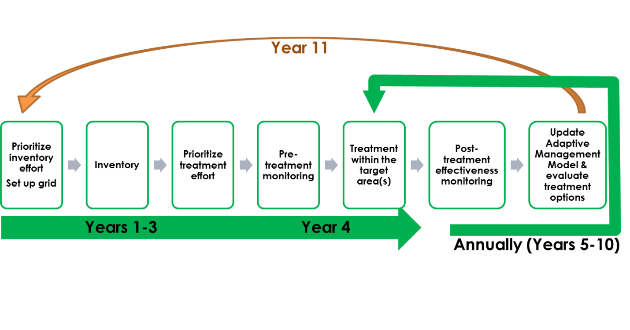

**Figure 1.** An example timeline for completing the FIAM steps. The inventory phase is expected to take one to three years to complete (in this example, three years). As soon as the inventory is finished, the effectiveness monitoring phase begins. Treatment efforts are prioritized, and the first target area(s) is (are) monitored and treated. Post-treatment effectiveness monitoring occurs the following year, along with model updating. Further treatments, additional monitoring, and model updating occur on an annual basis. Approximately every ten years, the refuge is re-inventoried. See SM 1 for a detailed outline of the FIAM steps.

Early detection, rapid response (EDRR) is a strategy of invasive species control that involves detecting new invasive species infestations and implementing a prompt and coordinated containment and eradication response. Although FIAM does not explicitly include EDRR surveys and treatment, by conducting the systematic inventory across a refuge, new or previously unknown populations of invasive plants may be encountered. For example, during the inventory at Muscatatuck NWR, at least two species were detected that had not previously been recorded at the refuge, and a known invasive species on the refuge was discovered to have a much wider distribution than had previously been observed. In fact, after conducting an initial systematic forest inventory in 2009‒2010 and refining the estimates using the FIAM inventory in 2011, Muscatatuck’s invaded acres, as reported in the internal Refuge Annual Performance Plan database, jumped from 2500 acres in FY2008 to 6400 acres in FY2012 because the inventories revealed far more widespread invasions than were previously estimated (USFWS 2016a). Muscatatuck’s inventory was conducted at a relatively fine resolution (0.25-ha grid); however, even at a coarser resolution (e.g., 1-ha grid) we expect managers to gain a reasonably accurate understanding of the distributions of invasive species on their refuges. In addition, it is possible to use this protocol to inventory most of a refuge at a coarser scale and use a smaller grid size to target areas of concern, such as high traffic areas. Finally, separate EDRR activities (such as regular monitoring of potential invasive species pathways) are considered by participants to be high priority and are expected to occur outside of the FIAM framework.

The inventory component of the protocol framework presented here supports the prioritization model in the FIAM project (Lonsdorf and Davis 2014; USFWS 2016b) and has undergone five years of pilot testing and refinement. Pilot testing included single-year implementation at Muscatatuck NWR and multi-year implementation at Big Oaks, Crab Orchard, and Cypress Creek NWRs. Because invasives can spread relatively rapidly, we recommend that a station complete the inventory component in one to three years in order to base prioritization decisions on up-to-date information. The refuge-scale inventory is a quick assessment of grid cells across the entire refuge based on metrics that will affect prioritization. At the center of each grid cell, the invasive plant species present and the state of infestation for each species are recorded. Based on these metrics and other GIS-derived metrics, we compute a priority score for each grid cell on the refuge. In addition, the refuge-scale inventory can guide prioritization and management decisions by providing maps of the spatial extent and severity of infestation for invasive plant species as well as maps of uninvaded areas. Finally, we included an optional measure of native species richness and occupancy in the inventory so managers can derive a systematic, albeit general, understanding of native species distribution relative to invasive species.

The effectiveness monitoring component of this protocol framework supports the FIAM adaptive management decision model and has undergone three years of pilot testing and refinement (however, the sampling design of the effectiveness monitoring was recently changed and has not yet been pilot tested). The management-scale effectiveness monitoring is a relatively quick method to document the level of infestation for each invasive species, as well as the richness and cover of native species, within a discrete area targeted for treatment. The adaptive management model includes a suite of common management strategies: mechanical, chemical, mechanical/ chemical combined, fire, and native species planting. The entire effectiveness monitoring process entails several steps: pre-treatment monitoring of a defined target area, treatment of invasive plants and documentation of treatment methods shortly thereafter, post-treatment monitoring of that target area the following year, and updating model weights based on the monitoring data. Additional post-treatment monitoring may be conducted in subsequent years. As data accumulate from multiple treatment areas, the model weights continue to be updated.

***Objectives***

Management objectives

Management objectives are statements detailing the resource outcomes a refuge plans to achieve. These objectives trigger the need for a survey. Each refuge using this protocol framework needs to clearly define their management objective(s) in a site-specific protocol before beginning a survey to ensure that they get the required information. Generally, for each of the refuges involved in the FIAM project, the broadest fundamental objective is to conserve a diversity of fish, wildlife, and plants and their habitats. More specifically, all NWRs are tasked with maintaining BIDEH and improving habitat for trust resources. By providing a comprehensive approach to invasive plant species management, participation in the FIAM project helps refuges meet these fundamental objectives (Figure 2).

To progress toward the broader fundamental objectives, refuges using this protocol framework may have narrower fundamental objectives of minimizing invasive plant species occupancy, minimizing spread of invasive plant species, and maximizing native plant species richness and occupancy in forest environments. NWRs may also want to minimize management costs, maximize public acceptability of management activities (e.g., recreational opportunities, hunting, aesthetics), and maximize protection of areas with critical habitat or species (Figure 2). For each fundamental objective, this protocol identifies measureable attributes, which are stepped down to specific metrics that are the focus of the inventory and monitoring.

Each participating cooperator should review their Habitat Management Plans (HMP) to verify that their specific management objectives are consistent with the more general objectives of the FIAM project. For example, Objective 1.1 of the Muscatatuck NWR HMP, states “…within 15 years, enhance 150 acres of upland forest by removing invasive species and employing various improvement techniques to ensure proper understory development, regeneration, and age class and species compositions” (USFWS 2011b, p. 100). The site specific survey protocol for each cooperator should identify and link station-specific objectives to the more general objectives of the project.

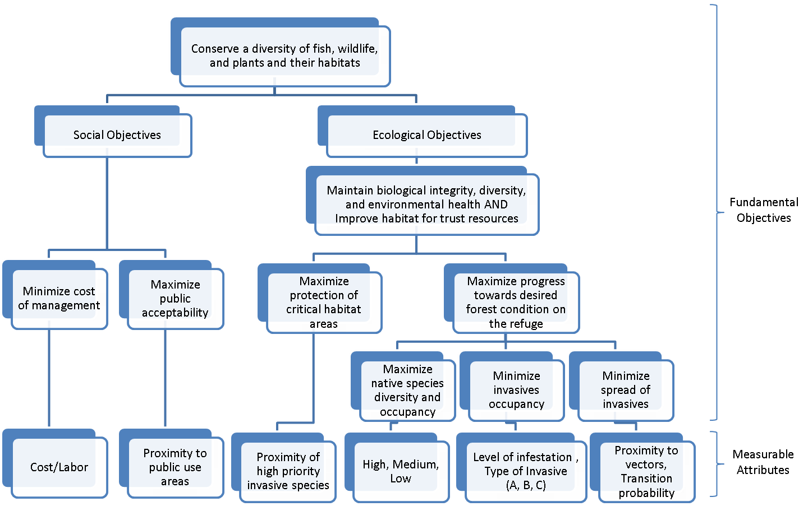

**Figure 2.** A general objective hierarchy linking FIAM metrics to objectives for controlling invasive plants on national wildlife refuges.

Generally, for each of the refuges involved in the FIAM project, this protocol framework supports progress toward meeting the objectives of minimizing invasive plant species occupancy and minimizing spread of invasive plant species in forest environments (Figure 2) by providing an initial inventory and distribution of invasive plant species, a tool to help refuge staff prioritize where to manage invasive plants, and objective measures of the effectiveness of invasive plant treatments. Including the optional metrics for native species within the inventory component can further inform decisions about where to control invasive species (e.g., managers can use these data to locate hotspots of native plant diversity on the landscape). Objectives for management of invasive plant species contribute to the larger common objective of obtaining a desired forest condition on each refuge.

Sampling objectives

Inventory: The refuge-scale inventory is intended to detect which invasive plant species are present and to assess the spatial extent and level of the infestation for each of the species detected. Inventory metrics were reduced from complex, highly accurate, time-consuming measures of forest condition used in protocols such as the USFS Forest Inventory and Analysis (USFS 2012) to states, or ordinal categories, that describe a level of accuracy that the project participants believe is adequate to decide where and for which species to implement management. Such state-based data collection and modeling that address project objectives are highly recommended for land management (see Element 2a: Sampling Design – Inventory; Nichols and Williams 2006; Lyons et al. 2008; Bestelmeyer et al. 2011). The primary goal of the inventory is not to be able to detect changes over time at the refuge scale (although this will be possible over long time spans) but instead to generate a systematic understanding of the current distributions of invasive species and level of infestation.

Sampling objectives provide the specifics for measuring the resource or related indicator targeted in the management objectives. For each management objective identified above, the refuge needs to specify, in the site-specific protocol, a sampling objective that includes the following:

1. what will be surveyed (resource or ecological indicator);
2. where the survey will be conducted (geographic location and type of environment, specific management units, Universal Transverse Mercator (UTM) coordinates, and a map of sampling points);
3. the attribute actually measured or estimated (e.g., infestation state, distance, cost);
4. the measurable state of the attribute (quantity/status); and
5. the time frame of the survey.

For example, if we take Objective 1.1 of the Muscatatuck NWR HMP again [“…within 15 years, enhance 150 acres of upland forest by removing invasive species and employing various improvement techniques to ensure proper understory development, regeneration, and age class and species compositions” (USFWS 2011b, p. 100)], an example of a sampling objective could be to estimate the level of infestation of 25 invasive plant species in 300 acres of upland forest habitat in 2018 and classify these species into three levels of aggressiveness (see Tables SOP-2.1 and SOP-2.2 for definitions).

The primary measureable attributes (Figure 2) of the refuge-scale inventory are two types of vegetation states: 1) the aggressiveness of the species detected, and 2) the level of infestation of invasive species. The two types of states are divided into classes, as follows:

* Type of each invasive species based on aggressiveness (see Table SOP-2.1 for list of species)
  + A-list species (High)
  + B-list species (Moderate)
  + C-list species (Low)
* State (level) of infestation of each invasive species (see Table SOP-2.2 for definitions)

|  |  |
| --- | --- |
| 0 | Absent |
| 1 | Few Plants |
| 2 | Patches or Moderate Abundance |
| 3 | Infested |

We define aggressiveness as the capacity of a species to spread through the landscape and the level of impact the species has on native biodiversity. Aggressiveness states were determined by the original participants completing the NatureServe I-rank assessment (Morse et al. 2004) for each species and then rounding up to the highest rank (e.g., if three refuges ranked tree of heaven as low, low, and moderate, the final rank would be moderate). The species list and rankings (Table SOP-2.1) may be changed when new species are observed or when new information is available regarding aggressiveness. However, any changes need to be consistent across all participating refuges and documented as a revision to the protocol.

Effectiveness monitoring: Monitoring of invasive plant species at the management scale before and after treatment is intended to assess the effectiveness of the management action in controlling the invasive plants in the target area. Invasive plant monitoring metrics similar to those used in the FIAM inventory provide a level of accuracy that the project participants felt was adequate to decide which management action to implement and whether that action was successful at reducing the infestation level of the treated species within the given target area. Each refuge needs to specify, in the site-specific protocol, effectiveness monitoring sampling objectives (with detail similar to those for inventory). For example, if we take Objective 1.1 of the Muscatatuck NWR HMP again [“…within 15 years, enhance 150 acres of upland forest by removing invasive species and employing various improvement techniques to ensure proper understory development, regeneration, and age class and species compositions” (USFWS 2011b, p. 100)], an example of an effectiveness monitoring sampling objective could be to reduce the mean level of infestation (preferably to 0) for the four worst invasives (A-list species) within a defined target area, given one or two years of treatment. At the same time, we want to increase the native species richness and cover.

The primary measureable attributes of the management-scale effectiveness monitoring are three types of vegetation states: 1) the aggressiveness of the invasive species, 2) the level of infestation of invasive species, and 3) native species richness and cover (i.e., native to that ecoregion). These states (i.e., the monitored attributes) are the foundation for the predictive adaptive management decision model and are collected before and after each management action is taken to monitor effectiveness of the action. The three types of states are each divided into classes, as follows:

* Type of each invasive species based on aggressiveness (as for Inventory; see Table SOP-2.1)
* State (level) of infestation of each invasive species (as for Inventory; see Table SOP-2.2)
* Native species richness and cover in four categories (see Table SOP-4.1)

Element 2a: Sampling Design – Inventory

***Sample design – Inventory***

For an inventory to be effective, certain data must be acquired, including identifying which invasive species are present, their location, and their relative abundance or level of infestation (NAWMA 2002; Rew and Pokorny 2006; Christensen et al. 2011). Invasive plant mapping approaches typically cover a particular area of interest and attempt to catalog every location of the target of interest. Mapping is very time intensive, but yields accurate data on the coverage of invasive species within the area of interest. Such approaches, however, require prioritization of areas to inventory and species to focus on in most situations.

In contrast, sampling approaches (e.g., randomized, systematic) for invasive species inventory take a sample of invasive species at defined points throughout the study area, collecting data on location, size, and density of invaded area. Sampling approaches provide absence, as well as presence, data and can often be less time intensive. Invasive species monitoring frequently focuses on presence only data; however, the collection of true absence data gives greater value to the dataset and allows the use of traditional statistical methods (Li et al. 2011). True absence data is essential to producing accurate assessments within any species distribution model (Vaclavik and Meentemeyer 2009). Systematic sampling approaches are often used for community or long-term ecological monitoring (e.g., Alberta Biodiversity Monitoring Program, Long-term Ecological Monitoring Programs for Denali National Park & Preserve and Kenai National Wildlife Refuge; Heglund et al. 2005; Morton et al. 2009). Systematic sampling is ideal for predictive modeling, such as creating species distribution maps, and has been advocated for long-term ecological monitoring (Stadt et al. 2006). It does not require stratification, is free of assumptions about species-specific distributions, and representative samples can be drawn from post-hoc boundaries.

The inventory component of this protocol uses a systematic sampling approach (i.e., a grid of points throughout the refuge) to support the inventory objective of developing a relatively complete refuge-scale understanding of the distribution and level of infestation of invasive plant species in order to be able to prioritize areas for management. We felt that, given budgetary and labor constraints, an extensive, streamlined inventory of the entire refuge will empower the manager to make more informed decisions than one based on intensively mapping only a portion of the refuge. However, one drawback to systematic sampling is the potential to under-sample resources, which are numerically rare or spatially clumped, such as the early invasion state of an exotic and potentially invasive species. Thus, this inventory protocol framework should be complemented with EDRR monitoring to detect these types of occurrences as part of a complete management approach for invasive species (USFWS 2004). Conversely, a benefit to traversing the entire refuge in a systematic sampling approach is the possibility of encountering previously unknown populations of invasive species. Encounters of particularly concerning species can be addressed by diverting resources from the ongoing inventory to appropriate EDRR responses.

Ideally, the entire systematic set of points is inventoried before any management actions are conducted, and the inventory can be repeated as needed depending on the expected expansion rates of the invasive species targeted by the inventory. It is anticipated that each refuge would attempt an inventory approximately every ten years. Once the inventory is complete and the prioritization model is run, effectiveness monitoring of invasive plant management actions will be conducted within priority target areas as part of FIAM.

The FIAM inventory protocol framework can be integrated with other protocols based on a systematic grid (e.g., U.S. Army Corps of Engineers forest inventory; Guyon et al. 2012) to provide streamlined field sampling to meet multiple objectives. However, our experience indicates that detailed forest inventories require 15‒30 minutes at each data collection point, while the FIAM inventory requires only a few minutes; therefore, integrating with another protocol may significantly prolong the time required to inventory the entire refuge.

Sampling units, sample frame, and target universe – Inventory

The sample frame is all forested environments within an entire refuge or station, minus areas that are inaccessible (permanently flooded, unexploded ordnance, etc.). The target universe for the inventory comprises the populations of invasive plant species within the forested parts of the refuge.

The FIAM inventory and accompanying prioritization model employ a systematic sampling design based on a square grid system. The sampling unit is a point at the center of each grid cell on the grid system established for each refuge. This protocol recommends a 100 x 100-m square (10,000 m2 or 1 ha sample unit; Figure 3), but the protocol can be adjusted to work with smaller or larger grid cells. As of 2017, Muscatatuck NWR has used a 0.25-ha grid cell and Big Oaks, Crab Orchard, Cypress Creek, and Mingo NWRs have used a 1-ha grid cell. We recommend that cooperators work with the Project Coordinator to determine the appropriate scale for the inventory. See SOP 1 for details about creating the grid in ArcGIS.

The recommended scale of the grid system is a pragmatic compromise among rapidness of the inventory, spatial resolution of the inventory, and an appropriate management scale. A 1-ha scale is achievable in terms of inventory effort, yet is also expected to yield enough information to estimate distributions of invasive species across a refuge and effectively use the prioritization model to target areas for management. The recommended range of grid cell sizes is between 0.25 ha and 2 ha, and grid cells need not be square. For example, a 1-ha grid could be achieved using a 50 x 200-m rectangular grid. Simulation analysis based on pilot work at Muscatatuck NWR and Crab Orchard NWR is ongoing to explore the robustness of the prioritization model relative to grid cell size. A smaller grid requires more staff investment (both in the field and for data entry) but yields finer resolution data.

As each refuge develops a site-specific protocol under this framework, it must specify and justify the grid cell size. In most cases, the grid cell size will be constant across the inventory; however, it is possible to use this protocol to inventory most of a refuge at a coarser scale but use a smaller grid size to target areas of concern, such as high traffic areas. It is recommended, but not required, to reuse the same grid points when the inventory is repeated at a later date.

***Sample selection and size – Inventory***

Because this is a systematic inventory, all accessible grid points (grid cell centers) are inventoried. In addition to the systematic inventory, the prioritization model can incorporate supplemental data from opportunistic sampling along roads, trails, and rivers or interpretation from aerial photos, if desired (Lonsdorf and Davis 2014; USFWS 2016b). Invasive species observed while walking between points may be noted in the comments field, especially those species of particular concern for the refuge. They may be used as supplemental data, but a geographic location must be included. If resources are to be diverted from the inventory to treat high priority species as soon as possible, accurate locations of such plants are essential for efficient treatment.

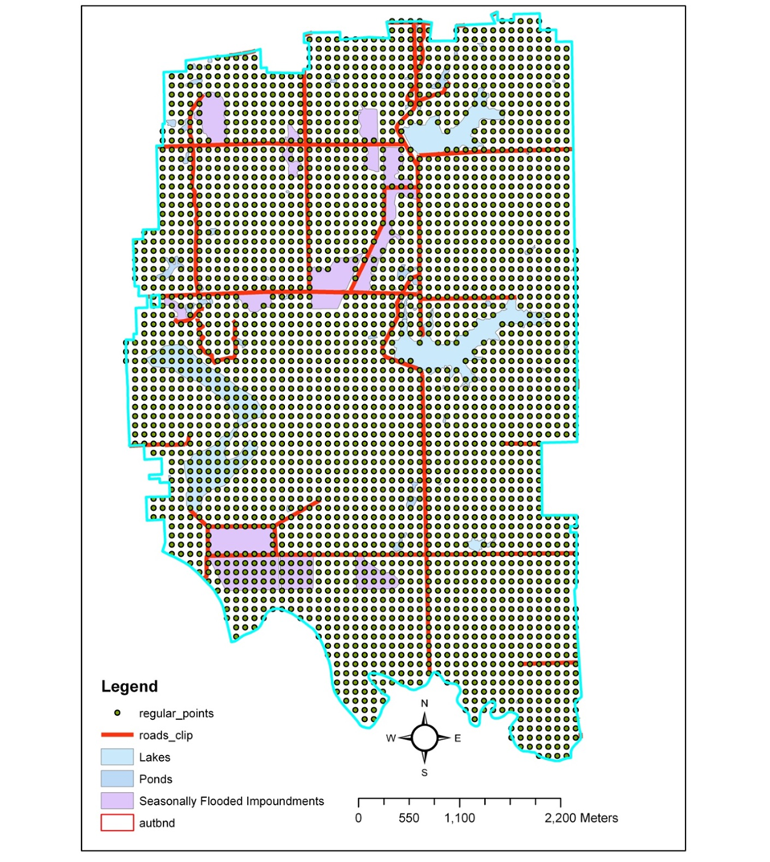

**Figure 3.** Example layout of grid points with 100 x 100-m spacing for systematic sampling at Muscatatuck NWR.

***Survey timing and schedule – Inventory***

Surveys should be conducted during the growing seasons for the targeted invasive plants (Table SOP-2.1). Surveys should not be conducted when plants are difficult to observe, such as when they are newly emerging or senesced. This is especially important for herbaceous species, which may not be evident outside their growing season. Also, surveys for flowering plants will likely have higher success during their flowering season when they are more noticeable (Moore et al. 2011). Some invasive plants have an extended growing season and so may be easier to detect early in the spring before native plants leaf out. However, phenology will likely differ somewhat among target species, so surveys should be timed to maximize detection across species, especially species of highest concern for the refuge. All observations have an associated date. If the area is subject to flooding, burning, or other major disturbance, avoid surveying until vegetation has recovered. Also, surveying during heavy rain or high winds should be avoided because species detection could be diminished.

***Sources of error*** ***– Inventory***

Detection is the largest potential source of error during the inventory. Detection will potentially vary by observer and will vary among grid cells because of differences in visibility. Detection probability should only be an issue for the “Few Plants” state. Detection probability is expected to approach 1 (i.e., 100% of plants that are present are detected) as search effort, plant size, and plant abundance increase (Garrard et al. 2008; Chen et al. 2009; Moore et al. 2011). For example, an experiment with orange hawkweed (*Hieracium aurantiacum*), an invasive, perennial, herbaceous, 25‒50 cm-tall plant, indicated that detection probability increased when plants were found in groups of ≥ 3 (Moore et al. 2011). In a similar distance sampling study, detection of Ute-ladies'-tresses orchid (*Spiranthes diluvialis*), a 20‒50 cm-tall, perennial, terrestrial orchid, ranged from 0.65‒1 along the transect line and ranged from 0‒1 at 5 m from the transect line at five study sites (Colket and Church 2005).

Distance sampling was used during a pilot study to test the detection probability of different invasive plants in different forest types (S.M. Blomquist and D.D. Wood, unpublished data; USFWS 2016b). For the eight species in our pilot study, detection was always 1 at the transect line, but dropped quickly beyond 0.5‒1 m for all species. However, modeled effective strip width ranged from 2‒6 m, and most species had a maximum detection distance ≥ 10 m (Table 1).

The sampling intensity (i.e., grid cell size) recommended here attempts to take these findings into consideration. For example, approximately 0.44-3.99% of Muscatatuck NWR (3,126 ha) was sampled using the chosen 0.25-ha sampling grid and assuming a 2‒6-m detection radius around the 11,024 sampling points. If a 1-ha grid was used, 0.11‒1.00% of the refuge would have been sampled. Generally, larger grid sizes will sample less of the refuge thereby decreasing the probability of detection. The potential influence of using larger grid cells on the prioritization model is currently being explored through simulation. As each refuge develops a site-specific protocol under this framework, it should take these considerations of detection probability into account. For example, if a refuge is most concerned with inventorying a suite of highly detectable species, it could use a coarser grid cell size. However, pilot inventories conducted under this framework have demonstrated that the time it takes to collect data on all invasive species at a point is minimal compared to the time it takes to walk between points, so limiting the

number of species searched for (by focusing on a specific suite of species) may not have much impact on efficiency.

**Table 1.** Results from a distance sampling study on the detection probability of eight invasive species at Muscatatuck NWR (S.M. Blomquist and D.D. Wood, unpublished data).

|  |  |  |  |  |
| --- | --- | --- | --- | --- |
| **Species** | **Detection probability** | **Standard error** | **Effective strip width (m)** | **Max distance detected (m)** |
| Amur honeysuckle | 0.2515 | 0.0243 | 4 | 5 |
| autumn olive | 0.2121 | 0.0185 | 6 | 10 |
| crown vetch | 0.4052 | 0.0524 | 2 | 4 |
| garlic mustard | 0.4049 | 0.0349 | 2 | 10 |
| Himalayan blackberry | 0.1776 | 0.0216 | 6 | 12 |
| Japanese honeysuckle | 0.3738 | 0.0212 | 2 | 10 |
| multiflora rose | 0.1723 | 0.0146 | 6 | 15 |
| sericea lespedeza | 0.1385 | 0.0310 | 6 | 15 |

Another source of error is incorrectly identifying a plant species. Proper training of field personnel is essential to reduce such errors. Although it is desirable to document the distribution of all invasive plants, training personnel to recognize more species requires more pre-season training time. Each refuge should document which plants were searched for and recorded, to distinguish between species searched for but absent (true zeros) and species not searched for (therefore no data).

Mis-categorizing the infestation level is a third source of error, which can also be mitigated by proper training. States of infestation categories are intentionally few in order to reduce observer variability, as well as to reduce the complexity of the prioritization model.

As with the collection and processing of any field data, errors can be introduced when either recording data in the field or entering data into the database. These errors can also be reduced by stressing attention to detail during pre-survey training and by reviewing data as it comes in, especially early in the field season. Both methods of data entry for FIAM (the Collector for ArcGIS application [Collector] and the SharePoint database) have drop-down menus for several fields (e.g., species, state of invasion, observer) to help reduce data entry errors. In addition, the SharePoint database has some built-in data validation procedures, and it converts dates and times to standard formats.

Element 2b: Sampling Design – Effectiveness Monitoring

***Sample design – Effectiveness monitoring***

A manager or biologist will use the inventory data and the prioritization model output to support the decision about where to allocate resources for control of invasive plants. In contrast to the refuge-wide inventory, effectiveness monitoring for management actions generally occurs at a smaller management scale (e.g., a 1-ha target management area). Target areas should be between 0.25–2.0 ha. This size range allows for a reasonable number of sampling units within a given target area (i.e., 6–50 points).

A target management area is outlined, representing the entire area that the biologist or manager is interested in restoring, including all patches and individual invasive plants that will be treated by the management action and also any clusters of native plants that are targeted for protection and/or expansion (Figure 4)[3]. This area should be small enough to implement a single management action over the entire area within a few days. Pre-treatment monitoring will generally occur immediately prior to the management actions for that area. Post-treatment monitoring is expected to occur in the growing season after treatment. We also assume that only one management action is implemented over each treatment area each year. After establishment, the boundary of each target area must remain fixed over time. Target areas should not overlap.

A fine-scale (e.g., 25 points/ha) monitoring grid is generated for the refuge prior to treatment. Any points from the monitoring grid that fall within the target management area represent the permanent monitoring points for that target area. A systematic sampling design was chosen over a random sampling to ensure that any delineated target area would encompass an adequate number of sampling units. It is also much easier and more efficient to navigate to systematic points in a forest compared to random points.

Sampling units, sample frame, and target universe ***– Effectiveness monitoring***

The sample frame consists of all possible points within each such target management area. The target universe is the populations of invasive and native plant species within the target management area.

The sampling units are located at each systematic point in the fine-scale monitoring grid described above. Based on the estimation of detection probability (see Sources of error – Inventory), the sampling unit is a 2-m radius circle (12.6 m2). Our pilot work found that the lowest effective strip width for the eight most common invasive species was 2 m (Table 1; Blomquist and Wood, unpublished data). This means that at distances greater than 2 m, some invasive plant species are not detected when they are present. Therefore, we limited our sampling unit radius to a conservative 2 m to account for this detection probability.

***Sample selection and size – Effectiveness monitoring***

The density of monitoring sampling points across the refuge will be 25 points/ha. This density was selected based on the average refuge’s capacity to collect monitoring data—a density of 25 points/ha will sample approximately 3.14% of a given management area, which is comparable to the sampling effort achieved in the inventory (see Sources of error – Inventory).

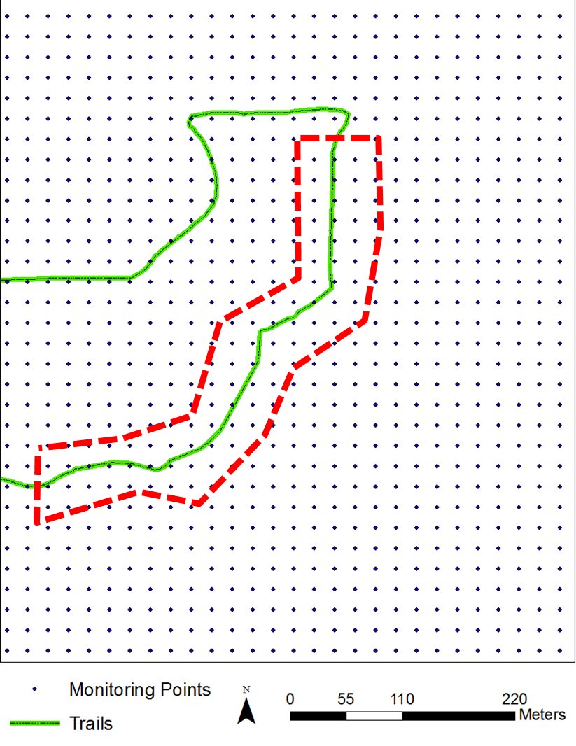

**Figure 4.** Example layout of a target management area (outlined in red, dashed line) along a public trail (green, solid line). Systematic points with a density of 25 points/ha are overlaid. The black dots that fall within the target management area represent permanent monitoring points.

***Survey timing and schedule*** – Effectiveness monitoring

See corresponding section in Inventory above for general guidance about survey timing. In addition, for each target management area in question, consider the particular species found in that management area during the inventory and targeted for control. Consider phenology and detectability of key native plants, as well as of target invasive plants.

***Sources of error*** – Effectiveness monitoring

This protocol does not require permanent marking of sampling units, mostly due to markers potentially interfering with the implementation of management actions. Participating refuges may rely on GPS coordinates and landmarks to return to the sampling units for subsequent data collection. Unless the refuge has access to high-quality, survey-grade equipment, it is unlikely that the exact same 2-m circle will be sampled. This introduces additional between-year variation in the metrics. We recommend trying to ensure a sub-meter GPS accuracy, if possible. Future pilot testing and data analysis will determine if this amount of variation hinders the ability to make inferences about the effectiveness of different treatments.

See corresponding section in Inventory above for additional discussion of sources of error.

Element 3: Field Methods and Processing of Collected Materials

***Spread prevention techniques***

It is important that steps be taken throughout the implementation of this protocol to minimize movement of invasive species propagules (seeds, etc.). The inventory component involves traversing an entire refuge and documenting invasive species at predetermined points, while the effectiveness monitoring component involves more intensive sampling within a smaller area targeted for invasive species control. Such foot or vehicle traffic poses a potential risk of transferring invasive species from one part of a refuge to another. We advise participants to adhere to the following guidelines to limit this risk (documents such as USFS [2001] give additional guidelines).

* Organize field work, if possible, to visit clean sites before going to infested sites.
* Inspect clothing (including boots, waders, chaps, etc.) to remove invasive seed or plant parts after being in an infested area. This is especially important when small-seeded or clinging-seeded species, such as garlic mustard, chaff flower or stiltgrass, have been encountered. Ideally, removed propagules should be bagged and incinerated.
* Clean equipment (vehicles, field equipment) after being in an infested area. Be aware that parking lots or other staging areas for vehicles can concentrate invasive plant propagules and become sources of spread.
* It is particularly important to clean dirt and seeds from clothing and equipment when moving between geographically isolated areas of the refuge, especially if travelling from an infested area to an uninfested area.
* Clothing and equipment can be sterilized with a 10% bleach solution. Equipment should be stored appropriately when not in use.
* When travelling from point to point, be aware of the vegetation you are walking through to assess the risk of spreading invasive plants.
* Be particularly aware of the species of highest concern. Collect location data on those plants and convey the information to appropriate personnel in order to treat them as soon as possible.
* Minimize travel through infested areas, if possible. Try to restrict entry into highly infested areas when there is high risk of spread (e.g., after seed set).
* During treatment actions, be aware that opening up the canopy, disturbing the soil, or removing invasive species may create conditions conducive to the expression of other invasive species whose seeds are already at that site. Where practical, revegetate with appropriate native species.

***Inventory***

The inventory protocol entails detecting and describing occurrences of invasive (and native, if desired) plant species. Details about field methods for the invasive plant inventory component of FIAM are found in SOP 2. In essence, the inventory requires visiting the center of each grid cell and collecting information about the invasive plant species observed and the level of infestation for each species. Optional data for native species may also be collected. Data are imported into ArcGIS to visualize species distributions (SOP 3). Data are also run through the prioritization model (SOP 3), a tool to help managers and biologists decide where to focus their efforts for invasive species control. When priority target management areas are chosen, the refuge may begin FIAM effectiveness monitoring. See “Processing of collected materials – Inventory” in SOP 2 for guidance about how to collect and document unknown plant species.

***Effectiveness monitoring***

The effectiveness monitoring protocol entails detecting and describing occurrences of invasive and native plant species within an area targeted for management of invasive plants. Details about field methods for the invasive plant effectiveness monitoring component of FIAM are found in SOP 4. In essence, the effectiveness monitoring requires going to each target management area and, at a number of sample points within the area, collecting information about the invasive plant species observed and the level of infestation for each species, as well as about native plant richness and cover. The same field methods will be used for vegetation monitoring pre- and post-treatment of invasive plants, and the data will be compared to assess the effectiveness of management. In general, pre-treatment monitoring will occur shortly before managing for invasive plants. Post-treatment monitoring will occur during the following growing season to document the effect of the management action. If desired, post-treatment monitoring may occur in subsequent years as well.

***Documenting management actions***

To assess the effectiveness of management, it is essential to accurately document the methods used to control invasive plants within a target management area. Details regarding making treatment decisions and documenting management actions are found in SOP 5.

Element 4: Data Management and Analysis

***Data entry, verification, and editing***

Two options for data entry are available and identical in the data fields for entry.

* Enter data in the field into a tablet or smartphone equipped to access Collector for ArcGIS. FIAM participants will be given access to a FIAM map within Collector. Work with the Project Coordinator to set up your mobile devices appropriately. At the end of the field season, the Project Coordinator and Data Manager will work with each refuge Survey Coordinator to upload all Collector data to the FIAM SharePoint database. We encourage cooperators to use the in-field data entry method if at all possible to save time, reduce errors, and avoid lengthy delays in data entry.
* Record data on paper forms. Microsoft Excel versions of the datasheets are available on the project SharePoint site in the library called *Protocols & Datasheets*. Data on paper datasheets will need to be entered by participants into the online SharePoint database.

Each surveyor should carry several copies of the paper forms as a backup in case the handheld computer fails. Each observer should also carry spare, charged batteries for the handheld computer and GPS unit. Field personnel should receive training on how to use the handheld computer and the appropriate software applications that are employed at each refuge prior to conducting inventories. Descriptions of each variable on the datasheets can be found in SOPs 2 and 4.

Ideally, data should be reviewed at the end of each day. Electronic data should be backed up daily by uploading it to a server or hard drive. Paper datasheets should be filed in a consistent place, and data should be entered into the database on the FIAM SharePoint site and proofread. If records need to be edited or proofread after entry, there is an option to “Edit Previous Entry” on the online data entry forms, which can be used to look up and review previously submitted entries. The FIAM database user guide may be found on the FIAM SharePoint site in the *Shared Documents* folder.

Data files and datasheets should be reviewed weekly by the Survey Coordinator for accuracy and completeness. Missing and incomplete data is a pervasive problem, and rapid identification of such errors, followed by close supervision and remedial training of field staff will resolve the majority of problems. If missing data problems are not detected quickly, it will cause major problems with analysis and interpretation of the data. It is up to the Survey Coordinator at each refuge to oversee the integrity of that refuge’s data, including proofreading. There is some built-in data validation in the SharePoint database, and the Project Coordinator and Data Manager can help stations troubleshoot data anomalies.

***Metadata***

Metadata describe a dataset, including details about what, where, when, why, and by whom data were collected. Metadata also include information about the reliability and scope of the data so a later user can understand any limitations of the dataset. The Project Coordinator and Data Manager have responsibility for overseeing and maintaining the metadata for this project. However, each refuge Survey Coordinator is responsible for accurately documenting that refuge’s metadata, in coordination with the Project Coordinator. Guidelines for documenting metadata may be found on the USGS Data Management website: <https://www2.usgs.gov/datamanagement/describe/metadata.php>.

Database fields for this protocol framework are described in the “Data collection procedures” sections of SOP 2 (Inventory) and SOP 4 (Effectiveness Monitoring) and in SOP 5 (Documenting Management Actions). A summary of database fields is in SM 7. Each refuge should use consistent species abbreviations and document the scientific name associated with each abbreviation. The USFWS Data Standard for species is the Integrated Taxonomic Information System (ITIS). Species codes used must be cross-walked to their Taxonomic Serial Number (TSN) number. For example, the TSN for *Microstegium vimineum* (Nepalese browntop/Japanese stiltgrass) is TSN 503829. Each participating refuge should document which species its crews were trained to identify and searched for each year, to distinguish true zeros from species that were not on the search list.

Metadata for geographic (GIS) data layers should include the datum or projection. Names for data layers produced from this protocol framework should include the refuge, year(s), and type of data (e.g., BigOaks_2014-16_Inv_AO for a map of autumn olive from inventory data collected during 2014 through 2016 at Big Oaks NWR).

***Data security and archiving***

All data will be stored on the centralized SharePoint database. The SharePoint database is backed up daily through the USFWS Denver server security protocols. Access to use the SharePoint database can be obtained from the Project Coordinator. Each year’s data (all refuges together) is archived by the Data Manager and kept on the SharePoint site.

If data are entered into a handheld computer via Collector, data from each sampling point will be automatically backed up on the USFWS Esri online account.

***Analysis methods***

Inventory – See SOP 3 for instructions on how to export the inventory to ArcMap and create species distribution maps. Maps may be generated for a single species or a group of species, with grids color coded based on infestation state. In addition, SOP 3 provides a brief description of the prioritization model used to help refuge staff decide where to manage invasive plant species (i.e., develop a list of high-priority grid cells). An ArcGIS-based tool is available to refuge staff to run the model, with the assistance of the Project Coordinator, if desired. The GIS tool and complete documentation are available on the project’s SharePoint site in the library called *Prioritization model*.

Effectiveness monitoring – Pre-treatment (or post-treatment) monitoring data for a target management area may be summarized to give an average of the infestation level for each invasive species and an average of each native species metric. After post-treatment data collection, pre- and post- metrics for each sample point will be compared using ordinal linear regression to assess change in invasive species infestation level and native species richness and cover (Sui and Stroup 2001; Rodriguez 2017). Each invasive species will be evaluated separately. See SM 4 for more detail and examples of report tables.

FIAM participants worked with modelers from Chicago Botanic Garden to develop an adaptive management model to assess the effectiveness of five common management actions for control of invasive species. The pre- and post-treatment monitoring data and the management data are inputs to the model. With enough data, we should be able to refine our understanding of the effectiveness of the suite of management actions under consideration. Details about the adaptive management model and its assumptions are in SM 2.

***Software***

The database was developed using the integration of Microsoft Access and SharePoint with Visual Basic code. A data collection map was created in Collector. This system allows automated analysis of the data by the Project Coordinator at the end of the management year. The FIAM coordinator database is available on the project’s SharePoint site. The GIS tool to run the prioritization model can be employed in ArcMap by adding the tool to the toolbox as described in the tool’s documentation.

Element 5: Reporting

Three report types are planned for data collected by this protocol framework: 1) summary project-level progress reports for the entire FIAM project (inventory and effectiveness monitoring combined), including any updates of the adaptive management model, 2) annual refuge reports for each component, including notes of missing data to be rectified, and 3) a final refuge report after completion of the inventory. The Project Coordinator, in conjunction with the Data Manager, is responsible for ensuring data are entered at all refuges and for producing the summary reports. Templates for tables that would be included in the summary reports can be found in SM 3 and SM 4.

In addition, the overall project record and the fact sheet will be updated annually. The project record is an administrative record of the project, and the fact sheet gives an overview of the project, updates the latest management and monitoring activities, and serves as a public relations tool for the FIAM project.

***Report contents and reporting schedule***

Summary project-level progress report – This report includes Inventory and Effectiveness Monitoring.

Inventory: At least every two years, a summary progress report for the inventory component of FIAM should be updated to report the inventory progress of each refuge involved in the project, along with summaries of any refuge inventory reports. This report should include details for each refuge such as: grid size used, number of cells inventoried, percent of inventory completed, number of cells invaded, and invasive species documented. A map of the area inventoried should be attached, along with the archived location of the GIS files.

Effectiveness monitoring: At least every two years, a summary progress report for the effectiveness monitoring component of FIAM should be updated to summarize the monitoring and management activities of each refuge involved in the project. This report should include details for each refuge such as: number of target areas pre-treatment monitored, treated, and post-treatment monitored; type of treatments applied; summaries of post- vs. pre-monitoring data; and outputs of the adaptive management model, including updates to predictions and weights. A map of the area treated and monitored should be attached, along with the archived location of the GIS files.

Periodically, when enough new data are incorporated into the model, the progress toward the overall project objectives and the magnitude of learning under the adaptive management framework will be assessed. An evaluation should be generated to describe the results to date and future revisions to the project following the spirit of double-loop learning (Williams et al. 2007). The Project Coordinator will be responsible for leading the analyses and writing of this evaluation, which should result in peer-reviewed publications.

Annual refuge report – Inventory – A summary refuge report should be generated at the end of each year (e.g., annually after each field season; see SM 3 for example tables). This report will be for internal use by the FIAM project participants and is intended to inform each refuge about its progress, including:

1. Progress in inventory (number of grids inventoried, percent complete)
2. Number uninvaded grids and number invaded grids
3. List of invasives observed so far, with number of grids in which each was observed
4. Spatial distribution of invaded/uninvaded areas (if desired by the refuge, interim data may be exported to a format compatible with ArcGIS for preliminary visualization)

Annual refuge report – Effectiveness monitoring – A summary refuge report should be generated at the end of each year (see SM 4 for example tables). This report will be for internal use by the FIAM project participants and is intended to inform each refuge about its progress, including:

1. Number of target management areas monitored and treated
2. Summary of pre-treatment monitoring data for each target area on that refuge
3. Summary of post-treatment monitoring data for each target area on that refuge with corresponding pre-treatment monitoring (and any previous post-treatment monitoring), management information, and results of any statistical comparison

Final station report – Inventory – A final summary station report and priority management table should be generated when a refuge finishes its inventory. This report will include the final summary of the information listed above in the annual station reports, as well as the recommended priority grid cells for management actions, along with characteristics such as the list of species present in each grid with their infestation states (see SM 3 for example table). The Project Coordinator will work with the refuge Survey Coordinator to export the completed dataset to a format compatible with ArcGIS, to generate the desired invasive plant distribution maps (which will be included in the final report), and to run the prioritization tool (see SOP 3). The final station report will be for internal use by the FIAM project participants and is intended to inform participants of recommended locations for management based on the findings of the inventory and prioritization model. This report can be generated by the Project Coordinator. The analyses performed by the prioritization model are described in SOP 3, and these will not be repeated in the final report. Ultimately, a refuge that finishes this inventory protocol and receives a list of prioritized grid cells is ready to start the FIAM effectiveness monitoring component of this protocol.

***Report distribution***

All reports, as well as the fact sheet, should be distributed to all interested parties. Key parties within USFWS include refuge leadership (e.g., Refuge Supervisors, Regional Refuge Biologist, I&M Coordinator, and Zone Biologists) and biology networks within the Midwest Region, the National Invasive Species Coordinator, the National Integrated Pest Management Coordinator, the Invasive Species Inventory and Monitoring working group, the National Invasive Species and Integrated Pest Management Coordination team. Key partners include local Cooperative Weed Management Areas (e.g., Southern Indiana CWMA, River to River CWMA) and the Midwest Invasive Plant Network Coordinator.

***Archiving***

The Sharepoint site serves as the “working” and collaboration hub for cooperators in the project, with clearly labelled folders for the current version of the protocol, training materials, communications (conference calls and meetings), and other documents needed to support collaboration. The database used for data entry resides here and is available to all collaborators.

A project was created in ServCat to serve as the permanent, long-term archive for the project. Key documents (all versions of the project record, fact sheets, protocol framework, site specific survey protocols for each cooperator, the database, and the database user’s guide), along with annual and periodic reports will be archived in ServCat. The versioning feature of ServCat will be very useful for this purpose.

Element 6: Personnel Requirements and Training

The training module for FIAM was developed during four years of pilot testing and through a contract with Karla Gauge, the River to River Cooperative Weed Management Area Coordinator. The section below is modified from her training module. The entire training module is available on the FIAM SharePoint site. See Table 2b for total expenditure of time on training during pilot testing of inventory.

***Roles and responsibilities***

The overall FIAM project is led by a Project Coordinator, appointed by the USFWS Midwest Region Division of Natural Resources Inventory and Monitoring (I&M) Coordinator. The Project Coordinator is responsible for overseeing the implementation of the project at each cooperating station to ensure consistency. The Project Coordinator is also responsible for assisting the Survey Coordinators at each station to develop the site-specific survey protocol (refuge-specific adaptations of this protocol framework, such as sampling objectives, grid size selection and prioritization of areas for inventory). In addition, the Project Coordinator will assist each refuge Survey Coordinator with creating and archiving the grid system, installing and running Collector, creating species distribution maps, and running the prioritization model.

The FIAM Data Manager, also appointed by the USFWS Midwest Region Division of Natural Resources I&M Coordinator, is responsible for managing the database in SharePoint. Together, the Project Coordinator and Data Manager are responsible for enrolling stations in the project, managing SharePoint permissions, helping Survey Coordinators upload their data, overseeing data integrity, updating the species list, running the adaptive management model, and generating summary reports. The Project Coordinator will lead data analyses and update the project record and other project reports, as necessary.

Each cooperator engaged in I&M under this protocol framework (refuge station or Partner field station) must appoint a Survey Coordinator to oversee I&M activities at that station and write the site-specific survey protocol. The Survey Coordinators are responsible for all aspects of implementing the survey at that station. It is the responsibility of the Survey Coordinator at each refuge to test survey crew personnel proficiency in identification, data collection methodology, and use of technology. The Survey Coordinator at each refuge (in consultation with the Project Coordinator) will also ensure the GIS and GPS work is completed appropriately (setting up the survey grids, loading points and routes to GPS units, downloading GPS units, etc.). The Survey Coordinator at each refuge is responsible for the data integrity at that refuge. Lacking an appointed Survey Coordinator, a station cannot engage effectively or maintain the level of data integrity necessary for participation in the FIAM project.

Each field crew member will hold responsibilities for planning, implementing (data collection, data management, analyzing), and reporting results as assigned by the Survey Coordinator at each refuge. It is the responsibility of the field crew members to reach the desired level of proficiency in completing these tasks.

***Qualifications***

While background in wildlife management, ecology, botany, or other biological sciences is preferred, prior knowledge of invasive plants and their identification is not necessary. Personnel must be able to walk long distances, over several hours in inclement weather and uneven terrain, following GPS points through a variety of habitats. Personnel must be able to accurately and neatly record data in electronic handheld devices or on datasheets, and surveys must be conducted in a way that reflects scientific integrity and scholarly conduct (212 FW 7.7). In addition, a person with intermediate GIS skills is needed for the preliminary GIS work, such as setting up the survey grids and loading points to GPS units.

***Training***

Types of training

A total of at least 40 hours of training is recommended for all field personnel. The Survey Coordinator at each refuge is responsible for ensuring the proper training of that refuge’s field personnel. All personnel will undergo approximately 8 hours of classroom training in invasive plant species identification, coupled with 24 hours of field training in field identification, survey techniques, and safety. Personnel will be given the opportunity for eight hours of self-study and practice prior to a field exam. Additionally, it is suggested that during training, the staff members conducting the training collect specimens of each invasive plant species to be mounted on herbarium sheets. In addition to the intensive training in invasive plant identification described here, it is important that field personnel are acquainted with key native plants, especially for the for the effectiveness monitoring component and the optional native species metrics for the inventory component. Finally, it is essential that all personnel are trained in procedures to minimize the risk of inadvertently transmitting invasive plant propagules between areas of the refuge.

Training module content

1. A slide show with photos of species and identifying characteristics is available and organized by family. The classroom training may use prepared slides taken from this slide show to review basic botany, plant families, and target species. The target species should be tailored by the Survey Coordinator at each refuge to reflect the appropriate species that are of interest or that are expected to be detected during surveys at that site. This slideshow and accompanying notes are available on the FIAM SharePoint site. It is also important to stress distinguishing the invasives from any similar native plants (e.g., native honeysuckle).
2. Descriptions of diagnostic characteristics and growth habits/forms will be given for each species. Species descriptions can be referenced online at the following sources:
   1. Miller et al. (2010; <http://www.srs.fs.fed.us/pubs/gtr/gtr_srs119.pdf>) provides a detailed description of 26 species including Amur honeysuckle, autumn olive, air yam, burningbush, common periwinkle, crownvetch, Chinese yam, European privet, garlic mustard, Japanese barberry, Johnsongrass, Japanese honeysuckle, Japanese knotweed, kudzu, Morrow's honeysuckle, multiflora rose, Nepalese browntop/stiltgrass, nodding plumeless thistle, Oriental bittersweet, princesstree, showy fly honeysuckle, sericea lespedeza, Tatarian honeysuckle, tree of heaven, and winter creeper.
   2. Accounts for other species can be found at Bugwood (<http://www.bugwood.org>). This website provides links to other websites with species accounts such as the Bugwood Wiki and [www.invasive.org](http://www.invasive.org).
3. It is recommended that each refuge also provide access to a plant field guide for reference.
4. Bringing freshly collected specimens into the classroom will further enhance training.
5. Each refuge Survey Coordinator should plan field days to visit field sites where as many of the target species as possible may be observed in situ. It may be necessary to leave refuge property to find known populations. Survey coordinators may need to consult with other invasive species control experts to determine field locations. Additionally, some point and county level distribution data may be available from EDDMapS (<http://www.eddmaps.org>). If the appropriate sampling permits can be obtained, personnel are encouraged to collect and press specimens to create a voucher for each species. Information on how to collect and preserve specimen can be found here: <http://www.nps.gov/museum/publications/conserveogram/11-12.pdf>.
6. The fourth day of the invasives survey training will be a day of self-study. Actual tasks may vary, depending on the Survey Coordinator and the experience of the field crew. Field crew personnel may use the day to do inside and outside review and develop their own “cheat sheets” to help them in the field. Alternatively, each of the field crew personnel may create a computer-based slide show with photographs and a brief description of a portion of the target species. For examples of this assignment, contact the Project Coordinator. Crew members may present their projects to the group immediately following this day of self-study. Survey crew personnel may be given the option to print their assignment as a field reference once data collection work begins.
7. Following classroom training and two days of field training, the identification skills of all the survey crew personnel will be tested for a 95% accuracy level. The slideshow will provide the basis for an in-class quiz, where the species names will be removed from each slide, and the survey personnel will be required to identify each species from the pictures. Personnel who do not receive a satisfactory 95% will undergo additional field training and retesting. Additionally, any personnel who are weak in identification skills should be paired with field crew members who score well on the exam for the first week of survey data collection or until the desired level of proficiency is reached.
8. Following the in-class quiz portion, each Survey Coordinator should field-test the survey personnel during a full day in the field. Take the crew(s) to an actual grid sampling point and have the crew(s) use a handheld device or the current version of the refuge-scale inventory datasheet (see SOP 2), to record each invasive plant present and the respective abundance, as well as other data according to the survey protocol. Survey coordinators will collect these sheets for scoring after each site, so that the correct responses may be discussed as a group. Proceed to additional grid points to continue to build the field skills of the survey crews such that they can work independently.
9. Adhere to refuge-specific safety training measures. Personnel should be trained on how to deal with a variety of situations: answering questions from the public, encountering a crime or a private-citizen emergency, regional-specific field dangers (such as ticks, insects, venomous snakes, toxic plants), potential injuries in the field (such as heat exhaustion, bee stings) and treatment or stabilization, and emergency contact numbers and protocol. Prior to entering a new survey area, personnel should consult with others who know the area to determine the appropriate dress and the equipment required.
10. Ensure all field personnel understand and comply with procedures to minimize the spread of invasive plant material (see “Spread Prevention Techniques” in Element 3).

Element 7: Operational Requirements

This section gives estimates of the budget, staff time, schedule, and other operational details required to complete all aspects of the FIAM inventory component (Tables 2a, 2b and 3) and effectiveness monitoring component (Tables 4 and 5) based on pilot testing from 2011‒2014. FIAM is intended to be flexible to allow survey effort to fluctuate with budgets and priorities at each station. The examples below simply illustrate how budget, staff time, and schedules have been used at the refuges that conducted pilot testing.

***Budget***

Below we provide two budgets each for the inventory component and the effectiveness monitoring component. An example of the budget required during pilot testing of the inventory in 2011 at Muscatatuck NWR is shown in Table 2a, with a breakdown of the time expenditures in Table 2b. A generalized anticipated budget for inventorying 1,000 grid cells using a standard 1-ha grid cell size is based on all pilot testing in 2011‒2014 (Table 3). An example of the budget required during pilot testing of the effectiveness monitoring in 2012 at Muscatatuck NWR is shown in Table 4. This table includes time spent conducting distance sampling, as well as time spent testing the effectiveness monitoring field methods. The sample design for monitoring has been revised, although the data collected at each sample point is generally the same. Therefore, the generalized anticipated budget for effectiveness monitoring of 100 monitoring points within target management areas is an estimate based on all pilot testing in 2012‒2013 (Table 5).

During pilot testing, the refuges relied primarily on volunteer interns to conduct the field work, but students in the Student Career Experience Program and the Pathways Program, biological technicians, and other seasonal staff members also were used. Numerous volunteer interns have been hired at each refuge. Volunteer interns have been typically undergraduate students that start in May and work full-time on FIAM for approximately eight to10 weeks with the first one to two weeks spent on training. In accordance with the policy during pilot testing, volunteer interns were reimbursed for housing or provided housing and provided a per diem allowance to offset living expenses. However, current USFWS policy no longer allows living allowances to local volunteers (150 FW 3.1D). This may make it difficult for refuges to acquire the same level of volunteer support to conduct invasive species inventories. Therefore, Tables 3 and 5 show the average hourly rate for a seasonal biotechnician and the approximate hours required to inventory 1,000 ha and monitor 100 sampling points. This should allow others joining the FIAM project to calculate the approximate labor requirements to conduct the protocol.

**Table 2a.** Example budget from Muscatatuck NWR inventory in 2011. Expenditures were used to inventory 11,024 sample points (50 x 50-m [0.25-ha] grid cells) across the 3,126-ha refuge, including training and set-up time.

|  |  |  |  |
| --- | --- | --- | --- |
| Budget item | Hours | Rate | Cost |
| Average USFWS FTE cost (Survey Coordinator) | 80 | $75920/yr | $2,920 |
| Other labor cost (i.e., volunteer interns) | 1,440 | $150/wk/intern | $5,400 |
| Average cost for equipment, contracts, travel, etc. |  |  | $1,000 |
| Total cost |  |  | $9,320 |

**Table 2b.** Example of labor requirements. At Muscatatuck NWR, 11,024 points were visited and sampled in the summer of 2011. The following table outlines the total expenditure of time (in hours) for the various activities and includes all hours spent by one staff member and six summer interns. Time estimates were derived directly from inventory work using a 0.25-ha grid system.

|  |  |  |
| --- | --- | --- |
| Activity | Description | Total hours |
| Invasive plant ID training | In the field, computer based, and independent study of books, etc. | 168 |
| GPS training | Initial set-up, navigating to points, etc. on Garmin 76 CSx units | 7 |
| GIS training | DNR Garmin, uploading and downloading points, making maps for field use, etc. | 11 |
| Preparation time | Making area maps, downloading points to GPS, strategy development, etc. | 371 |
| Purchasing supplies | Waders, knee boots, machetes, GPS units, brush pants, bug spray, etc. | 81 |
| GIS work | Initial point and area creation and setting up attribute files, etc. | 241 |
| Data collection | Visiting and recording data at 11,024 points | 995 |
| Data entry | Enter and proofread inventory data | 2001 |
| Miscellaneous | Gearing up, travel, fueling vehicles, logistical planning, etc. | 701 |
| Total |  | 1,520 hours |
| Hours/acre calculation | Average hours expended per acre inventoried (includes effort costs from all listed activities) | 0.22 hours/ acre  (13 minutes/ acre) |

1Indicates the total was estimated; detailed records of these activities were not recorded accurately.

**Table 3.** Anticipated budget for a refuge to set up and conduct an inventory of a 1,000 ha area with 1-ha grid cells. Actual time required will depend on how easy it is to walk between points (which takes the most time in the field) and the refuge’s overall level of infestation. The rate of the “Other Labor Cost” is higher than in Table 2a due to a change in USFWS policy (see Staff Time below).

|  |  |  |  |
| --- | --- | --- | --- |
| Budget item | Hours | Rate | Cost |
| Average USFWS FTE cost (Survey Coordinator at the refuge – GS-11 step 1 + 12%) | 80 | $66,355/yr | $2,552 |
| Other labor cost – field work (seasonal biotechs – GS-5 step 1 + 5%) | 400 | $653/wk | $6,530 |
| Data entry and validation (seasonal biotechs) | 40 | $653/wk | $653 |
| Average cost for equipment, contracts, travel, etc. |  |  | $1,000 |
| Total cost |  |  | $10,735 |

**Table 4.** Example budget from Muscatatuck NWR effectiveness monitoring in 2012. Expenditures were used to monitor 100 0.25-ha (50 x 50-m) grid cells (target management areas) prior to taking management actions, including training and set-up time.

|  |  |  |  |
| --- | --- | --- | --- |
| Budget item | Hours | Rate | Cost |
| Average USFWS FTE cost (Survey Coordinator) | 80 | $75920/yr | $2,920 |
| Other labor cost (i.e., volunteer interns) | 656 | $150/wk/intern | $2,460 |
| Average cost for equipment, contracts, travel, etc. |  |  | $500 |
| Total cost |  |  | $5,880 |

**Table 5.** Anticipated budget for a refuge to set up and conduct effectiveness monitoring of 100 monitoring points within target management areas. Actual time required will depend on how easy it is to walk between points (which takes the most time in the field) and the refuge’s overall level of infestation. The rate of the “Other Labor Cost” is higher than in Table 4 due to a change in USFWS policy (see Budget above).

|  |  |  |  |
| --- | --- | --- | --- |
| Budget item | Hours | Rate | Cost |
| Average USFWS FTE cost (Survey Coordinator at the refuge – GS-11 step 1 + 12%) | 10 | $66,355/yr | $319 |
| Other labor cost – field work (seasonal biotechs – GS-5 step 1 + 5%) | 60 | $653/wk | $980 |
| Data entry and validation (seasonal biotechs) | 4 | $653/wk | $66 |
| Average cost for equipment, contracts, travel, etc. |  |  | $50 |
| Total cost |  |  | $1,415 |

***Staff time***

This protocol can be implemented by refuge staff, seasonal biological technicians, and volunteer interns. The refuge Survey Coordinator will typically develop the site-specific protocol; coordinate the hiring, training and supervision of field crews; and oversee the local implementation of the sampling design and the data entry. The Project Coordinator is responsible for consulting with each refuge using the protocol to ensure consistency in implementation of the protocol.

***Schedule***

Inventory – A typical annual schedule for conducting activities associated with the inventory component of this protocol is shown in Table 6. This annual schedule is dictated by the growing seasons of the invasive plant species targeted for management and may need to be adjusted for each station. This cycle will occur each year until each refuge is entirely inventoried, and it is likely that a refuge will need to be re-inventoried at some point in the future. The FIAM participants in the Eastern Broadleaf Forest of southern Missouri, Illinois, and Indiana anticipated that the data from an inventory would be relatively accurate for seven years based on the growth and dispersal rates of the known invasive plant species.

**Table 6.** Example annual schedule of activities for refuge-scale inventory of invasive plants for the southern Midwest.

|  | **Jan** | **Feb** | **Mar** | **Apr** | **May** | **Jun** | **Jul** | **Aug** | **Sept** | **Oct** | **Nov** | **Dec** |
| --- | --- | --- | --- | --- | --- | --- | --- | --- | --- | --- | --- | --- |
| Planning |  |  |  |  |  |  |  |  |  |  |  |  |
| Training |  |  |  |  |  |  |  |  |  |  |  |  |
| Field work |  |  |  |  |  |  |  |  |  |  |  |  |
| Data entry |  |  |  |  |  |  |  |  |  |  |  |  |
| Analysis |  |  |  |  |  |  |  |  |  |  |  |  |
| Reporting |  |  |  |  |  |  |  |  |  |  |  |  |

Effectiveness monitoring – Effectiveness monitoring uses a pre- and post-treatment design where sampling occurs before and after a management action. Based on discussion with refuge staff, the most efficient way to implement this design is to conduct pre-treatment monitoring immediately prior to treatment. Usually, this will occur on the same visit to the target management area. The following growing season, the post-treatment monitoring occurs. The post-treatment monitoring can also serve as the pre-treatment monitoring for the subsequent year if that area is again chosen for management. A typical annual schedule for conducting activities associated with this protocol would be approximately the same as the inventory (Table 6), but, treatment itself, depending on the treatment action, may be extended into October. Although this cycle will occur each year, it is likely that the participants will revisit the progress made on the project after approximately seven to10 years and return to the set-up phase of AM to reconsider or adjust one or more elements in the adaptive management framework (Williams et al. 2007).

***Coordination***

Ideally, the results of the inventory and output of the prioritization model will be used to inform where management actions occur on each refuge for the FIAM project. Coordination of the inventory with the effectiveness monitoring and treatment activities is needed to fully implement the FIAM project. More details can be found in the project record on the FIAM project SharePoint.

Element 8: References

Bestelmeyer BT, Goolsby DP, Archer SR. 2011. Spatial perspectives in state‐and‐transition models: a missing link to land management? Journal of Applied Ecology 48: 746‒757.

Chen G, Kery M, Zhang J, Ma K. 2009. Factors affecting detection probability in plant distribution studies. Journal of Ecology 97: 1383‒1389.

Christensen SD, Ransom CV, Edvarchuk KA, Rasmussen VP. 2011. Efficiency and accuracy of wildland weed mapping methods. Invasive Plant Science and Management 4: 458‒465.

Colket B, Church KE. 2005. A comparison of traditional counts and distance sampling methods for estimating the abundance of Ute Ladies’-tresses (*Spiranthes diluvialis*). US Fish and Wildlife Service, Chubbuck, ID.

Dewey SA, Andersen KA. 2004. Strategies for early detection: using the wildfire model. Weed Technologies 18: 1396‒1399.

DiTomaso, JM. 2000. Invasive weeds in rangelands: species, impacts, and management. Weed Science 48(2): 255‒265.

Garrard GE, Bekessy SA, McCarthy MA, Wintle BA. 2008. When have we looked hard enough? A novel method for setting minimum survey effort protocols for flora surveys. Austral Ecology 33: 986‒998.

Gregory R, Long G. 2009. Using structured decision making to help implement a precautionary approach to endangered species management. Risk Analysis 29: 518‒532.

Guyon L, Deutsch C, Lundh J, Urich R. 2012. Upper Mississippi River Systemic Forest Stewardship Plan. U.S. Army Corps of Engineers. 124 pp. Available: <http://www2.mvr.usace.army.mil/UMRS/NESP/Documents/UMR%20Systemic%20Forest%20Stewardship%20Plan-Aug%202012.pdf>. (Accessed June 12, 2014.)

Hammond J, Keeney RL, Raiffa H. 1999. Smart Choices: A Practical Guide to Making Better Life Decisions. Cambridge, MA: Harvard Business School Press.

Heglund PJ, Saperstein LB, Taylor, EJ. 2005. Kanuti National Wildlife Refuge biological program review. Final Report. 1 September 2005. 63 pp.

Keeney, RL and Raiffa, H. 1993. Decisions with multiple objectives: Preferences and value tradeoffs. Cambridge University Press, Cambridge & New York. 569 pages.

Lesmeister DB, Blomquist SM, Lonsdorf EV, Wood D, Williams PJ, Pendley B, Mangan KE, Walker BA. 2014. Forest invasive adaptive management on National Wildlife Refuge lands in the Central Hardwood Region. Pages 22‒33 in: Groninger JW, Holzmueller EJ, Nielson CK, Dey DC, eds. 2014. Proceedings, 19th Central Hardwood Forest Conference; 2014 March 10‒12; Carbondale, IL. General Technical Report NRS-P-142. Newtown Square, PA: U.S. Department of Agriculture, Forest Service, Northern Research Station: 22‒35.

Leung B, Lodge DM, Finnoff D, Shogren JF, Lewis MA, Lamberti G. 2002. An ounce of prevention or a pound of cure: Bioeconomic risk analysis of invasive species. Proceedings of the Royal Society of London B: Biological Sciences 269: 2407‒2413.

Li W, Guo Q, Elkan C. 2011. Can we model the probability of presence of species without absence data? Ecography 34: 1096‒1105.

Lonsdorf, E. and A. Davis. 2014. Prioritizing invasive species management National Wildlife Refuges – a GIS tool. ArcGIS tool documentation. 12 pp. Available: <https://connect.doi.gov/fws/Portal/fip/Grid-Scale%20Prioritization%20Model/Invasive_species_Prioritization_tool_help-June2014.docx>. (Accessed September 23, 2016.)

Lyons JE, Runge MC, Laskowski HP, Kendall WL. 2008. Monitoring in the context of structured decision-making and adaptive management. Journal of Wildlife Management 72: 1683‒1692.

Miller JH, Chambliss E, Loewenstein N. 2010. A field guide for the identification of invasive plants in southern forests. U.S. Department of Agriculture Forest Service, Southern Research Station, Asheville, NC. Available: <http://www.srs.fs.fed.us/pubs/gtr/gtr_srs119.pdf>. (Accessed March 31, 2014.)

Moore JL, Hauser CE, Bear JL, Williams NSG, McCarthy MA. 2011. Estimating detection–effort curves for plants using search experiments. Ecological Applications 21: 601‒607.

Morse LE, Randall JM, Benton N, Hiebert R, Lu S. 2004. An Invasive Species Assessment Protocol: Evaluating Non-Native Plants for Their Impact on Biodiversity. Version 1. NatureServe, Arlington, Virginia.

Morton JM, Bowser M, Berg E, Magness D, Eskelin T. 2009. Long term ecological monitoring program on the Kenai National Wildlife Refuge, Alaska: An FIA adjunct inventory. In: McWilliams W, Moisen G, Czaplewski R, comps. 2009. 2008 Forest Inventory and Analysis (FIA) Symposium; October 21-23, 2008: Park City, UT. Proc. RMRS-P-56CD. Fort Collins, CO: U.S. Department of Agriculture, Forest Service, Rocky Mountain Research Station. Available: <https://www.researchgate.net/publication/237214193_Long_Term_Ecological_Monitoring_Program_on_the_Kenai_National_Wildlife_Refuge_Alaska_An_FIA_Adjunct_Inventory>. (Accessed May 26, 2016.)

[NAWMA] North American Weed Management Association. 2002. North American Invasive Plant Mapping Standards. North American Weed Management Association. Las Cruces, NM. Available: <http://www.nawma.org/Mapping/MappingMain.pdf>. (Accessed October 20, 2012.)

Nichols JD, Williams BK. 2006. Monitoring for conservation. Trends in Ecology and Evolution 21: 668-673.

Rew LJ, Pokorny ML, eds. 2006. Inventory and Survey Methods for Nonindigenous Plant Species. 1st ed. Bozeman, MT: Montana State University Extension.

Rodriguez, G. 2017. General linear models: Models for ordinal response data (lecture notes). Available: <http://data.princeton.edu/wws509/notes/c6s5.html>. (Accessed March 30, 2017.)

Stadt JJ, Schieck J, Stelfox HA. 2006. Alberta biodiversity monitoring program ‒ Monitoring effectiveness of sustainable forest management planning. Environmental Monitoring and Assessment 121: 33‒46.

Stohlgren, TJ and JL Schnase. 2006. Risk analysis for biological hazards: what we need to know about invasive species. Risk Analysis 26(1): 163‒173.

Sui Y, Stroup WW. 2001. A comparison of some methods to analyze repeated measures ordinal categorical data.Annual Conference on Applied Statistics in Agriculture. <http://newprairiepress.org/agstatconference/2001/proceedings/9> .

[USFWS] U.S. Fish and Wildlife Service. 2003. The National Strategy for Management of Invasive Species. Department of Interior, Washington, D.C. Available: <http://www.fws.gov/invasives/pdfs/NationalStrategyFinalRevised05-04.pdf>. (Accessed May 26, 2016.)

[USFWS] U.S. Fish and Wildlife Service. 2004. Integrated Pest Management: Guidance for Preparing and Implementing Integrated Pest Management Plans. Department of Interior, Washington, D.C. Available: <http://nctc.fws.gov/resources/course-resources/pesticides/Refuges/Guidance%20IPM%20Plan%20FWS.pdf>. (Accessed May 26, 2016.)

[USFWS] U.S. Fish and Wildlife Service. 2011a. Adaptive Management of Invasive Forest Plants: Eastern Broadleaf Forest Biology Network: Workshop Summary. US Fish and Wildlife Service, Midwest Region, National Wildlife Refuge System, Division of Biological Resources, Bloomington, MN. Available: <https://connect.doi.gov/fws/Portal/fip/Meeting_Notes/Old_(pre-2016)/2011_03_Invasive_forest_plants_workshop_summary_Mar2011.docx>

[USFWS] U.S. Fish and Wildlife Service. 2011b. Muscatatuck National Wildlife Refuge Habitat Management Plan. U.S. Fish and Wildlife Service, Seymour, IN.

[USFWS] U.S. Fish and Wildlife Service. 2013a. National Invasive Species Program Update FY 2011. Department of Interior, Washington, D.C. Available: <http://www.fws.gov/invasives/pdfs/InvasiveSpeciesFW2011FactSheet.pdf>. (Accessed May 25, 2016.)

[USFWS] U.S. Fish and Wildlife Service. 2013b. National Invasive Species Program Update FY 2012. Department of Interior, Washington, D.C. Available: <http://www.fws.gov/invasives/pdfs/InvasiveSpeciesProgramFactSheet_2012.pdf>. (Accessed May 25, 2016.)

[USFWS] U.S. Fish and Wildlife Service. 2016a. Refuge Annual Performance Plan [internal database, <https://rmis.fws.gov/RAPP/StartPage.aspx>]. (Accessed 15 June 2016.)

[USFWS] U.S. Fish and Wildlife Service. 2016b. Adaptive Management of Invasive Forest Plants: Project Record. Version 25 October 2016. U.S. Fish and Wildlife Service, Midwest Region, National Wildlife Refuge System, Division of Biological Resources, Bloomington, MN. Available: <https://ecos.fws.gov/ServCat/Reference/Profile/37545>. (Accessed January 12, 2017.)

[USFS] U.S. Forest Service. 2001. Guide to Noxious Weed Prevention Practices. Available: <http://www.fs.fed.us/invasivespecies/documents/FS_WeedBMP_2001.pdf>. (Accessed December 1, 2016.)

[USFS] U.S. Forest Service. 2012. Forest Inventory and Analysis National Core Field Guide. Volume 1: Field Data Collection Procedures for Phase 2 Plots. Version 6.0. U.S. Department of Agriculture, U.S. Forest Service, Arlington, VA. Available: <http://www.fia.fs.fed.us/library/field-guides-methods-proc/docs/2013/Core%20FIA%20P2%20field%20guide_6-0_6_27_2013.pdf>. (Accessed May 26, 2016). URL for Version 7.0 (2015): <http://www.fia.fs.fed.us/library/field-guides-methods-proc/docs/2015/Core-FIA-FG-7.pdf>. (Accessed May 26, 2016.)

Vaclavik, T and Meentemeyer, RK. 2009. Invasive species distribution modeling (iSDM): Are absence data and dispersal constraints needed to predict actual distributions? Ecological Modelling 220(23): 3248-3258.

Williams BK, Szaro RC, Shapiro CD. 2007. Adaptive Management: The U.S. Department of the Interior Technical Guide. Adaptive Management Working Group, U.S. Department of the Interior, Washington, DC.

Standard Operating Procedures (SOPs)

SOP 1: Creating Grid Points – Inventory and Effectiveness Monitoring

(Note: these procedures were developed using ArcMap 10.3.1 for Desktop)

The FIAM inventory is conducted on a grid of points overlaid on the refuge. This procedure details how to create the grid system using ArcGIS. Prior to using this procedure, refuge staff must choose a grid size (see Element 2a: Sampling Design – Inventory). You will need the following GIS layers for this procedure: refuge boundary, other refuge features (such as management units, roads, and streams) to divide the refuge into manageable subareas (optional), forest habitat and other habitat types to limit grid to forested habitats only (optional). If desired, the Project Coordinator can create these grid points for you.

Creating grid points

The following steps can be used to create grid points and monitoring points in ArcGIS. The grid points are the system to implement the inventory protocol framework at any location on a station participating in the FIAM project. Monitoring points serve as the permanent sampling units to monitor treated areas for stations participating in the FIAM project.

1. 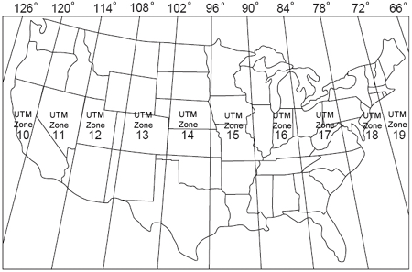Open a new empty map in ArcGIS, and set your projection and units for the data frame. To do this, select the View menu option and select Data Frame Properties. Select the General tab in the Data Frame Properties pop-up box, and select Meters for both Map and Display in the Units box. Click Apply. Next, select the Coordinate System tab and expand the Projected Coordinate System folder. In the directory, navigate to UTM > NAD 1983 > [your UTM zone]. See the figure below to determine which zone your refuge is in. Click Apply and OK.
2. Add the refuge boundary file to the data frame.
3. Open ArcToolbox. Navigate to Data Management Tools > Feature Class > Create Fishnet tool. Name the output file and select a location to save the file. Select the refuge boundary file as Template Extent. In the cell size width and cell size height fields, fill in the number of meters you want your grid cell size to be (e.g., for 1-ha square cells, enter 100 for both height and width). For monitoring sampling points, enter 20 for both height and width to achieve a 25 point/ha density. Fill in 0 (zero) for both number of rows and columns. Select polygon for geometry type. Click OK to run the tool.
4. From ArcToolbox, navigate to Analysis Tools > Extract > Clip. Select the output of the fishnet tool as the input feature. If you already have a forest habitat layer for your refuge, add this as the Clip Feature, run the tool, and then skip to step 6. If you don’t have a forest habitat layer for your refuge, use the entire refuge boundary file as the clip feature. Rename the output feature class if you desire. Click OK to run the tool. This will create a fishnet within the refuge boundary.
5. Because this project is primarily concerned with invasive plants within forests, we must delete all wetland units, grasslands, ditches, parking lots, and other non-forested areas from within the refuge boundary (however, non-forested areas that were inventoried can be kept, if desired). To do this, add any data layers (e.g., shapefiles) representing non-forested habitats within the refuge to the data frame. From the ArcToolbox, navigate to Analysis Tools > Overlay > Union. Add all data layers representing non-forested habitats to the input features list. Name the output feature class. Click OK to run the tool. This will create a single non-forested habitat layer for the refuge. From the ArcToolbox, navigate to Analysis Tools > Overlay > Erase. Add the refuge fishnet as the input features. Add the unioned data layer representing non-forested habitats on the refuge as the erase features. Rename the output feature class if you desire. Click OK to run the tool.
6. From ArcToolbox, navigate to Data Management Tools > Features > Feature Vertices to Points. Select the refuge fishnet (created previously) as the input feature. Rename the output feature class if you desire. Click OK to run the tool. This will create points at the vertices of the fishnet for the refuge. This will also create extra points at the edges of the forest boundaries that will typically be less than your grid cell size. It is up to the discretion of the Survey Coordinator at each refuge to sample at these boundary points. Work with the Project Coordinator to remove these boundary points, if desired.
7. In the Table of Contents, right-click your newly created data layer of points and select Open Attribute Table. Click the Table Options icon in the upper-left, and select Add Field. Name it "NUM" and leave the type as Short Integer. Click OK. Right-click the new field, and select Field Calculator. Set the Parser to Python. Check the Show Codeblock box. Paste the following into the Pre-Logic Script Code:

rec=0

def autoIncrement():

  global rec

  pStart = 1

  pInterval = 1

  if (rec == 0):

  rec = pStart

  else:

  rec += pInterval

  return rec

Paste the following code in the smaller box (labelled “NUM=”) below the Pre-Logic Script Code: autoIncrement()

Click OK. Add another field, but make it a Text field and name it MonID. Open Field Calculator on this. Set Parser to VB Script and uncheck the Show Codeblock. Under “MonID =”, type one of these two options:

For inventory grid points -> "MSC" & [NUM]

For monitoring points -> "MSC-M" & [NUM]

but instead of MSC, insert three or four letters that can identify your refuge/property. Click OK. This field represents the unique identifiers for the grid or monitoring points.

1. From ArcToolbox, navigate to Data Management Tools > Features > Add XY Coordinates. Select the points created in step 6 (refuge fishnet vertices) as the input feature. Click OK to run the tool. This will calculate the XY coordinates for each point and store that data in X and Y fields within the attribute table. These points represent the centroids of the inventory grid cells.

Creating subareas

The following six steps can be used to create subareas within the refuge in ArcGIS. During the pilot testing at Muscatatuck NWR, 23 separate subareas were created that divided the refuge into areas that could be sampled sequentially (Figure SOP-1.1). Wetlands, streams, ditches, roads, unit boundaries, etc. were used to develop the boundaries for each sampling subarea. Each subarea consisted of a subset of anywhere from 300 to 900 points. If you are not using Collector to navigate to inventory points, it is important to keep the waypoint limit of your GPS in mind when subdividing the refuge. At Muscatatuck, NWR Garmin 76 CSx units were used, which have a waypoint limit of 1,000. Some GPS units may only allow 500 points, so it will be important to determine the limit prior to creating subareas so that you will create areas that can be uploaded in entirety (e.g., all 1,000 points) to the GPS.

1. Open ArcCatalog, and create and name polygon shapefiles for all of the sample subareas you will create (i.e., area1, area2, etc.). To do this, open the Catalog window. Right-click on a folder where you want to save the shapefiles. Navigate to New > Shapefile. Name the Shapefile and change the Feature Type to Polygon. Click “Edit” button to set the coordinate system to Projected Coordinate System > UTM > NAD 1983 > [your UTM zone]. Click OK to create the shapefile. Repeat for as many subareas as you want.
2. The next step is to create the boundary of the sampling subareas. In the Table of Contents, right-click on the shapefile and navigate to Edit Features > Start Editing. In the Editor toolbar that appears, select the button Create Features. Select the shapefile in the upper box, then select “Polygon” in the Construction Tools box beneath that one. Use the tool to create the boundary of the area you want this shapefile to represent. When finished, click on Editor > Save Edits, then Stop Editing. Repeat for all of the sampling subareas created in the previous step.
3. Create and name point shapefiles for all of the sample subareas you created (e.g. area1pts, area2pts, etc.). To do this, open the Catalog window. Right-click on a folder where you want to save the shapefiles. Navigate to New > Shapefile. Name the shapefile and change the Feature Type to Point. Click “Edit” button to set the coordinate system to Projected Coordinate System > UTM > NAD 1983 > [your UTM zone]. Click OK to create the shapefile. Repeat for as many subareas as you created in step 1.
4. Open ArcToolbox, and navigate to Analysis Tools > Extract > Clip. This will open a dialog box; select the shapefile created in step 6 above as the input feature, then select the Area you want to clip points to (e.g. Area1), and input the name of the point shapefile for the sample subarea you are clipping as the output feature class (e.g. Area1pts). Click OK. If you get an error, go to the menu option Geoprocessing > Geoprocessing Options, and make sure you have the box checked for “Overwrite the outputs of geoprocessing operations.” This process will need to be repeated for each of the sample subareas you created.

Exporting grid points

After your grid points have been created in ArcMap, the labels and XY coordinates must be exported to a spreadsheet. If you have sampling subareas, each subarea must be exported separately. The spreadsheets then need to be sent to the Project Coordinator and the Data Manager.

1. To export as a Microsoft Excel spreadsheet, navigate to ArcToolbox > Conversion Tools > Excel > Table to Excel.
2. Add your layer file to the Input Table, and choose a location for your output table.
3. Click OK. Coordinate with the Project Coordinator to get these grid points loaded into the SharePoint database.

Archiving maps

Upload your final ArcMap file to the FIAM SharePoint site in the folder called “GIS_layers”.

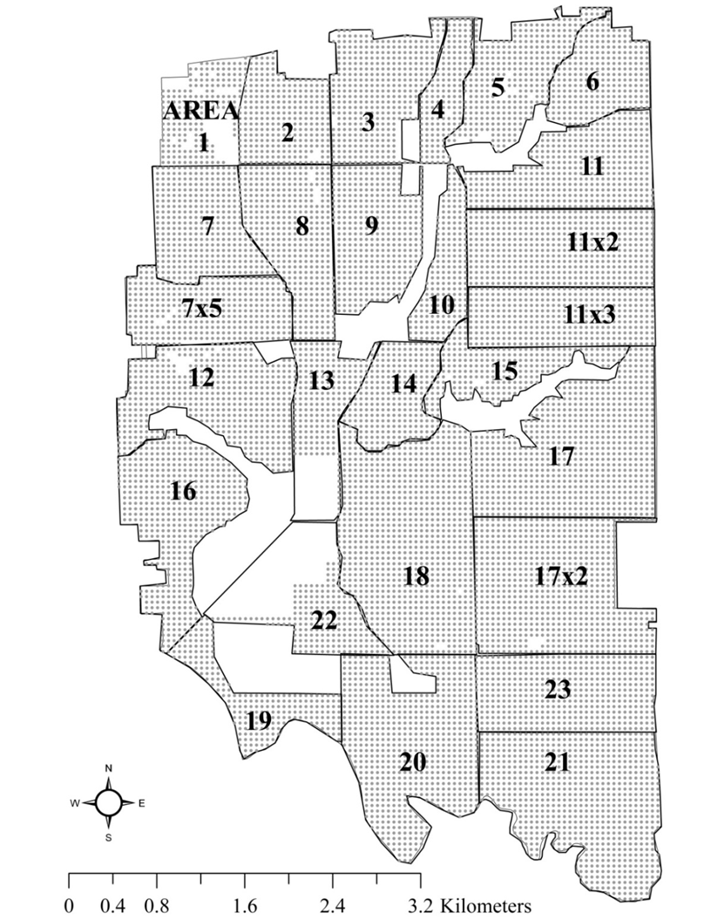

**Figure SOP-1.1.** Example of invasive species subareas at Muscatatuck NWR. This map shows the subareas used in 2011 at Muscatatuck NWR. Where applicable, subarea boundaries consisted of physical barriers to sampling such as ditches, wetlands, etc. This map utilizes a 50 x 50-m grid and points were sampled at 50-m intervals instead of 100-m intervals as prescribed in this protocol. It was found that the difference in effort expended to conduct the inventory at 50-m intervals was negligible in terms of data collection; however, data entry at the 50-m interval is four times greater than at the 100-m interval.

SOP 2: Field Methods – Inventory

This procedure details the field methods for the inventory phase of the FIAM project, including logistics and preparation, establishment of sampling units, processing of collected materials (if any), end-of-season procedures, and tips.

As indicated in Element 2a: Sampling Design – Inventory, the inventory is conducted on a grid of points overlaid on the refuge. Each participating station should confer with the Project Coordinator and the Data Manager prior to data collection to enroll the station in the database and determine naming conventions.

***Pre-survey logistics and preparation – Inventory***

The systematic grid and sampling subareas should be prepared, mapped, and loaded into GPS units prior to sampling (see Establishment of sampling units). Additionally, the following equipment is needed by observers:

* Map showing location of grid cells on refuge (grid map) and survey route if applicable
* GPS unit with coordinates for grid centers (sample points; optional if using Collector)
* Handheld computer (e.g., iPad, iPhone) with Collector installed
* Portable GPS and GLONASS receiver (to enhance GPS accuracy)
* Survey protocol
* Spare batteries and/or charger for smartphone, computer, and GPS unit
* Paper data forms (as backup)
* Clipboard
* Pencils
* Close focusing binoculars to help identify plants away from the point
* Field references, such as field guides or cheat sheets
* Plastic bags for specimen collection
* Camera to photograph unknown plants (use Collector rather than a separate camera to link photo to point)
* Measuring tape or rangefinder (if needed for estimating state of infestation category and visibility distance)

For details about pre-survey training procedures and safety precautions that were used successfully by pilot participants, see Element 6: Personnel Requirements and Training.

***Establishment of sampling units – Inventory***

The systematic grid system will be established prior to the inventory. Using ArcGIS, establish grid points with 100-m spacing (10,000 m2, 1 ha) or desired resolution of the inventory based on the site-specific protocol. SOP 1 outlines steps for establishing grid cells. Once established, the grid points and their coordinates need to be sent to the Project Coordinator or Data Manager.

Additionally, subareas within the refuge can be created by dividing the refuge into sections that can be sampled sequentially. The subareas subdivide the refuge and help streamline the logistical considerations of data management and travel. Barriers (e.g., wetlands, streams, ditches, roads, management unit boundaries) were used to develop the boundaries for each subarea during pilot testing, and each subarea consisted of a subset of 300 to 900 sample points. SOP 1 also outlines steps for establishing subareas. Using this subarea and grid system method, travel between points will be greatly reduced and efficiency will be enhanced. Having discrete subareas is also useful when the inventory will not be completed in one season. Managers can then prioritize which subareas to focus on first. For assistance with prioritizing areas for inventory, contact the Project Coordinator.

The Survey Coordinator at each refuge is encouraged to map a route for each observer (either in paper form or digitally in the GPS unit) to ensure the most efficient allocation of effort. When establishing subareas and routes, take precautions to reduce the risk of transmission of invasive plant propagules to uninfested areas (see Element 3: Spread Prevention Techniques).

***Data collection procedures (field, lab) – Inventory***

This inventory protocol entails detecting and describing occurrences of invasive (and native, if desired) plant species. Field personnel should review and adhere to the recommendations for limiting the spread of invasive species propagules during implementation of this inventory protocol (see Element 3: Spread Prevention Techniques).

Data collection for this inventory can be conducted by a single, trained observer walking from sample point to sample point, but it may be more efficient to conduct the inventory with one observer and one data recorder (see Element 6 for guidance about training field personnel). Data are either recorded directly into a mobile device using the Collector FIAM map developed for this project or onto paper datasheets (examples with and without the optional native species metrics are attached in SM 5). When no invasive plants are present, you must include an entry for that sample point to document the absent state. To maintain data quality, regardless of data recording method in the field, it is essential to check through the data collected for a grid point before moving on to the next grid point. Instructions for installing and running Collector on a mobile device can be found by contacting the Project Coordinator or at this folder on the FIAM SharePoint site: <https://connect.doi.gov/fws/Portal/fip/Protocols/Forms/AllItems.aspx>.

Sampling occurs at the center of each grid cell on the grid system established for each refuge. Each invasive species with its associated infestation category is documented at each point. In addition, native species richness and cover categories are optionally noted. The size of the area sampled around each point will vary based on visibility distance at the point. Based on data from pilot inventories, the limit of detection varies from two to six meters away from the point, producing a circular sampling area from 12.6 to 113.1 m2 (see Element 2a: Sources of error – Inventory for more detail). The observer should attempt to observe plants as far away from the point as possible, given the visibility.

Before starting for the day or a new set of points, the observer will record:

* Refuge
* Subarea (if any)
* Date
* Start time
* Observers

At each designated sample point, the observer will record:

* Grid point number
* Visibility distance category
* Name (code) of each invasive species
* State of the infestation for each invasive species
* Native species richness category for trees, shrubs and vines, herbaceous plants (optional)
* Cover category for native trees, shrubs and vines, herbaceous plants (optional)
* Any comments about that point (optional)

The end time will be recorded at the end of the day or at the end of a set of points.

For ease of logistics, the observer should walk the set of designated sample points like walking a transect line. The route taken should be determined by the Survey Coordinator at each refuge prior to the survey, and the observer should maintain this route as best as possible. To document the actual route taken by the observer, the track log function on the GPS unit can be used to automatically track the route of the observer if preferred by the Survey Coordinator at each refuge. If this approach is used, the observer must start and stop the track at the start and end of each day.

Mission planning may prove beneficial as signals are often weaker under canopy, so optimizing when to sample is critical in forested systems. During the day, there are windows of time (usually one-half hour to one hour) when there are not enough satellites visible to the GPS unit to navigate at high levels of accuracy. Global Navigation Satellite System Planning is a way to look at the satellite availability for a given day and find out what times you should avoid collecting data due to accuracy issues. That information can be used to time breaks or to identify periods when you will not attempt to collect data. We recommend you quit collecting data if GPS accuracy is above 50 ft.

Refuge – Record the name of the refuge without spaces (BigOaks, Muscatatuck, etc.). Be consistent with spelling, capitalization, etc. Refuge (station) names should be standardized via consultation with the Project Coordinator. Refuge names will be linked to their Cost Center Codes in the SharePoint database.

Subarea – If the refuge is divided into subareas (SOP 1), record the subarea. This field is optional and for logistical purposes only; it is only on the datasheet, not entered into the database.

Date – Record the date of observation. Enter the date as mm/dd/yy.

Start time – Record the time at the start of observations for the day (or for a set of points), using a 24-hr clock (e.g., 14:10 = 2:10 p.m.).

Observer(s) – Record the name(s) of observer(s). Register observers with the Data Manager prior to entering data into SharePoint. A look-up table is maintained in SharePoint where each observer is given a unique number, which in turn is used throughout the main data tables. The database has room for one or two observers; if there are more than two observers (e.g., during a training day), record the two principal observers.

Grid point number – It is essential to carefully record the grid point number, as there are several thousand points for each refuge. This information is obtained when creating the sampling points (SOP 1) or from the Project Coordinator. If using Collector, this information will be automatically filled in. A GPS unit should be used to navigate to each point. When no invasive plants are present, you must include an entry for that sample point to document the absent state.

Visibility – Visibility distance is the distance that you can see and identify plants, with the help of binoculars if you have them. As described in Element 2a: Sampling Design – Inventory, the size of the sample area at each point is variable and dependent on local vegetation conditions. Given the purpose of the inventory, this variation in detection is not a major impediment to data analysis and inference, and the observer should try to identify all invasive plants around them as far as possible. To quantify this variation in the size of sample unit, visibility distance will be estimated visually at each sample point.

Look in all directions to develop a single estimate of visibility distance at each sample point. The observer should look at the understory (i.e., 0‒1 m from the ground) when estimating visibility distance. Visibility distance has been separated into five states (0–4) that describe the visibility for understory forest plants based on the pilot work in 2011‒2104. Once the visibility is determined, all metrics recorded thereafter at the point must be within this determined sampling area. Visibility state is collected because, although it is not currently used in our analyses, it could be useful for a post-hoc analysis of detection or as an index of confidence in the data.

Visibility states are defined as:

|  |  |
| --- | --- |
| 0 | The observer can see 0‒1 m |
| 1 | The observer can see 2‒5 m |
| 2 | The observer can see 6‒10 m |
| 3 | The observer can see 11‒15 m |
| 4 | The observer can see > 15 m |

Name of invasive species – Record each invasive species observed at the grid point using a standard code (Field Code in Table SOP-2.1). Observers should not attempt to limit their observations to a specific radius surrounding the sample point but attempt to see all invasive plants that are visible from that sample point. In general, the trained observer may see a few meters to 10 m at best. If visibility is low, the observer may have to walk a few meters in each direction around the point to accurately determine the presence of each invasive species. Even if a plant looks dead or dying, record it if you can identify the species, and note its condition in the Comments field. If using the paper datasheet and more than four invasive plant species are found at a single sample point, record the field code of the additional species in the Comments field or on a new line clearly designated with the number of the appropriate sample point.

If an invasive plant species is found that is not in Table SOP-2.1, record an appropriate code and write the full common and scientific names in the comments section of the datasheet. If you are unsure of the identification of a species and suspect it is an invasive, record the species field code as X1, X2, etc., collect a specimen to confirm identification (see Processing of collected materials, below), take a picture of the infestation, and add any notes in the Comments field. In either case, also alert the Project Coordinator or Data Manager about new species that should be added to the SharePoint master list.

Table SOP-2.1 includes species that are known to occur or have potential to occur on the participating refuges. However, not all species are concerning to all refuges, so it is important for each refuge to document which species its field crews were trained to identify and actually searched for each year. It is especially important to train field crews on species that have not yet been detected at a refuge but would be of high concern because of their aggressiveness. The Survey Coordinator at each refuge should work with the Project Coordinator to develop that refuge’s target species list. The more species, the better for the inventory, but the more training observers will need (see “Training” in Element 6). Although Table SOP-2.1 includes more than forty species, there have not been any reports by participating refuges of problems with their field crews being able to conduct the work. We emphasize that the task here is to identify plants within a small defined area, which is a distinctly different skill from trying to outline all populations of several species.

**Table SOP-2.1.** Invasive plant species known to occur or have potential to occur in Eastern Broadleaf Forest Biology Network NWR forests. The species are categorized based on aggressiveness (A = highly aggressive, B = moderately aggressive, C = low aggressiveness, -- indicates that the species rank has not yet been determined by participating refuges). Plant names are consistent with the Integrated Taxonomic Information System (ITIS) Database (<http://www.itis.gov>) and the USDA Plants Database (<https://plants.usda.gov>). ITIS Taxonomic Serial Numbers (TSN) are given.

|  |  |  |  |  |  |
| --- | --- | --- | --- | --- | --- |
| Scientific Name | Common Name | Field Code | ITIS TSN | USDA Species Code | Species Rank |
| *Achyranthes japonica* | Japanese chaff flower | JC | 181937 | ACJA | A |
| *Ailanthus altissima* | tree of heaven | TO | 28827 | AIAL | B |
| *Albizia julibrissin* | silktree (mimosa) | MM | 26449 | ALJU | -- |
| *Alliaria petiolata* | garlic mustard | GM | 184481 | ALPE4 | A |
| *Berberis thunbergii* | Japanese barberry | JB | 18835 | BETH | A |
| *Bromus inermis* | smooth brome | SB | 40502 | BRIN2 | -- |
| *Carduus nutans* | nodding plumeless thistle | NT | 35787 | CANU4 | A |
| *Celastrus orbiculatus* | Oriental bittersweet | OB | 506068 | CEOR7 | A |
| *Cirsium vulgare* | bull thistle | BT | 36428 | CIVU | B |
| *Clematis terniflora* | sweet autumn virginsbower | SV | 18712 | CLTE4 | C |
| *Commelina communis* | Asiatic dayflower | AD | 39127 | COCO3 | -- |
| *Dioscorea bulbifera* | air yam | AY | 43369 | DIBU | A |
| *Dioscorea polystachya (syn.: D. oppositifolia)* | Chinese yam | CY | 810115 | DIOP | A |
| *Elaeagnus umbellata* | autumn olive | AO | 27776 | ELUM | A |
| *Euonymus alatus* | burningbush | BB | 27946 | EUAL13 | C |
| *Euonymus fortunei* | winter creeper (purple wintercreeper) | WC | 27950 | EUFO5 | A |
| *Table SOP-2.1, continued* |  |  |  |  |  |
| *Scientific Name* | Common Name | Field Code | ITIS TSN | USDA Species Code | Species Rank |
| *Glechoma hederacea* | ground ivy | GI | 502801 | GLHE2 | C |
| *Heracleum mantegazzianum* | giant hogweed | GH | 502954 | HEMA17 | B |
| *Humulus japonicus* | Japanese hop | HO | 503065 | HUJA | B |
| *Lespedeza cuneata* | sericea lespedeza | SL | 25898 | LECU | B |
| *Ligustrum vulgare* | European privet | EP | 32980 | LIVU | A |
| *Lonicera japonica* | Japanese honeysuckle | JH | 35283 | LOJA | A |
| *Lonicera maackii* | Amur honeysuckle | AH | 35298 | LOMA6 | A |
| *Lonicera morrowii* | Morrow's honeysuckle | MH | 35299 | LOMO2 | A |
| *Lonicera tatarica* | Tatarian honeysuckle | TH | 35306 | LOTA | A |
| *Lonicera X bella (morrowii × tatarica)* | showy fly honeysuckle | SH | 35286 | LOBE | C |
| *Lysimachia nummularia* | creeping jenny | CJ | 23993 | LYNU | B |
| *Lythrum salicaria* | purple loosestrife | PL | 27079 | LYSA2 | A |
| *Melilotus officinalis* | sweetclover | WS | 26150 | MEOF | C |
| *Microstegium vimineum* | Nepalese browntop (stiltgrass) | NB | 503829 | MIVI | A |
| *Paulownia tomentosa* | princesstree | PT | 33460 | PATO2 | B |
| *Perilla frutescens* | beefsteakplant | BS | 32634 | PEFR4 | -- |
| *Phalaris arundinacea1* | reed canarygrass | RC | 41335 | PHAR3 | A |
| *Phragmites australis1* | common reed | CR | 41072 | PHAU7 | A |
| *Poa pratensis* | Kentucky bluegrass | KB | 41088 | POPR | -- |
| *Polygonum cuspidatum* | Japanese knotweed | JK | 20889 | POCU6 | A |
| *Polygonum perfoliatum* | Asiatic tearthumb | AT | 20914 | POPE10 | B |
| *Populus alba* | white poplar | WP | 22451 | POAL7 | A |
| *Pueraria montana* | kudzu | KZ | 504683 | PUMO(L) | B |
| *Rosa multiflora* | multiflora rose | MR | 24833 | ROMU | B |
| *Rubus armeniacus* | Himalayan blackberry | HB | 837296 | RUAR9 | B |
| *Salix alba* | white willow | WW | 565478 | SAAL2 | C |
| *Schedonorus arundinaceus* | tall fescue | TF | 784875 | SCAR7 | -- |
| *Securigera varia* | crownvetch | CV | 521245 | SEVA4 | A |
| *Sesbania herbacea2* | bigpod sesbania (coffee weed) | CW | 507837 | SEHE8 | C |
| *Sorghum halepense* | Johnsongrass | JG | 42111 | SOHA | A |
| *Verbascum thapsus* | common mullein | CM | 33394 | VETH | -- |
| *Vinca minor* | common periwinkle | CP | 30238 | VIMI2 | C |

1Phalaris arundinacea and Phragmites australis each exist as both a native subspecies/strain and an aggressive nonnative subspecies/strain.

2Although Sesbania herbacea is native, it is considered a noxious weed in Arkansas and Louisiana and is a species of concern on some participating refuges.

State (level) of infestation for each invasive species – At each sample point (i.e., the center of each grid cell), visually estimate the state of each invasive plant species by assessing the abundance of each species within the observed area. States (levels) of infestation are defined in Table SOP-2.2. Definitions differ slightly according to plant growth form. Don’t try to count the number of individual vines for species such as bittersweet or Japanese honeysuckle, but focus instead on the amount of area covered. For each invasive species observed (see above), the observer should look in all directions to develop a single estimate of the state of that invasive plant species at the sample point. If visibility is low, the observer may have to walk a few meters in each direction around the point to accurately determine the infestation state of each invasive species. If using the paper datasheet and more than four invasive plant species are found at a single sample point, record the state of the species (with its plant code) in the Comments section or on a new line designated with the number of the appropriate sample point.

**Table SOP-2.2.** Definitions of states of infestation according to growth form.

|  |  |  |
| --- | --- | --- |
|  | Herbaceous | Woody |
| 0. Absent | No invasive plants are present. | |
| 1. Few Plants | 1‒5 widely-scattered plants are observed. | 1‒3 widely-scattered plants are observed. |
| 2. Patches or Moderate Abundance | > 5 plants observed (scattered or in one or more patches1) and they occupy < 25% of the area in aggregate. | > 3 plants observed (scattered or in one or more patches1) and they occupy < 25% of the area in aggregate. |
| 3. Infested | Many plants observed, they are densely distributed or widely scattered throughout the area, and they occupy > 25% of the area. | |

1 Patches are defined as > 0.5 m apart, per Dewey and Anderson (2004).

Native plant richness category (optional) – The observer will record visual estimates of the richness of the native plant community (i.e., plants other than known invasives) at three canopy layers: trees, shrubs and vines, and herbaceous plants. Follow Cowardin et al.’s (1979) classification of herbaceous plants (< 1.3 m tall), shrubs (1.3–6 m tall), and trees (> 6 m tall), and include vines with shrubs. Native species richness has been separated into four states that describe how diverse the plant community is at each canopy level independently. Use the following categories:

|  |  |
| --- | --- |
| 0 | No native species of that growth form are present |
| 1 | 1 to 3 native species of that growth form are present |
| 2 | 4 to 6 native species of that growth form are present |
| 3 | > 6 native species of that growth form are present |

Names of native species are not recorded, so observers do not need to be able to identify all native plant species but need to be able to judge which species are different from each other in order to estimate the richness category for each vegetation layer (tree, shrub and vine, herbaceous).

Category for cover of native species (optional) – To characterize the abundance of native species, the observer will record the aggregate cover (percent of the ground obscured by above-ground parts of plants) of all native species in three canopy layers: trees, shrubs and vines, and herbaceous plants. Use the following categories:

|  |  |
| --- | --- |
| 0 | 0% (Absent) |
| 1 | ≤ 5% (Low Abundance) |
| 2 | 6–25% (Moderate Abundance) |
| 3 | > 25% (High Abundance) |

Comments (optional) – Record comments about the point (or generally about the set of points on that datasheet), including any noticeable disturbance, such as evidence of spraying or other management. The comments field may be used to record names and states of additional invasive species within the observed area (if using paper datasheets and more than four species are observed at a point). Also, invasive species observed while walking between points may be noted in comments, especially those species of particular concern for the refuge. This will allow an EDRR response, if necessary. In addition, if such opportunistic observations are to be used in the prioritization model, a geographic location must be recorded.

End time – Record the end time at the end of the survey. Record the time at the end of observations for the day (or for a set of points), using a 24-hr clock (e.g., 15:36 = 3:36 p.m.).

***Processing of collected materials – Inventory***

If observers are uncertain of the identification of an invasive plant, they are encouraged to collect and press a specimen for later identification. In the field, photograph the specimen before collection, being sure to photograph identifying features of the plant as well as an overall view showing the plant’s habit and surroundings. However, be cautious when collecting plants to avoid collecting a rare native plant. In general, if there are fewer than about 10 plants of that species in the vicinity, consider whether to only photograph the plant for identification. The observer needs to balance the risk of harming a rare native plant with the risk of overlooking an unknown invasive.

Collect the specimen by clipping the above ground part and placing it in a plastic bag with a damp paper towel until returning to the office or lab. Specimens keep better if they are kept cool. Record the GPS coordinates of the plant to facilitate finding it if it needs to be treated. Use Collector to take the photo and automatically link to the sample point. All collected specimens and photographs (especially the photo numbers) should be noted in the comments fields for that sample point in the database or datasheet. It can be useful to include a sticky note with the point number as each photograph is taken to keep photos organized.

Once at the lab, press the specimen using a standard plant press. All photographs and pressed specimens should be labeled with the date and sample point and stored in the location designated by the refuge in the site-specific protocol. More details on preparing specimens can be found in Element 6: Personnel Requirements and Training.

***End-of-season procedures – Inventory***

At the end of the season, all field equipment (e.g., waders, boots, chaps) should be cleaned of all debris, sterilized with a 10% bleach solution, dried, and stored appropriately for the off season. To reiterate, it is especially important to clean field equipment if moving between geographically isolated areas of the refuge or station to avoid moving invasive plant propagules (e.g., seeds) to uninfested areas.

All electronic data collection and navigation devices should be checked to ensure all data on each device has been downloaded and all devices have been cleaned using the manufacturer’s recommended cleaning solution. If applicable, all paper datasheets should be stored in a secure location after entry and quality assurance/quality control processes are completed. All collected materials should be checked for proper identification. All equipment should be stored in a designated location at each refuge.

Tips and hints from pilot testing, by Dan Wood

Below are tips and hints from pilot testing from 2011‒2014 and an example datasheet for refuge-scale inventory. Microsoft Word versions of the current datasheets can be found on the FIAM project SharePoint site.

* Collection of ancillary data (e.g., old dump sites at Muscatatuck NWR, forest inventory data using a grid-based system [USFS 2012]) can be collected concurrently.
* Brushpants are necessary.
* Machetes may be necessary to traverse thick brush. Use appropriate safety precautions.
* Knowing the refuge is helpful in planning what to wear/bring into a given sample area. Some areas are uplands and have no ephemeral streams/wetlands. There would be no need for waders or knee boots in such areas. However, other bottomland areas may require knee boots or chest waders.
* In sunny, hot, muggy, mosquito- and tick-infested seasons (the only time when we can adequately sample for most invasive species), it is important to maintain available stocks of sunscreen, bug spray, water and/or electrolyte drinks, etc. for the safety of the field crew. Morale is difficult to maintain in these conditions, so it may be best to start early (i.e., shortly after sunrise) to collect data when temperatures are at their lowest levels. Also, it may be important to switch tasks as the drudgery and monotony of the work is demotivating at times.

References – Inventory

Cowardin LM, Carter V, Golet FC, LaRoe ET. 1979. Classification of wetlands and deepwater habitats of the United States. U. S. Department of the Interior, Fish and Wildlife Service, Washington, D.C.

Dewey SA, Andersen KA. 2004. Strategies for early detection: using the wildfire model. Weed Technologies 18: 1396‒1399.

[USFS] U.S. Forest Service. 2012. Forest Inventory and Analysis National Core Field Guide. Volume 1: Field Data Collection Procedures for Phase 2 Plots. Version 6.0. U.S. Department of Agriculture, U.S. Forest Service, Arlington, VA. Available: <http://www.fia.fs.fed.us/library/field-guides-methods-proc/docs/2013/Core%20FIA%20P2%20field%20guide_6-0_6_27_2013.pdf>. (Accessed May 26, 2016). URL for Version 7.0 (2015): <http://www.fia.fs.fed.us/library/field-guides-methods-proc/docs/2015/Core-FIA-FG-7.pdf>. (Accessed May 26, 2016.)

SOP 3: Creating Species Distribution Maps and the Prioritization Model

The FIAM inventory documents the invasive plant species and their level of infestation on a systematic grid throughout a refuge. The inventory culminates by using these data to create a series of maps to visualize the distribution of each species or a user-defined group of species. Inventory data may also be run through a prioritization model to facilitate decisions about where to focus management actions. Both the creation of species distribution maps and the prioritization model are described here. The full documentation of the prioritization model is found on the FIAM SharePoint site in the library *Prioritization model*.

Importing inventory data into ArcMap

After the inventory has been completed and the data are proofread for errors, the data should be imported into ArcMap for visualization and further analysis.

1. Ensure that the data are in a GIS-friendly format. Work with the Project Coordinator to do this.
2. Go to File > Add Data > Add XY Data.
3. Click the folder icon, and navigate to your spreadsheet of data.
4. Match the X and Y coordinate fields with the corresponding spreadsheet column headings. Leave the Z Field blank.
5. Make sure the coordinate system is set to NAD_1983_UTM_Zone_[your zone #].
6. Click OK. Ignore any error messages.
7. Right-click on the resulting layer in the Table of Contents, and go to Data > Export Data.
8. Choose a location and name for the final shapefile. Make sure to Save As a shapefile.
9. Click Save, then OK.

Data manipulation and analysis to create species distribution maps

Once all of the data have been imported into ArcGIS (you should check this by examining the shapefile’s attribute table), you are now ready to create predicted distribution maps of each individual invasive species. If you desire, you can also combine species by aggressiveness ranking or create a map of non-invaded areas by combining all species. Species distribution maps can be additional useful decision aids to supplement the tabular and visual output of the prioritization tool described in the prioritization model section below. Two approaches may be useful.

1. Method 1: map the state by grid cell (Figure SOP-3.1)
   1. To do this, first convert your point shapefile to raster data. In ArcToolbox, navigate to Conversion Tools > To Raster > Point to Raster.
   2. Select your point data as the Input Feature.
   3. Select the species you want to map as the Value Field. If you would like to create a map of all invasive species, you would need to create a new value field of the average (or maximum) state value for all species, using Add Field function.
   4. Select a location for the output raster dataset.
   5. Under Cell Assignment Type, select Mean. This will give the average infestation state for cells containing multiple points. Most cells should only have a single point, but you may have added multiple points closer than the predetermined grid size along the edges of forest.
   6. Change the Cellsize field to your grid cell size (in meters). In most cases, this will be 100.
   7. Click OK.
   8. In the resulting raster layer, click the color ramp bar to change the color or invert the ramp.
2. Method 2: use Kriging interpolation to create a predictive species distribution (Figure SOP-3.2)
   1. Within ArcToolbox, select Spatial Analyst Tools. If Spatial Analyst is not available you will need to select it as an extension. You can do this by going to the Customize menu at the top of the screen and select Extensions, and check the box for Spatial Analyst. Once it is available in ArcToolbox, expand the Spatial Analyst, select Interpolation, and select Kriging.
   2. Select the point file as the Input point features.
   3. In the Z value field select the column from the attribute table that corresponds with the data you would like to interpolate (this will be the state values for a particular invasive species). If you would like to create a map of all invasive species, you would need to create a new value field of the average (or maximum) state value for all species, using Add Field function.
   4. Choose a location for the output raster. Leave all other settings as the defaults.
   5. Click OK.
   6. To clip the resulting raster file to the refuge boundary, go to Data Management Tools > Raster > Raster Processing > Clip. After you specify the refuge boundary shapefile to clip to as your Output Extent, put a checkmark beside the 'Use Input Features for Clipping Geometry' option. Rename the output file if desired, and press OK.
   7. The interpolation will appear as its own layer that should be modified to reflect the categories of state. The state values are on an ordinal scale (i.e., 0, 1, 2, or 3); however, the interpolation uses a continuous scale between 0 and 3. To change this:
      1. Right-click on the layer, and select Properties.
      2. Select the Symbology tab, and click the Classify button on the right.
      3. Either use one of the preset options or select Manual as the method and choose your own Break Values. You now have an interpolated layer. Species distribution maps can be examined in conjunction with the prioritization model to assess infestations relative to spatial data, addressing questions such as whether infestations are along roads.
   8. To export the interpolation scores for the grid cell, use the Extract Values to Table tool under Simulation in the Geostatistical Analyst (turn on this extension if you haven’t already).
      1. Select the shapefile containing the grid of the refuge you saved previously as the input feature.
      2. Select the interpolated layer as the input raster.
      3. Rename the output file if you desire.
      4. Click OK to run the tool. This will create a table with the predicted state from the interpolation summarized by grid cell.
      5. Export this file. This file can be used for comparison with the output of the prioritization model to see the influence of the species distribution by itself versus the influence of the other factors (proximity to critical areas, potential vectors, and uninvaded areas) in the prioritization model.

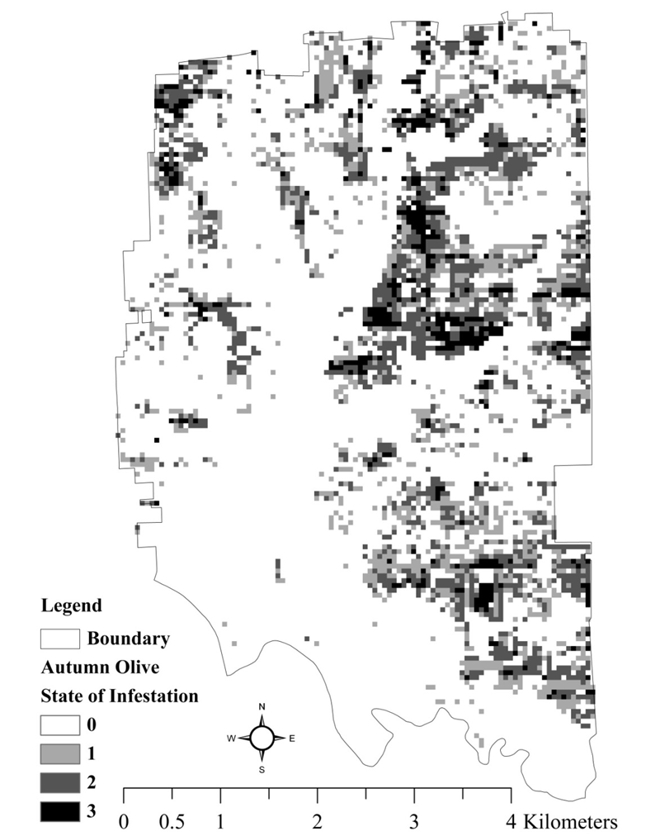

**Figure SOP-3.1.** Autumn olive distribution based on 2011 inventory at Muscatatuck NWR. Mapped using Method 1.

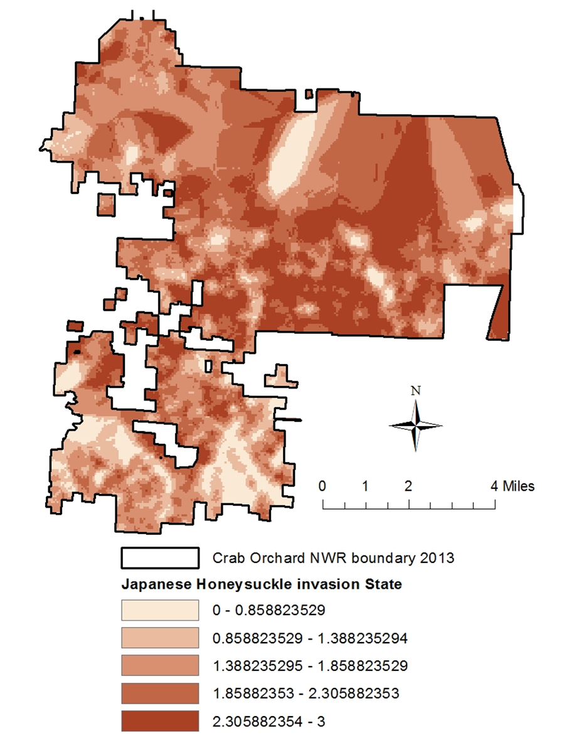

**Figure SOP-3.2.** Japanese honeysuckle distribution based on 2013‒2015 inventory at Crab Orchard NWR. Mapped using Method 2.

The prioritization model and GIS tool to implement the spread score

The inventory data are used in a site prioritization model, which ranks infested areas based on GIS-derived metrics on distance to critical areas (e.g., known locations of at-risk species), the proportion of nearby (within 250 m) cells that are uninvaded (in other words, the degree of isolation of that population of invasives), and distance to potential vectors for spread (roads, trails, streams, etc.). The goal of the prioritization model is to provide guidance on where to treat invasive species within refuge boundaries. It is not meant to be prescriptive, so it does not provide a single solution per se, but rather, it provides a spread score of the invaded areas. The spread score reflects the potential, based on proximity, for the invasive species to spread to uninvaded areas, negatively impact critical areas, or spread along vectors. It makes no assumptions about budget, treatment effectiveness, or other objectives one might have for management. Thus, it is simply designed to organize and summarize known information on location of the invasive species, relative to important areas and vectors, for incorporation into refuge management.

An ArcGIS tool has been created to implement the spread score of the prioritization model. This tool is available on the FIAM project SharePoint in the *Prioritization model* library (Invasive species Prioritization tool help file and zip folder). There are several ArcGIS data layers needed to run the tool: the refuge boundary, management units, critical areas, invasive species locations (data from any source may be used here, not just the FIAM inventory), raster land cover map, and up to two layers with potential vectors (streams, roads, and trails). The user also needs to input weights that describe the relative importance of three aspects of risk to the refuge: 1) that critical areas will be invaded, 2) that the invasive species will spread quickly along vectors such as roads, and 3) that suitable habitat (as defined by the user) without the invasive species will be invaded. Using these inputs, the tool produces several output GIS layers that show the potential threat of the invasive species relative to each of the three aspects of risk, as well as the weighted average (i.e., the priority scores for each grid; Figure SOP-3.3). The user can adjust the weights to visualize how prioritization changes depending on different management concerns. A manager can work with the Project Coordinator to tailor the prioritization model to focus on species or objectives that are of particular concern on that refuge (e.g., perceived to be disruptive to biological outcomes or to public use). For more information on how to use the tool and the modeling behind it, see the help document, which is included with the tool on the FIAM SharePoint site along with example input files (Invasive species Prioritization tool help file and zip folder).

Currently, the tool does not account for the infestation state metric collected during the FIAM inventory, nor does it consider the aggressiveness (A-list, B-list, and C-list) of the species. It also doesn’t consider the total number of species at a point. A tool more specifically tailored for FIAM data will be considered if there is sufficient interest from FIAM participants.

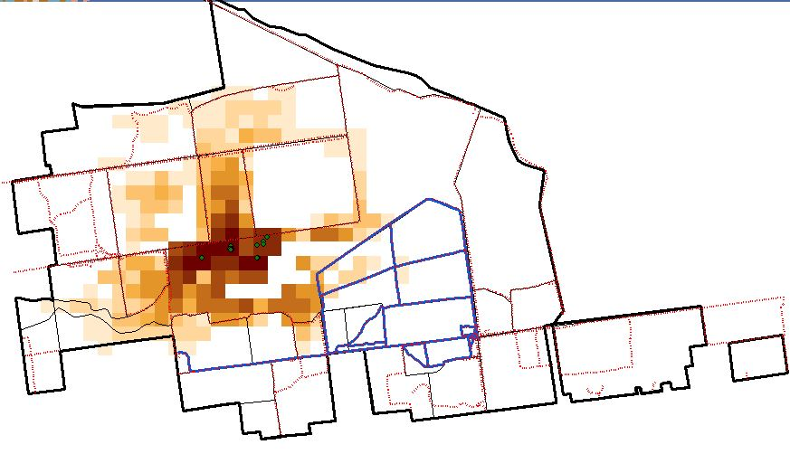

**Figure SOP-3.3.** Example output of prioritization tool. Darker colored grid cells are higher priority. In this example, all the weight is put on critical areas (white dots).

SOP 4: Field Methods – Effectiveness Monitoring

This procedure details the field methods for the effectiveness monitoring phase of the FIAM project, including logistics and preparation, establishment of sampling units, data collection, processing of collected materials (if any), and end-of-season procedures. The same methods are used for both pre-treatment monitoring and post-treatment monitoring. Typically, effectiveness monitoring would take place after the inventory is complete, but these methods may be used regardless of the status of the inventory. A completed inventory, however, will give a manager or biologist superior information when prioritizing where to treat invasives.

Pre-treatment monitoring will generally occur immediately prior to the management actions for that area. However, there may be circumstances where this is not practical. For example, a burn may be deemed to be most effective in late fall to control a certain shrub, but to accurately document all the invasive plants present, monitoring should occur earlier in the growing season.

Post-treatment monitoring is expected to occur in the growing season after treatment. To reduce phenological error, we recommend that post-monitoring occurs in roughly the same part of the season (e.g., early spring, late summer, etc.) as pre-monitoring occurred the year prior. If desired, post-treatment monitoring may occur in subsequent years as well, to assess the long-term effect of the management action. Furthermore, if a target area was treated the year before, and an additional follow-up management action is planned for the current year, monitoring from the current year can serve as both post-treatment monitoring to evaluate the previous year’s management and pre-treatment monitoring for the current year’s management. See SOP 5 for guidance in documenting management actions.

Pre-survey logistics and preparation – Effectiveness monitoring

Collector for ArcGIS is strongly recommended for collecting monitoring data. Observers should make sure that this app is installed on their mobile device before going into the field. The latest version of the USFWS guide for using Collector can be obtained by contacting the Project Coordinator or at this folder on the FIAM SharePoint site: <https://connect.doi.gov/fws/Portal/fip/Protocols/Forms/AllItems.aspx>. A map of the working area with the monitoring sampling unit layer (see Establishment of sampling units – Effectiveness Monitoring) should also be downloaded beforehand using this app.

The following equipment is needed by observers:

* Printed map showing the general management area overlaid with the sampling points
* GPS unit with coordinates for sampling points (optional if using Collector)
* Handheld computer (e.g., iPad, iPhone) with Collector installed
* Portable GPS and GLONASS receiver (to enhance GPS accuracy)
* Survey protocol
* Spare batteries for smartphone, computer, and GPS unit
* Paper data forms (as backup)
* Clipboard
* Pencils
* Close focusing binoculars to help identify plants away from the point
* Field references, such as field guides or cheat sheets
* Plastic bags for specimen collection
* Camera to photograph unknown plants (use Collector rather than a separate camera to link photo to point)
* Measuring tape (for establishing 2-m radius sampling area)

For details about pre-survey training procedures and safety precautions that were used successfully by pilot participants, see Element 6: Personnel Requirements and Training.

Establishment of sampling units – Effectiveness monitoring

The systematic monitoring points will be established prior to collecting pre-treatment monitoring data. Using ArcGIS, establish the points with 20-m spacing to achieve a 25-point/ha sampling density. To do this, follow the steps in SOP 1, and for step 3, enter 20 for both height and width. Be sure to follow the instructions in step 7 to get grid numbers with a prefix that distinguishes your monitoring grid points from your inventory grid points. If your inventory was implemented using a 20 x 20-m grid cell size, your inventory grid points can be reused as monitoring sampling points and this step can be skipped. Once established, the grid points and their coordinates need to be sent to the Project Coordinator or Data Manager.

Based on the results of the inventory and prioritization, along with refuge-specific criteria, the manager or biologist will have decided where to treat invasive species. Prior to monitoring data collection, the target area must be delineated (and named) to ensure that pre-treatment monitoring, the treatment itself, and post-treatment monitoring all occur in the same place (Figure SOP-4.1). This can be done in the office using aerial imagery or in the field using Collector. This area should represent the entire area that the biologist or manager is interested in restoring, and should include not only all patches and individual invasive plants that will be treated in the management action, but also any clusters of native plants that are targeted for protection and/or expansion. Ignore the monitoring sampling points as you are delineating the area. The points from the monitoring grid that fall within the target area are the permanent monitoring sampling points for that area. They will be visited for pre-treatment monitoring and all post-treatment monitoring. Any point within 2 m of the boundary should not be sampled.

At this stage in the FIAM project, we are only monitoring small to medium sized management actions. Target areas should be between 0.25–2.0 ha. This size range allows for a reasonable number of sampling units within a given target area (i.e., 6–50 points). In the future, this project may incorporate smaller or larger management actions with tailored sampling designs for monitoring.

If you are not using Collector (which creates a map layer automatically), you should maintain one GIS layer to keep track of treated areas. Name the layer similar to: BigOaks_Invasive_Treatment_Polygons. Each target area polygon should be assigned a unique name (such as UnitA_01; up to 50 characters), which will be used by the monitoring and management action data forms; post-treatment monitoring in subsequent years will also reference the same target area.

Navigate to each sampling point using GPS. This protocol does not require permanent marking of sampling points, mostly due to markers potentially interfering with the implementation of management actions. Participating refuges may rely on GPS coordinates and landmarks to return to the sampling units for subsequent data collection. Unless the refuge has access to high-quality, survey-grade equipment, it is unlikely that the exact same 2-m circle will be sampled. This introduces additional between-year variation in the metrics. We recommend trying to ensure a sub-meter GPS accuracy, if possible. Alternatively, points may be permanently marked with rebar flush to the ground; a metal detector would be required to relocate these points in subsequent years.

***Data collection procedures (field, lab***) – Effectiveness monitoring

This effectiveness monitoring protocol entails detecting and describing occurrences of invasive and native plant species within an area targeted for management of invasive plants. The sampling units are located at each systematic point in the fine-scale monitoring grid. The sampling unit is a 2-m radius circle (12.6 m2) around each point. Field personnel should review and adhere to the recommendations for limiting the spread of invasive species propagules during implementation of this inventory protocol (see Element 3: Spread Prevention Techniques).

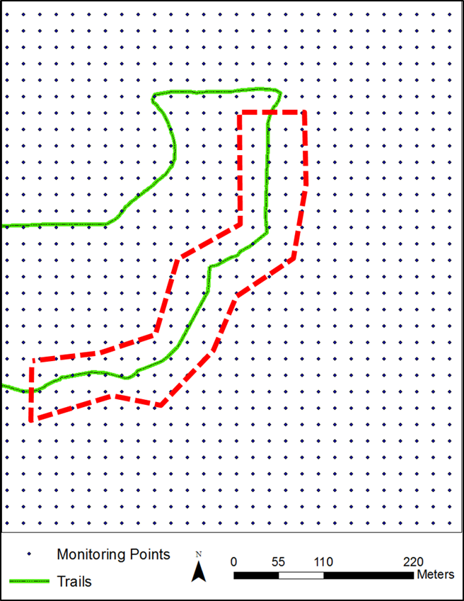

**Figure SOP-4.1.** Example layout of a target management unit (outlined in red, dashed line) along a public trail (green, solid line). Systematic points with a density of 25 points/ha are overlaid. The black dots that fall within the target management area represent permanent monitoring points.

Data collection for this inventory can be conducted by a single, trained observer navigating to each sampling point within the target management area, but it may be more efficient to conduct the monitoring with one observer and one data recorder (see Element 6 for guidance about training field personnel). Data are either recorded directly into a mobile device using the Collector FIAM map developed for this project or onto paper datasheets (example is attached in SM 5). To maintain data quality, regardless of data recording method in the field, it is essential to check through the data collected for a sample point before moving on to the next point. Each participating station should confer with the Project Coordinator and the Data Manager prior to data collection to enroll the station in the database and determine naming conventions.

Each invasive species with its associated infestation category is documented at each sampling point. In addition, native species richness and cover are noted. The observer will record the time spent sampling all of the points within a management area.

Before starting in a new management area, the observer will record:

* Refuge
* Target area name
* Date
* Start time
* Observers

At each sampling point, the observer will establish the 2-m radius sampling area and record:

* Monitoring point number
* Name (code) of each invasive species
* State of the infestation for each invasive species
* Phenological stage for each invasive species
* Native species richness category for trees, shrubs and vines, herbaceous plants
* Native species cover category for trees, shrubs and vines, herbaceous plants
* Any comments about that point (optional)

The end time will be recorded at the end data collection within a management area.

Refuge – Record the name of the refuge without spaces (BigOaks, Muscatatuck, etc.). Be consistent with spelling, capitalization, etc. Refuge (station) names should be standardized via consultation with the Project Coordinator. Refuge names will be linked to their Cost Center Codes in the SharePoint database.

Target area name – A unique name for the target management area.

Date – Record the date of observation. Enter the date as mm/dd/yy.

Start time – Record the time at the start of observations for each management area, using a 24-hr clock (e.g., 14:10 = 2:10 p.m.).

Observer(s) – Record the name(s) of observer(s). Register observers with the Data Manager prior to entering data into SharePoint. A look-up table is maintained in SharePoint where each observer is given a unique number, which in turn is used throughout the main data tables. The database has room for one or two observers; if there are more than two observers (e.g., during a training day), record the two principal observers.

Monitoring point number – The unique identifier for the monitoring sampling point. This information is obtained when creating the monitoring sampling points (SOP 1) or from the Project Coordinator. If using Collector, this information will be automatically filled in.

Name of invasive species – Record each invasive species observed at each monitoring sample point using a standard code (Table SOP-2.1). Observers should limit their observations to a 2-m radius circle. If a patch is only partially within the circle, ignore any part of the patch outside of 2 m. If visibility is low, the observer may have to walk a meter in each direction around the point to accurately determine the presence of each invasive species. Even if a plant looks dead or dying, record it if you can identify the species and note its condition in the Comments field. If using the paper datasheet and more than three invasive plant species are found at a single sample point, record the field code of the additional species in the Comments field or on a new line clearly designated with the number of the appropriate sample point.

If an invasive plant species is found that is not in Table SOP-2.1, record an appropriate code and write the full common and scientific names in the comments section. If you are unsure of the identification of a species and suspect it is an invasive, record the species field code as X1, X2, etc., collect a specimen to confirm identification, take a picture of the infestation, and add any notes in the Comments field (see “Processing collected materials – Inventory” in SOP 2 for further guidance). In either case, also alert the Project Coordinator or Data Manager about new species that should be added to the SharePoint master list.

Table SOP-2.1 includes species that are known to occur or have potential to occur on the participating refuges. However, not all species are concerning to all refuges, so it is important for each refuge to document which species its field crews were trained to identify and actually searched for each year. See “Data collection procedures (field, lab) – Inventory” in SOP 2 for further detail about name of invasive species.

State (level) of infestation for each invasive species – At each sample point, visually estimate the state of infestation of each invasive plant species observed (see above). States (levels) of infestation are defined in Table SOP-2.2. Definitions differ slightly according to plant growth form. If using the paper datasheet and more than three invasive plant species are found at a single sample point, record the state of the species (with its plant code and phonological stage) in the Comments section or on a new line designated with the number of the appropriate sample point.

Phenological stage – At each sample point and for each invasive species, record only the dominant phenological stage. If multiple phenological stages are observed, record only the dominant phenological stage. An understanding of the current phenological stage of the invasive plants observed will inform management decisions regarding treatment options. Stages include:

1. Pre-emergent (bare stems or tight buds – i.e., prior to leaf out or flowering)
2. Basal rosette
3. Pre-flowering (has leaves only)
4. Flowering (including mature buds)
5. Seed or fruit present (post-flowering)
6. Senescing/senesced (leaves dropping/dropped)
7. Other

Native plant richness category – The observer will record visual estimates of the richness of the native plant community (i.e., plants other than known invasives) at three canopy layers: trees, shrubs and vines, and herbaceous plants. Follow Cowardin et al.’s (1979) classification of herbaceous plants (< 1.3 m tall), shrubs (1.3–6 m tall), and trees (> 6 m tall), and include vines with shrubs. Native species richness has been separated into four states that describe how diverse the plant community is at each canopy level independently. Use the following categories:

|  |  |
| --- | --- |
| 0 | No native species of that growth form are present |
| 1 | 1 native species of that growth form are present |
| 2 | 2 to 4 native species of that growth form are present |
| 3 | > 4 native species of that growth form are present |

Note that these categories are different from the categories used in the inventory because a smaller area is observed. Names of native species are not recorded, so observers do not need to be able to identify all native plant species but need to be able to judge which species are different from each other in order to estimate the richness category for each vegetation layer (tree, shrub and vine, herbaceous).

Category for cover of native species – To characterize the abundance of native species, the observer will record the aggregate cover (percent of the ground obscured by aboveground parts of plants) of all native species for trees, shrubs and vines, and herbaceous plants. Use the following categories:

|  |  |
| --- | --- |
| 0 | 0% (Absent) |
| 1 | ≤ 5% (Low Abundance) |
| 2 | 6–25% (Moderate Abundance) |
| 3 | > 25% (High Abundance) |

Comments (optional) – Record comments about the sample point (or generally about the set of points in the management area), including any noticeable disturbance, such as evidence of spraying or other management. The comments field may be used to record names, states, and phonological stages of additional invasive species within the observed area (if using paper datasheets and more than three species are observed at a point). Also, invasive species observed while walking between points may be noted in comments, especially those species of particular concern for the refuge. This will allow an EDRR response, if necessary.

End time – Be sure to record the end time at the end of the survey for each management area, using a 24-hr clock (e.g., 15:36 = 3:36 p.m.).

Tips on efficiently and effectively conducting the field portion of data collection may be found in SOP 2. An example datasheet for effectiveness monitoring may be found in SM 5.

***Processing of collected materials – Effectiveness monitoring***

See “Processing of collected materials – Inventory” in SOP 2.

***End-of-season procedures – Effectiveness monitoring***

See “End-of-season procedures – Inventory” in SOP 2.

***References – Effectiveness monitoring***

Cowardin LM, Carter V, Golet FC, LaRoe ET. 1979. Classification of wetlands and deepwater habitats of the United States. U. S. Department of the Interior, Fish and Wildlife Service, Washington, D.C.

SOP 5: Documenting Management Actions

Accurately documenting management actions is an essential step in effectiveness monitoring. Based on the results of the invasive plant inventory and other factors, the manager or biologist (in cooperation with the Project Coordinator, if desired) has decided where to treat invasive species. However, before conducting and documenting a management action to control invasive plants, the boundary of the target management area must be delineated, and pre-treatment monitoring data collected, as detailed in SOP 4.

Conducting management action

Decisions about how and when to treat invasive plants within each target area are at the discretion of the manager and biologist, but should be based on an understanding of the biology of the target species. If FIAM monitoring data have been collected on the target area in the past, the manager and biologist may consult with the Project Coordinator about treatment recommendations from the adaptive management model.

The treatment of any given target area may take one or several days. For the purposes of this project and the adaptive management model, we assume that the management action is implemented over the entire target area (i.e., 100% of the infestation is treated or targeted for treatment). We also assume that only one management action is implemented over each treatment area each year. If problems arise that prevent comprehensive treatment, note that in the Comments field on the data form.

Management action data forms

For the purposes of this project, we are only documenting five types of invasive species management actions plus no action (rest). The five types of management actions are:

* mechanical (cutting, mowing, etc.)
* chemical (foliar herbicide application, etc.)
* mechanical/chemical (cut-stump, hack-and-squirt, etc.)
* fire (i.e., prescribed burns)
* native species planting (seeding, planting trees, etc.)

Except for “no action,” each management action has a distinct data form that asks for more specific information. A separate form should be completed after each completed management action on each target area each year. For example, if the refuge treated Target Area X with fire and Target Areas Y and Z with mechanical/chemical, they should complete three data forms. However, different subtypes of actions (e.g., using two different chemicals) can be completed on the same target area without completing a separate form. Complete the forms during or as soon after conducting the management action as possible, to be able to accurately record the data.

If no management action was taken on a target area that was treated in the past, a full data form is not required, but the Survey Coordinator should document which target area is resting that season either by entering the information on the SharePoint database or sending the information to the Project Coordinator. Data forms can either be entered on paper datasheets or through Collector. If using paper datasheets, the Survey Coordinator must ensure that the information is entered into the SharePoint database. Example datasheets for documenting management actions are found in SM 6.

Data fields common to all five management actions

*Refuge* – Record the refuge on which the management action is occurring.

*Target area name* – Record the unique name for that target area (see “Establishment of sampling units – Effectiveness Monitoring” in SOP 4).

*Description of location* – Add any additional information to help identify the area (where on the refuge it is, nearby landmarks, distinguishing features, etc.).

*Person(s) conducting the action* – Identify the staff member(s) or contractor(s) implementing the management action.

*Start date of action* – Calendar date management action began.

*End date of action* – Calendar date management action ended.

*Target invasive species* – List all invasive species subject to the management action(s).

*Size class* – For each woody invasive species, indicate what size class was targeted with the action. Options include: All, > 6 in diameter at breast height (DBH), 3‒6 in DBH, 1–2.9 in DBH, < 1 in DBH.

*Phenological stage* – Indicate the dominant phonological stage of each invasive species, if it has been more than two weeks since pre-treatment monitoring.

1. Pre-emergent (bare stems or tight buds – i.e., prior to leaf out or flowering)
2. Basal rosette
3. Pre-flowering (has leaves only)
4. Flowering (including mature buds)
5. Seed or fruit present (post-flowering)
6. Senescing/senesced (leaves dropping/dropped)
7. Other

*Total hours spent* – Estimate the number of personnel hours spent implementing the action, including planning and travel time to site.

*Air temp.* – Starting air temperature in Fahrenheit.

*Wind direction* – Starting wind direction, reported as the direction from which it originates (e.g., wind is out of the north).

*Wind speed* – Starting wind speed in miles per hour.

*% Cloud cover* – Starting percentage of clouds covering the sky.

*Cost* – Indicate the cost of the management action (not including personnel). For example, include cost of chemical, fuel, and other materials (but do not include one-time equipment costs).

*Comments* – Provide any other important information on the management action. For example, note extreme weather changes that may have affected the action, problems that prevented implementation of the action over the entire unit, or clarification on information provided in other fields.

Mechanical data fields

*Mechanical type* – Indicate what kind of mechanical treatment was used (e.g. Fecon/brush hog/mulcher, hand cutting, crushing via Marsh Master, chainsaw, hand-pulling, girdling, bulldozing, mowing, digging, or other.).

Chemical data fields

*Pesticide trade name(s)* – For example, Garlon 3A. If multiple chemicals were used on the same target area, note which chemical was used on which invasive species in the comments section. Drop-down for this field available in the database.

*Total amount* – Total volume of each pesticide applied (include units; drop-down available in database).

*Application method(s)* – Foliar, basal bark drip, or other (clarify in comments). If multiple methods were used on the same target area, note which method was used for which invasive species (and pesticide).

*Solution type* – Water soluble mixture, basal oil mixture, gas or diesel mixture, inverted mixture, powder, granular, other.

Fire data fields

*Fire duration* – How long the fire burned (in hours).

*Fuel type* – Ground, surface, or crown/aerial.

*% Fuel moisture* – Approximate percentage of water in a fuel (vegetation) available to a fire (derived from weather data by the burn boss).

*% Consumption* – Note approximately how much land within the target area was burned.

Native species planting data fields

*Species planted* – List all the species that were planted. If using a seed mix, name the mix here and list the species in the Comments.

*Life stage* – Seeds, seedlings, saplings, root production method (RPM) trees, etc.

*Planting method* – Drill, broadcast, mechanically planted, or hand planted.

*Amount planted* – For seeds, by weight (in pounds). For plugs, total number.

*Precipitation* – Total precipitation (in inches) in the three days prior to the action.

Mechanical/Chemical data fields

*Mechanical type* – Indicate what kind of mechanical treatment was used (e.g. Fecon/brush hog/mulcher, hand cutting, crushing via Marsh Master, chainsaw, hand-pulling, girdling, bulldozing, mowing, digging, or other.).

*Pesticide trade name(s)* – For example, Garlon 3A. If multiple chemicals were used on the same target area, note which chemical was used on which invasive species in the comments section. Drop-down for this field available in the database.

*Total amount* – Total volume of each pesticide applied (include units; drop-down available in database)

*Application method(s)* – Cut-stump, hack and squirt, girdling and spraying, mow-spray, or other. If multiple methods were used on the same target area, note which method was used for which invasive species (and pesticide).

*Solution type* – Water soluble mixture, basal oil mixture, gas or diesel mixture, inverted mixture, powder, granular, and other (describe in comments).

Supplemental Materials (SM)

SM 1: Outline of FIAM Inventory and Effectiveness Monitoring Protocol Steps

Inventory

*Prior to inventory (with help from Project Coordinator):*

1. Decide on scale to use and create grid for refuge, clarify naming conventions in database (SOP 1).
2. Create subareas, if desired (SOP 1).
3. Develop a strategy for inventorying the refuge in a timely manner.
4. Map routes for observers, if desired (to improve logistics).

Inventory:

1. Visit each grid center point to collect data (SOP 2).
2. Enter, upload, and proofread data (Element 4).

After inventory (with help from Project Coordinator; also can do this as an interim, annual step):

1. Review summary from Team (tables and graphs for number of points invaded, species seen, etc.).
2. Create species distribution maps for each invasive species observed (SOP 3).
3. Create distribution maps for native richness and cover (SOP 3).
4. Run Prioritization Model (SOP 3).
   1. Decide on input for invasive layer (single species, a group of species, or all species).
   2. Decide on weights for proximity to vectors, critical areas, and uninvaded areas.
5. Use species distributions, prioritization model output, and station concerns to determine which areas to target for treatment

Effectiveness monitoring

Prior to pre-treatment monitoring (with help from Project Coordinator):

1. Determine which areas to treat and review naming conventions in database (see “After Inventory”).
2. Create higher density monitoring grid for each target area (or entire refuge) (SOP 1).
3. Outline target area—either in the office (on a map) or by digitizing in the field.
   1. Monitoring grid points within the target area are the monitoring sampling points for that target area.

Pre-treatment monitoring:

1. Visit each monitoring grid point within the target area to collect data (in a 2-m radius circle) (SOP 4).
2. Enter, upload, and proofread data (Element 4).

Prior to treatment (with help from Project Coordinator, if desired):

1. Decide whether to focus on one, several, or all invasive species in a target area.
2. Decide how each area will be treated.
   1. Run pre-treatment monitoring data through AM model for recommendations, or
   2. Base treatment on current knowledge

Documenting treatment actions:

1. Document details of treatment actions for each target area (SOP 5).

Post-treatment monitoring (the following growing season):

1. Visit each monitoring grid point within the target area to collect data (SOP 4).
   1. Record same data as described in Pre-treatment Monitoring.
2. Enter, upload, and proofread data (Element 4).

SM 2: Adaptive Management (AM) Model Documentation

The AM model considers two primary metrics of a target management area: the invasion state and the native state. There are four levels of invasion state and four levels of native state (see SOPs 2 and 4), creating 16 possible combination states. The AM model is currently under revision to reflect changes in the effectiveness monitoring field methods, as well as to make refinements to the model. Monitoring sampling has been revised from occurring at points along a belt transect within an inventory grid cell to occurring at points on a small systematic grid within a user-defined target management area. The basic computations of the AM model will likely remain similar and are described below.

Refinements under consideration include: analyzing species separately (now all invasive species are lumped together when deriving the overall invasion state, and effectiveness of management alternatives is separated based on aggressiveness [A-list species, etc.] but not by individual species), incorporating surrounding context (e.g., the role of adjacent A-list species), and changing the management alternatives under consideration (e.g., native species planting was considered ineffective [see below], but is rarely used on its own; it is usually a follow-up to another action).

The original AM model was developed with a monitoring sample design based on the same grid cells as the inventory. The native state was defined by the native species richness (four categories, which were assigned numbers 0‒3 [similar to SOP 4]) at three canopy levels in a number of sample points within the grid cell. Richness was averaged across the sample points for each canopy layer. An overall native state for the cell was computed by taking a weighted average, where shrubs and trees each had double the weight of herbaceous plants, and rounding any decimal value up to the next integer. The weighted average reflects the fact that woody species are dominant in these forested systems. The invasion state was defined by the least-preferred invasive state (four categories, which were assigned number 0‒3 [similar to SOP 2] of the most aggressive species. An overall invasion state for the cell was computed by averaging the invasion state across the sample points, and rounding any decimal value up to the next integer.

Six management alternatives were chosen to be incorporated into the AM model: mechanical, chemical, mechanical/chemical combined, fire, native species planting, and no action (rest). Other possible treatments (although they might occur on a refuge) are not incorporated into the model. State-and-transition models, in which the transitions from one state to the other are unknown, were created to tie treatments to effectiveness monitoring.

Theoretical transition probabilities were developed for how each category of plant (i.e., aggressiveness level and invasion state) changes with and without management based on staff experience, literature, and agency guidance. These transition probabilities represent hypotheses that predict how each species should respond to management, and the models formalize our primary uncertainty about how our management affects the ecology of invasive plant species. Transition matrices relative to both the native state and the invasion state were developed for the action with maximum effectiveness (assumed to be mechanical/chemical) and for the action with least effectiveness (native species planting, assumed to be equivalent to no action). The transition matrices for chemical, mechanical, and fire were scaled linearly between the two extremes.

A critical aspect of the AM process is the development of credibility measures for each model, which represent relative beliefs or weights. Learning through AM occurs when each model’s prediction is confronted with observations of the system (i.e., when new post-treatment data are collected), and these relative belief measures are updated through Bayes theorem (Williams et al. 2002). Thus, monitoring data collected from refuges participating in FIAM will increase the reliability of these predictions over time. More details on the modeling framework, including model updating and development of expected utilities, are available in Adams et al. (2011), Hunt et al. (2016), and in the *Model Documentation* folder on the FIAM SharePoint site.

References

Adams CR, Lonsdorf E, Galatowitsch S. 2011. Directing Succession through Adaptive Management in National Wildlife Refuges: Reed Canary Grass Control & Transition to Wetland Forests & Meadows (RCGAM). Refuge Cooperative Research Program Final Report. Bloomington, MN: US Fish and Wildlife Service.

Hunt VM, Gannon JJ, Zorn JE, Moore CT, Lonsdorf EV. 2016. A Decision Support Tool for Adaptive Management of Native Prairie Ecosystems. Interfaces Articles in Advance: 1‒11.

Williams BK, Nichols JD, Conroy MJ. 2002. Analysis and management of animal populations: modeling, estimation, and decision making. Academic Press.

SM 3: Summary Report Templates – Inventory

Three types of reports from inventory data will be produced: 1) an annual refuge report, which summarizes inventory progress for each participating refuge, including a missing data table for quality control purposes, 2) an annual project-level report, which summarizes progress at all participating refuges, and 3) after a refuge completes its inventory, a final refuge report, which summarizes the completed inventory and provides prioritization recommendations (i.e., where to focus efforts for invasive species control). The Project Coordinator is responsible for ensuring data is entered at all refuges and for producing the summary reports.

Example tables (using data from Crab Orchard NWR) that can be used as templates for the annual refuge reports are shown in Tables SM-3.1, SM-3.2, and SM-3.3. An example prioritization summary table for a final refuge inventory report is shown in Table SM-3.4. Example graphs for the FIAM inventory project-level report are shown in Figures SM-3.1 and SM-3.2.

**Table SM-3.1.** Example annual refuge report summary of inventory progress after 2015 field season at Crab Orchard NWR, which has 11,507 total grid points. Time expended is calculated from the start and end times recorded during surveys, and multiplied by two (assume always two observers).

|  |  |  |  |  |
| --- | --- | --- | --- | --- |
| Refuge | Year | # of Grid Cells Inventoried  (includes duplicates) | % of Refuge Forest Inventoried | Person-hours Expended during the Inventory |
| Crab Orchard | 2013 | 2,878 | 25 | 779 |
| Crab Orchard | 2014 | 3,829 | 33 | 1,410 |
| Crab Orchard | 2015 | 2,556 | 22 | 1,091 |
| Crab Orchard | Total | 9,263 (9,177 unique) | 80 | 3,280 |

**Table SM-3.2.** Example annual refuge report summary of uninvaded (shaded) and invaded grids, by number of invasive species and maximum state observed at Crab Orchard NWR. Includes data from 2013‒2015 for 9,177 grid cells (but have not removed the 86 duplicate grids, so total is 9,263). Last row is the average number of invasive species observed for each maximum state level and overall. Last column is the average maximum state recorded for each number of invasives observed and overall.

|  |  |  |  |  |  |  |
| --- | --- | --- | --- | --- | --- | --- |
| Number of Invasive Species Observed | Maximum State = 0 | Maximum State = 1 | Maximum State = 2 | Maximum State = 3 | Total # Grid Cells | Average Maximum State |
| 0 | 947 | -- | -- | -- | 947 | 0 |
| 1 | -- | 515 | 348 | 283 | 1,146 | 1.8 |
| 2 | -- | 328 | 743 | 1,002 | 2,073 | 2.3 |
| 3 | -- | 170 | 1,005 | 1,805 | 2,980 | 2.5 |
| 4 | -- | 69 | 575 | 897 | 1,541 | 2.5 |
| 5 | -- | 10 | 194 | 255 | 459 | 2.5 |
| 6 | -- | 4 | 47 | 46 | 97 | 2.4 |
| 7 | -- | 1 | 9 | 8 | 18 | 2.4 |
| 8 | -- | 0 | 1 | 1 | 2 | 2.5 |
| Total # Grid Cells | 947 | 1,097 | 2,922 | 4,297 | 9,263 | 2.1 |
| Average # Invasives | 0 | 1.9 | 2.9 | 3.0 | 2.5 |  |

**Table SM-3.3.** Example annual refuge report summary of invasive species observed at Crab Orchard NWR, by state of infestation and number of grids. Includes data from 2013‒2015 for 9,177 grid cells (but have not removed the 86 duplicates).

|  |  |  |  |  |  |  |
| --- | --- | --- | --- | --- | --- | --- |
| Species | Aggres-siveness Category | # Grid Cells with Low Abundance (State = 1) | # Grid Cells with Moderate Abundance  (State = 2) | # Grid Cells with High Abundance  (State = 3) | Total # Grid Cells where Plant was Observed | Average Invasion State when Observed |
| JH | Japanese honeysuckle | A | 1,629 | 3,133 | 2,430 | 7,192 | 2.1 |
| MR | multiflora rose | B | 1,792 | 2,296 | 1,395 | 5,483 | 1.9 |
| AO | autumn olive | A | 1,899 | 1,888 | 1,427 | 5,214 | 1.9 |
| NB | Nepalese browntop/stiltgrass | A | 469 | 652 | 631 | 1,752 | 2.1 |
| AH | Amur honeysuckle | A | 757 | 359 | 71 | 1,187 | 1.4 |
| HB | Himalayan blackberry | B | 559 | 260 | 35 | 854 | 1.4 |
| OB | Oriental bittersweet | A | 364 | 199 | 61 | 624 | 1.5 |
| PW | purple wintercreeper | A | 268 | 75 | 12 | 355 | 1.3 |
| CJ | creeping jenny | B | 86 | 92 | 48 | 226 | 1.8 |
| BS | Beefsteak plant | -- | 88 | 70 | 31 | 189 | 1.7 |
| EP | European privet | A | 81 | 9 | 0 | 90 | 1.1 |
| TO | tree of heaven | B | 35 | 15 | 9 | 59 | 1.6 |
| BB | burningbush | C | 48 | 3 | 0 | 51 | 1.1 |
| GM | garlic mustard | A | 21 | 12 | 17 | 50 | 1.9 |
| MM | Mimosa | -- | 22 | 7 | 2 | 31 | 1.4 |
| CP | common periwinkle | C | 1 | 4 | 5 | 10 | 2.4 |
| JB | Japanese barberry | A | 7 | 2 | 0 | 9 | 1.2 |
| CY | Chinese yam | A | 6 | 1 | 0 | 7 | 1.1 |
| CV | crownvetch | A | 0 | 2 | 3 | 5 | 2.6 |
| SL | sericea lespedeza | B | 1 | 4 | 0 | 5 | 1.8 |
| TH | Tatarian honeysuckle | A | 1 | 1 | 1 | 3 | 2.0 |
| AT | Asiatic tearthumb | B | 0 | 1 | 0 | 1 | 2.0 |
| HO | Japanese hop | B | 0 | 0 | 1 | 1 | 3.0 |
| WC | winter creeper | A | 1 | 0 | 0 | 1 | 1.0 |

**Table SM-3.4.** Example final refuge report list of highest priority grid cells recommended for management and monitoring activities at Muscatatuck NWR. These are fabricated data for purposes of illustration.

|  |  |  |  |  |
| --- | --- | --- | --- | --- |
| Year | Grid Point Number | Priority for Management and Monitoring | Species (State) Observed | Spread Score (range for all points: 0‒0.62) |
| 2014 | 4780 | 1 | AO(3), JH(2), GM(3) | 0.62 |
| 2014 | 6984 | 2 | AH(3) | 0.58 |
| 2014 | 3085 | 3 | HB(1), GM(1) | 0.58 |
| 2014 | 1508 | 4 | AO(2), JH(2), GM(2) | 0.54 |
| 2014 | 1279 | 5 | AO(3), JH(3) | 0.53 |
| 2014 | 9485 | 6 | AO(2), JH(1), GM(3), CV(1), NB (1) | 0.49 |
| 2014 | 9065 | 7 | AO(2), JH(2), GM(1) | 0.47 |
| 2014 | 9634 | 8 | MR(3) | 0.47 |
| 2014 | 3367 | 9 | MR(1), AO(3) | 0.46 |
| 2014 | 9159 | 10 | AH(3), JH(1), NB(2) | 0.45 |

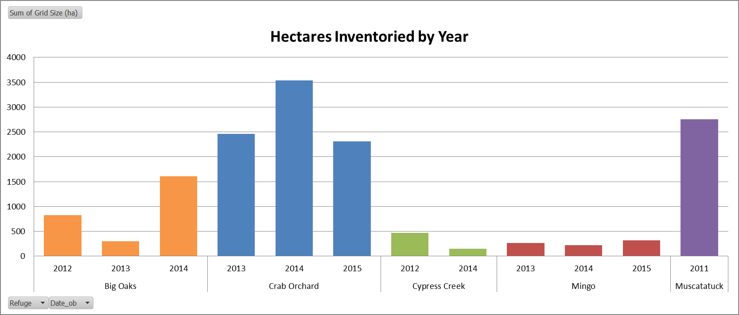

**Figure SM-3.1.** Example FIAM inventory project-level report summary of inventory progress after the 2015 field season at each participating refuge (excluding Muscatatuck NWR).

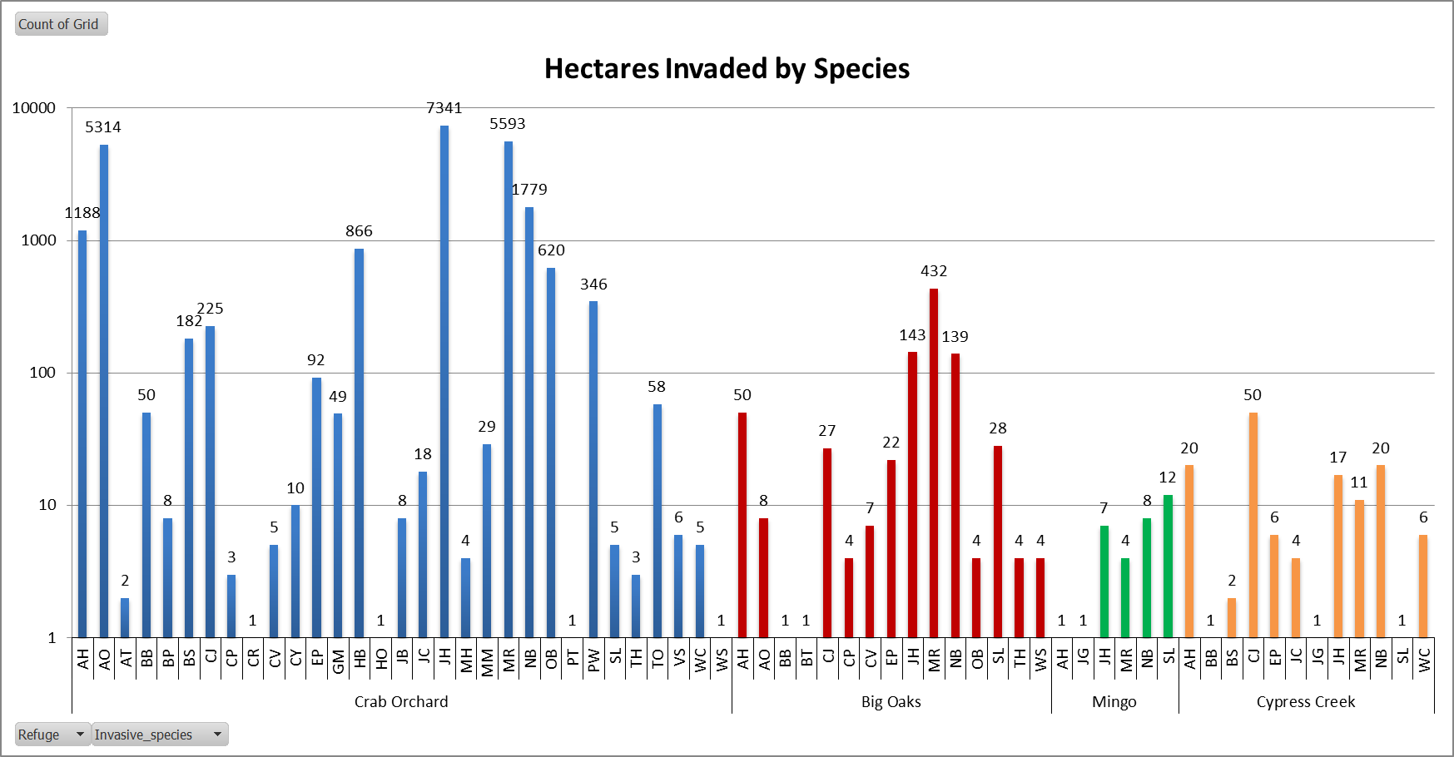

**Figure SM-3.2.** Example FIAM inventory project-level report summary of invasive species observed at each participating refuge (except Muscatatuck NWR) up until 2015. Above each bar is the total number of grid cells where that species was observed. The total number of grid cells inventoried for each refuge is given in Table SM-4.1.

SM 4: Summary Report Templates – Effectiveness Monitoring

Two types of reports from effectiveness monitoring data will be produced: 1) an annual refuge report, which summarizes effectiveness monitoring data and management activities for each target management area at that refuge, including a missing data table for purposes of quality control, and 2) at least every two years, a project-level report, which summarizes progress at all participating refuges, including updates to the adaptive management model. The Project Coordinator is responsible for ensuring data is entered at all refuges and for producing the summary reports.

An annual refuge report should include:

* Summary of pre-treatment monitoring data for each refuge by target area.
* Summary of post-treatment monitoring data for each refuge by target area with corresponding pre-treatment monitoring (and any previous post-treatment monitoring), as well as management information (see Figure SM-4.1 for an example).
* The results of any statistical comparison.

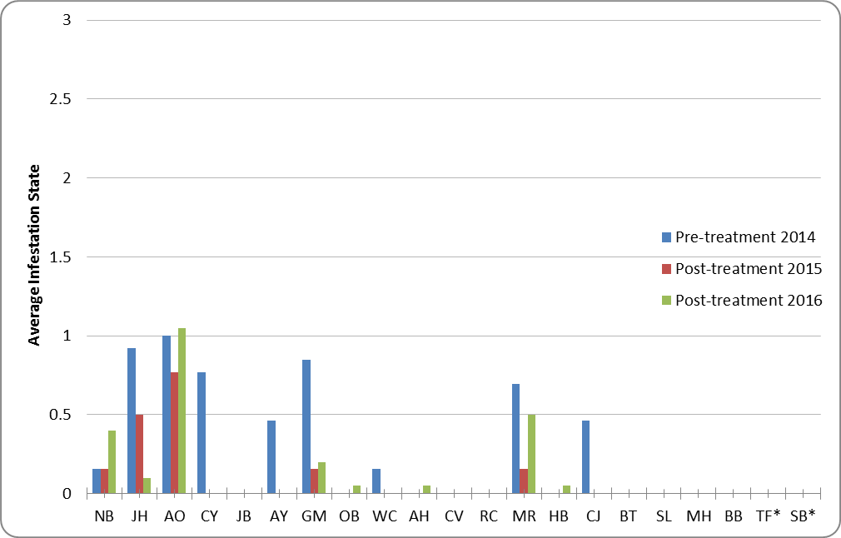

**Figure SM-4.1.** Example summary of a target area at Muscatatuck NWR that was monitored before and after a mechanical/chemical treatment.

A project-level summary report should include:

* Summary of pre-treatment monitoring and management activity by refuge and action (see Table SM-4.1 for an example with fabricated information).
* Summary of post-treatment monitoring activity by refuge, action, and number of years since action.
* Outputs from AM model, including updates to predictions/weights.

**Table SM-4.1.** Example summary of the number and size of target areas where monitoring and management activities occurred at each refuge. These data are fabricated for purposes of illustration.

|  |  |  |  |  |  |  |  |
| --- | --- | --- | --- | --- | --- | --- | --- |
|  |  |  | # Target Areas (Total Size in ha) for Each Management Action | | | | |
| Year | Refuge | # of Target Areas Pre-Monitored | Mechanical | Chemical | Mechanical/Chemical | Fire | Native Species Planting |
| 2013 | Big Oaks | 35 | 1 (1) | 11 (15) | 10 (8) | 10 (20) | 3 (3) |
| 2013 | Crab Orchard | 51 | 6 (2) | 32 (15) | 3 (1) | 0 | 10 (5) |
| 2013 | Cypress Creek | 28 | 1 (1) | 5 (5) | 15 (15) | 7 (13) | 0 |
| 2013 | Mingo | 39 | 2 (1) | 30 (20) | 5 (4) | 0 | 2 (1) |
| 2013 | Muscat-atuck | 75 | 4 (1) | 49 (12) | 7 (2) | 7 (2) | 8 (2) |
| 2013 | Patoka River | 64 | 1 (1) | 42 (20) | 5 (5) | 9 (16) | 7 (5) |

SM 5: Datasheets – Inventory and Effectiveness Monitoring

Two versions of the inventory datasheet are included: one with the optional native species metrics and the other without those data fields.

An effectiveness monitoring datasheet, which should be used for pre-treatment and post-treatment vegetation monitoring, is also provided. The datasheets for documenting management (treatment) actions are found in SM 6.

These datasheets may also be found in the *Protocols & Datasheets* library on the FIAM SharePoint site: <https://connect.doi.gov/fws/Portal/fip/SitePages/Home.aspx>.

FIAM INVASIVE SPECIES INVENTORY DATASHEET – With Optional Native Species Metrics *(Updated 2-28-17)*

|  |  |  |  |  |  |  |  |  |  |  |  |  |  |  |  |  |
| --- | --- | --- | --- | --- | --- | --- | --- | --- | --- | --- | --- | --- | --- | --- | --- | --- |
| Refuge: |  | Subarea: |  | Date: | | | Start Time: | | | | End Time: | | | | Observer(s): | |
| Inventory Grid # | Vis | INV1 | St1 | INV2 | St2 | INV3 | St3 | INV4 | St4 | TNSR | T% | SNSR | S% | HNSR | H% | Comments (or Inv5, 6, …and State5, 6, …) |
|  |  |  |  |  |  |  |  |  |  |  |  |  |  |  |  |  |
|  |  |  |  |  |  |  |  |  |  |  |  |  |  |  |  |  |
|  |  |  |  |  |  |  |  |  |  |  |  |  |  |  |  |  |
|  |  |  |  |  |  |  |  |  |  |  |  |  |  |  |  |  |
|  |  |  |  |  |  |  |  |  |  |  |  |  |  |  |  |  |
|  |  |  |  |  |  |  |  |  |  |  |  |  |  |  |  |  |
|  |  |  |  |  |  |  |  |  |  |  |  |  |  |  |  |  |
|  |  |  |  |  |  |  |  |  |  |  |  |  |  |  |  |  |
|  |  |  |  |  |  |  |  |  |  |  |  |  |  |  |  |  |
|  |  |  |  |  |  |  |  |  |  |  |  |  |  |  |  |  |
|  |  |  |  |  |  |  |  |  |  |  |  |  |  |  |  |  |
|  |  |  |  |  |  |  |  |  |  |  |  |  |  |  |  |  |
|  |  |  |  |  |  |  |  |  |  |  |  |  |  |  |  |  |
|  |  |  |  |  |  |  |  |  |  |  |  |  |  |  |  |  |
|  |  |  |  |  |  |  |  |  |  |  |  |  |  |  |  |  |
|  |  |  |  |  |  |  |  |  |  |  |  |  |  |  |  |  |
|  |  |  |  |  |  |  |  |  |  |  |  |  |  |  |  |  |
|  |  |  |  |  |  |  |  |  |  |  |  |  |  |  |  |  |
|  |  |  |  |  |  |  |  |  |  |  |  |  |  |  |  |  |
|  |  |  |  |  |  |  |  |  |  |  |  |  |  |  |  |  |
|  |  |  |  |  |  |  |  |  |  |  |  |  |  |  |  |  |
|  |  |  |  |  |  |  |  |  |  |  |  |  |  |  |  |  |
|  |  |  |  |  |  |  |  |  |  |  |  |  |  |  |  |  |
|  |  |  |  |  |  |  |  |  |  |  |  |  |  |  |  |  |
| **Visibility Distance**  0 0-1 m (0-3 ft)  1 2-5 m (6-16 ft)  2 6-10 m (20-33 ft)  3 11-15 m (36-49 ft)  4 > 15 m (> 49 ft) | **INV1, INV2, …**  See Table SOP-2.1 of protocol for species field codes | | **State1, State2, …**  0 Plants are absent  1 Few plants  2 Patches or Mod. Abundance (< 25%)  3 Infested/Abund. (> 25%) | | | | **Tree/ShrubVine/Herbaceous**  **Native Species Richness**  0 No native species  1 1 to 3 native species  2 4 to 6 native species  3 > 6 native species | | | | **Native Sp Cover (T%, S%, H%)**  0 0% (Absent)  1 ≤ 5% (Low Abundance)  2 6-25% (Moderate Abund.)  3 > 25% (High Abundance) | | | | **General Comments** | |

FIAM INVASIVE SPECIES INVENTORY DATASHEET *(Updated 2-28-17)*

|  |  |  |  |  |  |  |  |  |  |  |
| --- | --- | --- | --- | --- | --- | --- | --- | --- | --- | --- |
| Refuge: | Subarea: Date: Start Time: | | | | | | End Time: | | | Observer(s): |
| Inventory Grid # | Vis | INV1 | St1 | INV2 | St2 | INV3 | St3 | INV4 | St4 | Comments (or Inv5, 6, …and State5, 6, …) |
|  |  |  |  |  |  |  |  |  |  |  |
|  |  |  |  |  |  |  |  |  |  |  |
|  |  |  |  |  |  |  |  |  |  |  |
|  |  |  |  |  |  |  |  |  |  |  |
|  |  |  |  |  |  |  |  |  |  |  |
|  |  |  |  |  |  |  |  |  |  |  |
|  |  |  |  |  |  |  |  |  |  |  |
|  |  |  |  |  |  |  |  |  |  |  |
|  |  |  |  |  |  |  |  |  |  |  |
|  |  |  |  |  |  |  |  |  |  |  |
|  |  |  |  |  |  |  |  |  |  |  |
|  |  |  |  |  |  |  |  |  |  |  |
|  |  |  |  |  |  |  |  |  |  |  |
|  |  |  |  |  |  |  |  |  |  |  |
|  |  |  |  |  |  |  |  |  |  |  |
|  |  |  |  |  |  |  |  |  |  |  |
|  |  |  |  |  |  |  |  |  |  |  |
|  |  |  |  |  |  |  |  |  |  |  |
|  |  |  |  |  |  |  |  |  |  |  |
|  |  |  |  |  |  |  |  |  |  |  |
|  |  |  |  |  |  |  |  |  |  |  |
|  |  |  |  |  |  |  |  |  |  |  |
|  |  |  |  |  |  |  |  |  |  |  |
|  |  |  |  |  |  |  |  |  |  |  |
|  |  |  |  |  |  |  |  |  |  |  |
| **Visibility Distance**  0 0-1 m (0-3 ft)  1 2-5 m (6-16 ft)  2 6-10 m (20-33 ft)  3 11-15 m (36-49 ft)  4 > 15 m (> 49 ft) | | **INV1, INV2, …**  See Table SOP-2.1 of protocol for species field codes | | **State1, State2, …**  0 Plants are absent  1 Few plants  2 Patches or Mod. Abundance (< 25%)  3 Infested/Abund. (> 25%) | | | | **General Comments** | | |

FIAM INVASIVE SPECIES EFFECTIVENESS MONITORING DATASHEET *(Updated 2-28-17)*

|  |  |  |  |  |  |  |  |  |  |  |  |  |  |  |  |  |
| --- | --- | --- | --- | --- | --- | --- | --- | --- | --- | --- | --- | --- | --- | --- | --- | --- |
| Refuge: | Target Area: | | | | Date: | | | Start Time: | | | | End Time: | | | | Observer(s): |
| Monitoring Point # | INV1 | St1 | Phe1 | INV2 | St2 | Phe2 | INV3 | St3 | Phe3 | TNSR | T% | SNSR | S% | HNSR | H% | Comments |
|  |  |  |  |  |  |  |  |  |  |  |  |  |  |  |  |  |
|  |  |  |  |  |  |  |  |  |  |  |  |  |  |  |  |  |
|  |  |  |  |  |  |  |  |  |  |  |  |  |  |  |  |  |
|  |  |  |  |  |  |  |  |  |  |  |  |  |  |  |  |  |
|  |  |  |  |  |  |  |  |  |  |  |  |  |  |  |  |  |
|  |  |  |  |  |  |  |  |  |  |  |  |  |  |  |  |  |
|  |  |  |  |  |  |  |  |  |  |  |  |  |  |  |  |  |
|  |  |  |  |  |  |  |  |  |  |  |  |  |  |  |  |  |
|  |  |  |  |  |  |  |  |  |  |  |  |  |  |  |  |  |
|  |  |  |  |  |  |  |  |  |  |  |  |  |  |  |  |  |
|  |  |  |  |  |  |  |  |  |  |  |  |  |  |  |  |  |
|  |  |  |  |  |  |  |  |  |  |  |  |  |  |  |  |  |
|  |  |  |  |  |  |  |  |  |  |  |  |  |  |  |  |  |
|  |  |  |  |  |  |  |  |  |  |  |  |  |  |  |  |  |
|  |  |  |  |  |  |  |  |  |  |  |  |  |  |  |  |  |
|  |  |  |  |  |  |  |  |  |  |  |  |  |  |  |  |  |
|  |  |  |  |  |  |  |  |  |  |  |  |  |  |  |  |  |
|  |  |  |  |  |  |  |  |  |  |  |  |  |  |  |  |  |
|  |  |  |  |  |  |  |  |  |  |  |  |  |  |  |  |  |
|  |  |  |  |  |  |  |  |  |  |  |  |  |  |  |  |  |
|  |  |  |  |  |  |  |  |  |  |  |  |  |  |  |  |  |
|  |  |  |  |  |  |  |  |  |  |  |  |  |  |  |  |  |
|  |  |  |  |  |  |  |  |  |  |  |  |  |  |  |  |  |
| **INV1, INV2, …**  See Table SOP-2.1 of protocol for species field codes | **State1, State2, …**  0 Plants are absent  1 Few plants  2 Patches or Mod. Abund. (< 25%)  3 Infested/Abund. (> 25%) | | | | **Phenological Stage (Phe1, Phe2, …)**  1 Pre-emergent (bare stems, tight buds, prior to leaf out/flowering)  2 Basal rosette  3 Pre-flowering (has leaves only)  4 Flowering (including mature buds)  5 Seed or fruit present (post-flowering)  6 Senescing/senesced (leaves dropping/dropped)  7 Other | | | | | | | **Tree/ShrubVine/Herbaceous**  **Native Species Richness**  0 No native species  1 1 native species  2 2 to 4 native species  3 > 4 native species  (Different from Inventory) | | | | **Native Sp Cover (T%, S%, H%)**  0 0% (Absent)  1 ≤ 5% (Low Abundance)  2 6-25% (Moderate Abundance)  3 > 25% (High Abundance) |

SM 6: Datasheets – Documenting Management Actions

A separate datasheet is provided for each management action included in the adaptive management model: mechanical, chemical, mechanical/chemical, fire, and native species planting. Each datasheet comprises two pages (definitions and room for additional comments on the second page) and is meant to be printed double-sided.

Microsoft Excel versions of these datasheets may be found in the *Protocols & Datasheets* library on the FIAM SharePoint site: <https://connect.doi.gov/fws/Portal/fip/SitePages/Home.aspx>.

|  |  |  |  |  |  |  |  |  |  |  |  |  |  |  |  |  |  |  |  |  |  |  |  |  |  |  |  |  |  |  |  |  |  |  |  |  |  |  |  |  |  |  |  |  |  |  |  |  |  |  |  |  |  |  |  |  |  |  |  |  |  |  |  |  |  |  |  |  |  |  |  |  |  |  |  |  |  |  |  |  |  |  |  |  |  |  |  |  |  |  |  |  |  |  |  |  |  |  |  |  |  |  |  |  |  |  |  |  |  |  |  |  |  |  |  |  |  |  |  |  |  |  |  |  |  |  |  |  |  |  |  |  |
| --- | --- | --- | --- | --- | --- | --- | --- | --- | --- | --- | --- | --- | --- | --- | --- | --- | --- | --- | --- | --- | --- | --- | --- | --- | --- | --- | --- | --- | --- | --- | --- | --- | --- | --- | --- | --- | --- | --- | --- | --- | --- | --- | --- | --- | --- | --- | --- | --- | --- | --- | --- | --- | --- | --- | --- | --- | --- | --- | --- | --- | --- | --- | --- | --- | --- | --- | --- | --- | --- | --- | --- | --- | --- | --- | --- | --- | --- | --- | --- | --- | --- | --- | --- | --- | --- | --- | --- | --- | --- | --- | --- | --- | --- | --- | --- | --- | --- | --- | --- | --- | --- | --- | --- | --- | --- | --- | --- | --- | --- | --- | --- | --- | --- | --- | --- | --- | --- | --- | --- | --- | --- | --- | --- | --- | --- | --- | --- | --- | --- | --- | --- | --- |
| **Forest Invasive Adaptive Management** | | | | | | | | | | | | | | | | | | | | | | | | | | | | | | | | | | | | | | | | | | | | | | | | | | | | | | | | | | | | | | | | | | | | | | | | | | | | | | | | | | | | | | | | | | | | | | | | | | | | | | | | | | | | | | | | | | | | | | | | | | | | | | | | | | | | |
| *Management Action Datasheet* **- *MECHANICAL*** *(updated 2-28-17)* | | | | | | | | | | | | | | | | | | | | | | | | | | | | | | | | | | | | | | | | | | | | | | | | | | | | | | | | | | | | | | | | | | | | | | | | | | | | | | | | | | | | | | | | | | | | | | | | | | | | | | | | | | | | | | | | | | | | | | | | | | | | | | | | | | | | |
| **Refuge** | | | | | | | | | | | | | | | | | | | | | |  |  | **Target Area Name** | | | | | | | | | | | | | | | | | | | | | | | | | | | | | | | | | | | | | | **Person(s) Conducting the Action** | | | | | | | | | | | | | | | | | | | | | | | | | | | | | | | | | | | | | | | | | | | | | | | | | | | | | | | | | | | | | | | | | | | | | | |
|  | | | | | | | | | | | | | | | | | | | | | |  |  |  | | | | | | | | | | | | | | | | | | | | | | | | | | | | | | | | | | | | | |  | | | | | | | | | | | | | | | | | | | | | | | | | | | | | | | | | | | | | | | | | | | | | | | | | | | | | | | | | | | | | | | | | | | | | | |
|  | | | | | | | | | | | | | | | | | | | | | |  |  |  | | | | | | | | | | | | | | | | | | | | | | | | | | | | | | | | | | | | | |  | | | | | | | | | | | | | | | | | | | | | | | | | | | | | | | | | | | | | | | | | | | | | | | | | | | | | | | | | | | | | | | | | | | | | | |
| **Start Date**  **of Action** | | | | | | | | | | | | | | | | | | | | | |  |  | **End Date**  **of Action** | | | | | | | |  | | | | | | | | | | | |  | | | |  | | | |  | | | | | | | |  | | **Total Hours Spent** | | | | | | | | | | | | | | | | | | | | | | | | | | | | | | | | | | | | | | | | | | | | | | | | | | | | | | | | | | | | | | | | | | | | | | |
| **Description of Location** | | | | | | | | | | | | | | | | | | | | | | | |  | | | | | | | |  | | | | | | | | | | | |  | | | |  | | | |  | | | | | | | |  | | **Cost** | | | | | | | | | | | | | | | | | | | | | | | | | | | | |  | | |  | | | | | | |  | |  | | | | | | | | | | | | |  | | | | | | | | | | | | | | | | |
| **Air Temp.** | | | | | | | | | | | | | | | | | | | | | |  | **Wind Direction** | | | | | | | | |  | | | | | | | | | | | | **Wind Speed** | | | | | | | | | | | | | | | | | |  | | | | | | | | | | | | | | | | | | | | | | | | | | | | | **% Cloud Cover** | | | | | | | | | | | | | | | | | | | | | | | | |  | | | | | | | | | | | | | | | | |
|  | | | | | | | | | | | | | | | | | | | | | |  |  |  | | | | | | | |  | | | | | | | | | | | |  | | | |  | | | |  | | | | | | | |  | |  | | | | | | | | | | | | | | | | | | | | | | | | | | | | |  | | |  | | | | |  | | | |  | | | | | | | | | | | | |  | | | | | | | | | | | | | | | | |
| **Target Invasive Species** | | | | | | | | | | | | | | | | | | | | | | | |  | | | | | | | | **Phenological Stage** | | | | | | | | | | | | | | | | | | | | | | | | | | | | **Size Class** | | | | | | | | | | | | | | | | | | | | | | | | | | | | | | | | | | | | | | | **Mechanical Type** | | | | | | | | | | | | | | | | | | | | | | | | | | | | | | | | | |
|  | | | | | | | | | | | | | | | | | | | | | |  |  |  | | | | | | | |  | | | | | | | | | | | |  | | | |  | | | |  | | | | | | | |  | |  | | | | | | | | | | | | | | | | | | | | | | | | | | | | |  | | |  | | | | |  | | | |  | | | | | | | | | | | | |  | | | | | | | | | | | | | | | | |
|  | | | | | | | | | | | | | | | | | | | | | |  |  |  | | | | | | | |  | | | | | | | | | | | |  | | | |  | | | |  | | | | | | | |  | |  | | | | | | | | | | | | | | | | | | | | | | | | | | | | |  | | |  | | | | |  | | | |  | | | | | | | | | | | | |  | | | | | | | | | | | | | | | | |
|  | | | | | | | | | | | | | | | | | | | | | |  |  |  | | | | | | | |  | | | | | | | | | | | |  | | | |  | | | |  | | | | | | | |  | |  | | | | | | | | | | | | | | | | | | | | | | | | | | | | |  | | |  | | | | |  | | | |  | | | | | | | | | | | | |  | | | | | | | | | | | | | | | | |
|  | | | | | | | | | | | | | | | | | | | | | |  |  |  | | | | | | | |  | | | | | | | | | | | |  | | | |  | | | |  | | | | | | | |  | |  | | | | | | | | | | | | | | | | | | | | | | | | | | | | |  | | |  | | | | |  | | | |  | | | | | | | | | | | | |  | | | | | | | | | | | | | | | | |
|  | | | | | | | | | | | | | | | | | | | | | |  |  |  | | | | | | | |  | | | | | | | | | | | |  | | | |  | | | |  | | | | | | | |  | |  | | | | | | | | | | | | | | | | | | | | | | | | | | | | |  | | |  | | | | |  | | | |  | | | | | | | | | | | | |  | | | | | | | | | | | | | | | | |
|  | | | | | | | | | | | | | | | | | | | | | |  |  |  | | | | | | | |  | | | | | | | | | | | |  | | | |  | | | |  | | | | | | | |  | |  | | | | | | | | | | | | | | | | | | | | | | | | | | | | |  | | |  | | | | |  | | | |  | | | | | | | | | | | | |  | | | | | | | | | | | | | | | | |
|  | | | | | | | | | | | | | | | | | | | | | |  |  |  | | | | | | | |  | | | | | | | | | | | |  | | | |  | | | |  | | | | | | | |  | |  | | | | | | | | | | | | | | | | | | | | | | | | | | | | |  | | |  | | | | |  | | | |  | | | | | | | | | | | | |  | | | | | | | | | | | | | | | | |
|  | | | | | | | | | | | | | | | | | | | | | |  |  |  | | | | | | | |  | | | | | | | | | | | |  | | | |  | | | |  | | | | | | | |  | |  | | | | | | | | | | | | | | | | | | | | | | | | | | | | |  | | |  | | | | |  | | | |  | | | | | | | | | | | | |  | | | | | | | | | | | | | | | | |
|  | | | | | | | | | | | | | | | | | | | | | |  |  |  | | | | | | | |  | | | | | | | | | | | |  | | | |  | | | |  | | | | | | | |  | |  | | | | | | | | | | | | | | | | | | | | | | | | | | | | |  | | |  | | | | |  | | | |  | | | | | | | | | | | | |  | | | | | | | | | | | | | | | | |
| **Management Comments** | | | | | | | | | | | | | | | | | | | | | | | | | | | | | | | | | | | | | | | | | | | | | | | | | | | | | | | | | | | | | | | | | | | | | | | | | | | | | | | | | | | | | | | | | | | | | | | | | | | | | | | | | | | | | | | | | | | | | | | | | | | | | | | | | | | | |
|
| *Management Action Datasheet* **- *MECHANICAL*** *(continued)* | | | | | | | | | | | | | | | | | | | | | | | | | | | | | | | | | | | | | | | | | | | | | | | | | | | | | | | | | | | | | | | | | | | | | | | | | | | | | | | | | | | | | | | | | | | | | | | | | | | | | | | | | | | | | | | | | | | | | | | | | | | | | | | | | | | | |
| **Management Comments** | | | | | | | | | | | | | | | | | | | | | | | | | | | | | | | | | | | | | | | | | | | | | | | | | | | | | | | | | | | | | | | | | | | | | | | | | | | | | | | | | | | | | | | | | | | | | | | | | | | | | | | | | | | | | | | | | | | | | | | | | | | | | | | | | | | | |
|
|
|
|
|
|
|
|
|
|
|
|
| **Phenological Stage** | | | | | | | | | | | | | | | | | | | | | | | | | | | | |  | | | | | | | | | | | | | | | | | | | | | | | | | | | | | | | | | | | |  | | | |  | | | | |  | | **Size Class** | | | | | | | | | | | | | | | | | | | | | | | | | | | | | | |  | | |  | | | | | | | |  | | | | | |  | | | | | | | | |
| 1        Pre-emergent (bare stems or tight buds – i.e., prior to leaf out or flowering) | | | | | | | | | | | | | | | | | | | | | | | | | | | | | | | | | | | | | | | | | | | | | | | | | | | | | | | | | | | | | | | | | | | | | | | | | | | | > 6 in diameter at breast height (dbh) | | | | | | | | | | | | | | | | | | | | | | | | | | | | | | | | | | | | | | | | | | | | | | | | | | | | | | | | |
| 2        Basal rosette | | | | | | | | | | | | | | | | | | | | | | | | | | | | |  | | | | | | | | | | | | | | | | | | | | | | | | | | | | | | | | | | | |  | | | |  | | | | |  | | 3-6 in dbh | | | | | | | | | | | | | | | | | | | | | | | | | | | | | | |  | | |  | | | | | | | |  | | | | | |  | | | | | | | | |
| 3        Pre-flowering (has leaves only) | | | | | | | | | | | | | | | | | | | | | | | | | | | | | | | | | | | | | | | | | | | | | | | | | | | | | | | | | | | | | | | | |  | | | |  | | | | |  | | 1-2.9 in dbh | | | | | | | | | | | | | | | | | | | | | | | | | | | | | | |  | | |  | | | | | | | |  | | | | | |  | | | | | | | | |
| 4        Flowering (including mature buds) | | | | | | | | | | | | | | | | | | | | | | | | | | | | | | | | | | | | | | | | | | | | | | | | | | | | | | | | | | | | | | | | | | | | |  | | | | |  | | < 1 in dbh | | | | | | | | | | | | | | | | | | | | | | | | | | | | | | |  | | |  | | | | | | | |  | | | | | |  | | | | | | | | |
| 5        Seed or fruit present (post-flowering) | | | | | | | | | | | | | | | | | | | | | | | | | | | | | | | | | | | | | | | | | | | | | | | | | | | | | | | | | | | | | | | | | | | | |  | | | | |  | |  | | |  | | | |  | | | |  | | | | | | | | | | |  | | | | | | | | |  | | |  | | | | | | | |  | | | | | |  | | | | | | | | |
| 6        Senescing/senesced (leaves dropping/dropped) | | | | | | | | | | | | | | | | | | | | | | | | | | | | | | | | | | | | | | | | | | | | | | | | | | | | | | | | | | | | | | | | | | | | | | | | | |  | |  | | |  | | | |  | | | |  | | | | | | | | | | |  | | | | | | | | |  | | |  | | | | | | | |  | | | | | |  | | | | | | | | |
| 7        Other (describe in comments) | | | | | | | | | | | | | | | | | | | | | | | | | | | | | | | | | | | | | | | | | | | | | | | | | | | | | | | | | | | | | | | | |  | | | |  | | | | |  | |  | | |  | | | |  | | | |  | | | | | | | | | | |  | | | | | | | | |  | | |  | | | | | | | |  | | | | | |  | | | | | | | | |
|  | | | | | | | | | | | | | | | | | | | | | | | | | |  | | | |  | | | | | | | | | | | | | | | | | | | | | | | | | | | | | | | | | | |  | | | |  | | | | |  | |  | | |  | | | |  | | | |  | | | | | | | | | | |  | | | | | | | | |  | | |  | | | | | | | |  | | | | | |  | | | | | | | | |
| **Mechanical Type** | | | | | | | | | | | |  | | | | | | | | | | | | | | | | | | | | | | | | | | | | | | | | | | | | | | | | | | | | | | | | | | | | |  | | | |  | | | | |  | |  | | |  | | | |  | | | |  | | | | | | | | | | |  | | | | | | | | |  | | |  | | | | | | | |  | | | | | |  | | | | | | | | |
| 1 hand pulling | | | | | | | | | | | | 7 hydro axe | | | | | | | | | | | | | | | | | | | | | | | | | | | | | | | | | | | | | | | | | | | | | | | | | | | | | | | | |  | | | | |  | |  | | |  | | | |  | | | |  | | | | | | | | | | |  | | | | | | | | |  | | |  | | | | | | | |  | | | | | |  | | | | | | | | |
| 2 roller chopping | | | | | | | | | | | | 8 mowing | | | | | | | | | | | | | | | | | | | | | | | | | | | | | | | | | | | | | | | | | | | | | | | | | | | | | | | | |  | | | | |  | |  | | |  | | | |  | | | |  | | | | | | | | | | |  | | | | | | | | |  | | |  | | | | | | | |  | | | | | |  | | | | | | | | |
| 3 girdle | |  | | | | | | | | | | 9 disking | | | | | | | | | | | | | | | | | | | | | | | | | | | | | | | | | | | | | | | | | | | | | | | | | | | | |  | | | |  | | | | |  | |  | | |  | | | |  | | | |  | | | | | | | | | | |  | | | | | | | | |  | | |  | | | | | | | |  | | | | | |  | | | | | | | | |
| 4 bulldoze | |  | | | | | | | | | | 10 Fecon/brush hog/mulcher | | | | | | | | | | | | | | | | | | | | | | | | | | | | | | | | | | | | | | | | | | | | | | | | | | | | | | | | | | | | | |  | |  | | |  | | | |  | | | |  | | | | | | | | | | |  | | | | | | | | |  | | |  | | | | | | | |  | | | | | |  | | | | | | | | |
| 5 chainsaw/handcutting | | | | | | | | | | | | 11 other (describe in comments) | | | | | | | | | | | | | | | | | | | | | | | | | | | | | | | | | | | | | | | | | | | | | | | | | | | | | | | | | | | | | |  | |  | | |  | | | |  | | | |  | | | | | | | | | | |  | | | | | | | | |  | | |  | | | | | | | |  | | | | | |  | | | | | | | | |
| 6 digging | | | | | | | | | | | |  | | | | | | | | | | | | | | | | | |  | | | | | | | | | | | | | | | | | | | | | | | | | | | | | | | | | | |  | | | |  | | | | |  | |  | | |  | | | |  | | | |  | | | | | | | | | | |  | | | | | | | | |  | | |  | | | | | | | |  | | | | | |  | | | | | | | | |
|  | | | | | | | | | | | |  | | | | | | | | | | | | | | | | | |  | | | | | | | | | | | | | | | | | | | | | | | | | | | | | | | | | | |  | | | |  | | | | |  | |  | | |  | | | |  | | | |  | | | | | | | | | | |  | | | | | | | | |  | | |  | | | | | | | |  | | | | | |  | | | | | | | | |
| **Forest Invasive Adaptive Management** | | | | | | | | | | | | | | | | | | | | | | | | | | | | | | | | | | | | | | | | | | | | | | | | | | | | | | | | | | | | | | | | | | | | | | | | | | | | | | | | | | | | | | | | | | | | | | | | | | | | | | | | | | | | | | | | | | | | | | | | | | | | | | | | | |
| *Management Action Datasheet* **- *CHEMICAL*** *(updated 2-28-17)* | | | | | | | | | | | | | | | | | | | | | | | | | | | | | | | | | | | | | | | | | | | | | | | | | | | | | | | | | | | | | | | | | | | | | | | | | | | | | | | | | | | | | | | | | | | | | | | | | | | | | | | | | | | | | | | | | | | | | | | | | | | | | | | | | |
| **Refuge** | | | | | |  | | | | | | |  | | | | | | | **Target Area Name** | | | | | | | | | | | | | | | | | | | | | | | | | | | | | | | | | | | | | | | | | | | | | | **Person(s) Conducting the Action** | | | | | | | | | | | | | | | | | | | | | | | | | | | | | | | | | | | | | | | | | | | | | | | | | | | | | | | | | | | | | | | |
|  | | | | | |  | | | | | | |  | | | | | | |  | | | | | | | | | | | | | | | | | | | | | | | | | | | | | | | | | | | | | | | | | | | | | |
|  | | | | | |  | | | | | | |  | | | | | | |  | | | | | | | | | | | | | | | | | | | | | | | | | | | | | | | | | | | | | | | | | | | | | |
| **Start Date**  **of Action** | | | | | |  | | | | | | |  | | | | | | | **End Date**  **of Action** | | | | | | | |  | | | | | | |  | | | | | | | | | | | | | | | | | | | | | |  | | | |  | | | | | **Total Hours Spent** | | | | | | | | | | | | | | | | | | | | | | | | | | | | | | | | | | | | | | | | | | | | | | | | | | | | | | | | | | | | | | | |
| **Description of Location** | | | | | | | | | | | | | | | | | | | |  | | | | | | | |  | | | | | | |  | | | | | | | | | | | | | | | | | | | | | |  | | | |  | | | | | **Cost** | | | | | | | | | | | | | | | | | | | | | | | | | | | | | | | | | | | | | |  | | | | | | | |  | | | | | | |  | | | | | |  | | | | |
| **Air Temp.** | | | | | |  | | | | | | | **Wind Direction** | | | | | | | | | | | | | | |  | | | | | | | **Wind Speed** | | | | | | | | | | | | | | | | | | | | | | | | | | | | | | |  | | | | |  | | | | | | | | | | | **% Cloud Cover** | | | | | | | | | | | | | | | | | | | | | | | | | | | | | |  | | | | | | |  | | | | | |  | | | | |
|  | | | | | |  | | | | | | |  | | | |  | | | | | | | | | | |  | | | | | | |  | | | | | | | | | | | | | | | | | | | | | |  | | | |  | | | | |  | | | | |  | | | | | | | | | | |  | | | | | | | | | | | | | | | | | | | | | |  | | | | | | | |  | | | | | | |  | | | | | |  | | | | |
| **Target Invasive Species** | | | | | | | | | | | | | | | | |  | | | | | | | | | | |  | | | | | | | **Phenological Stage** | | | | | | | | | | | | | | | | | | | | | | | | | | | | | | | | | | | | | | | | | | | | | | | **Size Class** | | | | | | | | | | | | | | | | | | | | | | | | | | | | | | | | | | | | | | | | | | | | | | | |
|  | | | | | | | | | | | | | | | | | | | | | | | | | | | | | | | | | | |  | | | | | | | |  | | | | | | |  | | | | | | | | | | | | | | | |  | | | | | | |  | | | | | | | | |  | | | | | | | | | | | | | |  | | | | | | | | | | | | | | | |  | | | | | | |  | | | | | |  | | | | |
|  | | | | | | | | | | | | | | | | | | | | | | | | | | | | | | | | | | |  | | | | | | | |  | | | | | | |  | | | | | | | | | | | | | | | |  | | | | | | |  | | | | | | | | |  | | | | | | | | | | | | | |  | | | | | | | | | | | | | | | |  | | | | | | |  | | | | | |  | | | | |
|  | | | | | | | | | | | | | | | | | | | | | | | | | | | | | | | | | | |  | | | | | | | |  | | | | | | |  | | | | | | | | | | | | | | | |  | | | | | | |  | | | | | | | | |  | | | | | | | | | | | | | |  | | | | | | | | | | | | | | | |  | | | | | | |  | | | | | |  | | | | |
|  | | | | | | | | | | | | | | | | | | | | | | | | | | | | | | | | | | |  | | | | | | | |  | | | | | | |  | | | | | | | | | | | | | | | |  | | | | | | |  | | | | | | | | |  | | | | | | | | | | | | | |  | | | | | | | | | | | | | | | |  | | | | | | |  | | | | | |  | | | | |
|  | | | | | | | | | | | | | | | | | | | | | | | | | | | | | | | | | | |  | | | | | | | |  | | | | | | |  | | | | | | | | | | | | | | | |  | | | | | | |  | | | | | | | | |  | | | | | | | | | | | | | |  | | | | | | | | | | | | | | | |  | | | | | | |  | | | | | |  | | | | |
|  | | | | | | | | | | | | | | | | | | | | | | | | | | | | | | | | | | |  | | | | | | | |  | | | | | | |  | | | | | | | | | | | | | | | |  | | | | | | |  | | | | | | | | |  | | | | | | | | | | | | | |  | | | | | | | | | | | | | | | |  | | | | | | |  | | | | | |  | | | | |
| **Pesticide Trade Name (s)\*** | | | | | | | | | | | | | | | | |  | | | | | | | | | | | **Total Amount** | | | | | | | | | | | | | | | | | | | | | | **Application Method(s)** | | | | | | | | | | | | | | | | | | | | | | | | | | | | | | | | | | | | | | | | | | | | | | **Solution Type** | | | | | | | | | | | | | | | | | | | | | | | | | | | | |  | | | | |
|  | | | | | |  | | | | | | |  | | | |  | | | | | | | | | | |  | | | | | | |  | | | | | | | |  | | | | | | |  | | | | | | | | | | | | | | | |  | | | | | | |  | | | | | | | | |  | | | | | | | | | | | | | |  | | | | | | | | | | | | | | | |  | | | | | | |  | | | | | |  | | | | |
|  | | | | | |  | | | | | | |  | | | |  | | | | | | | | | | |  | | | | | | |  | | | | | | | |  | | | | | | |  | | | | | | | | | | | | | | | |  | | | | | | |  | | | | | | | | |  | | | | | | | | | | | | | |  | | | | | | | | | | | | | | | |  | | | | | | |  | | | | | |  | | | | |
|  | | | | | |  | | | | | | |  | | | |  | | | | | | | | | | |  | | | | | | |  | | | | | | | |  | | | | | | |  | | | | | | | | | | | | | | | |  | | | | | | |  | | | | | | | | |  | | | | | | | | | | | | | |  | | | | | | | | | | | | | | | |  | | | | | | |  | | | | | |  | | | | |
| **Management Comments** | | | | | | | | | | | | | | | | | | | | | | | | | | | | | | | | | | | | | | | | | | | | | | | | | | | | | | | | | | | | | | | | | | | | | | | | | | | | | | | | | | | | | | | | | | | | | | | | | | | | | | | | | | | | | | | | | | | | | | | | | | | | | | | | | |
|
| *Management Action Datasheet* **- *CHEMICAL*** *(continued)* | | | | | | | | | | | | | | | | | | | | | | | | | | | | | | | | | | | | | | | | | | | | | | | | | | | | | | | | | | | | | | | | | | | | | | | | | | | | | | | | | | | | | | | | | | | | | | | | | | | | | | | | | | | | | | | | | | | | | | | | | | | | | | | | |
| **Management Comments** | | | | | | | | | | | | | | | | | | | | | | | | | | | | | | | | | | | | | | | | | | | | | | | | | | | | | | | | | | | | | | | | | | | | | | | | | | | | | | | | | | | | | | | | | | | | | | | | | | | | | | | | | | | | | | | | | | | | | | | | | | | | | | | | |
|
|
|
|
|
|
|
|
|
|
|
|
| **Phenological Stage** | | | | |  | | | |  | | | | | | | | | | | | | | | | | | | | | | | | | | | |  | | | | | | | | | | | | | | | | | | | | | **Size Class** | | | | | | | | | | | | | | | | | | | | | | | | | | | | | | | | | | | | | | | | | | | | | | | |  | | |  | | | | | |  | | | | | | |  | | | | | | |
| 1        Pre-emergent (bare stems or tight buds – i.e., prior to leaf out or flowering) | | | | | | | | | | | | | | | | | | | | | | | | | | | | | | | | | | | | | | | | | | | | | | | | | | | | | | | | > 6 in diameter at breast height (dbh) | | | | | | | | | | | | | | | | | | | | | | | | | | | | | | | | | | | | | | | | | | | | | | | | | | | | | | | | | | | | | | | | | | | | | | | | |
| 2        Basal rosette | | | | |  | | | |  | | | | | | | | | | | | | | | | | | | | | | | | | | | |  | | | | | | | | | | | | | | | | | | | | | 3-6 in dbh | | | | | | | | | | | | | | | | | | | | | | | | | | | | | | | | | | | | | | | | | | | | | | | |  | | |  | | | | | |  | | | | | | |  | | | | | | |
| 3        Pre-flowering (has leaves only) | | | | | | | | | | | | | | | | | | | | | | | | | | | | | | | | | | | | |  | | | | | | | | | | | | | | | | | | | | | 1-2.9 in dbh | | | | | | | | | | | | | | | | | | | | | | | | | | | | | | | | | | | | | | | | | | | | | | | |  | | |  | | | | | |  | | | | | | |  | | | | | | |
| 4        Flowering (including mature buds) | | | | | | | | | | | | | | | | | | | | | | | | | | | | | | | | | | | | |  | | | | | | | | | | | | | | | | | | | | | < 1 in dbh | | | | | | | | | | | | | | | | | | | | | | | | | | | | | | | | | | | | | | | | | | | | | | | |  | | |  | | | | | |  | | | | | | |  | | | | | | |
| 5        Seed or fruit present (post-flowering) | | | | | | | | | | | | | | | | | | | | | | | | | | | | | | | | | | | | | |  | | | | | | | | | | | | | | | | | | | | |  | | | | | | | | | | | | | | | |  | | |  | | | | | | |  | | |  | | | | | | | | | | | |  | | | | | | | |  | | |  | | | | |  | | | | | | |  | | | | |
| 6        Senescing/senesced (leaves dropping/dropped) | | | | | | | | | | | | | | | | | | | | | | | | | | | | | | | | | | | | | | | | | | | | | | | | | | | | | | | | | | |  | | | | | | | | | | | | | | | |  | | |  | | | | | | |  | | |  | | | | | | | | | | | |  | | | | | | | |  | | |  | | | | |  | | | | | | |  | | | | |
| 7        Other (describe in comments) | | | | | | | | | | | | | | | | | | | | | | | | | | | | | | | | | | | | | |  | | | | | | | | | | | | | | | | | | | | |  | | | | | | | | | | | | | | | |  | | |  | | | | | | |  | | |  | | | | | | | | | | | |  | | | | | | | |  | | |  | | | | |  | | | | | | |  | | | | |
|  |  | | | | | |  | | | |  | | | | | | | | | | | | | | | | | | | | | | | | | | |  | | | | | | | | | | | | | | | | | | | | |  | | | | | | | | | | | | | | | |  | | |  | | | | | | |  | | |  | | | | | | | | | | | |  | | | | | | | |  | | |  | | | | |  | | | | | | |  | | | | |
| **Application Methods** | | | | | | |  | | | | | | | | | | | | **Solution Type** | | | | | | | | | | | | | | | | | | | | | | | | | | | | | | | | | | | | | | | | **\*If multiple chemicals were used on the same target area, note which chemical was used on which invasive species in the comments section.** | | | | | | | | | | | | | | | | | | | | | | | | | | | | | | | | | | | | | | | | | | | | | | | | | | | | | | | | | | | | | | | |  | | | | |
| foliar |  | | | | | |  | | | | | | | | | | | | 1 water soluble mixture | | | | | | | | | | | | | | | | | | | | | | | | | | | | | | | | | | | | | | | |  | | | | |
| basal bark drip | | | | | | |  | | | | | | | | | | | | 2 basal oil mixture | | | | | | | | | | | | | | | | | | | | | | | | | | | | | | | | | | | | | | | |  | | | | |
| other (describe in comments) | | | | | | | | | | | | | | | | | | | 3 gas or diesel mixture | | | | | | | | | | | | | | | | | | | | | | | | | | | | | | | | | | | | | | | |  | | | | |
|  |  | | | | | |  | | | | | | | | | | | | 4 inverted mixture | | | | | | | | | | | | | | | | | | | | | | | | | | | | | | | | | | | | | | | |  | | | | |
|  |  | | | | | |  | | | | | | | | | | | | 5 powder | | | | | | | | | | | | | | | | | | |  | | | | | | | | | | | | | | | | | | | | |  | | | | |
|  |  | | | | | |  | | | | | | | | | | | | 6 granular | | | | | | | | | | | | | | | | | | |  | | | | | | | | | | | | | | | | | | | | |  | | | | | | | | | | | | | | | |  | | |  | | | | | | |  | | |  | | | | | | | | | | | |  | | | | | | | |  | | |  | | | | |  | | | | | | |  | | | | |
|  |  | | | | | |  | | | | | | | | | | | | 7 other (describe in comments) | | | | | | | | | | | | | | | | | | | | | | | | | | | | | | | | | | | | | | | | | | | | | | | | | | | | | | | |  | | |  | | | | | | |  | | |  | | | | | | | | | | | |  | | | | | | | |  | | |  | | | | |  | | | | | | |  | | | | |
|  |  | | | | | |  | | | |  | | | | | | | | | | | | | | | | | | | | | | | | | | |  | | | | | | | | | | | | | | | | | | | | |  | | | | | | | | | | | | | | | |  | | |  | | | | | | |  | | |  | | | | | | | | | | | |  | | | | | | | |  | | |  | | | | |  | | | | | | |  | | | | |
| **Forest Invasive Adaptive Management** | | | | | | | | | | | | | | | | | | | | | | | | | | | | | | | | | | | | | | | | | | | | | | | | | | | | | | | | | | | | | | | | | | | | | | | | | | | | | | | | | | | | | | | | | | | | | | | | | | | | | | | | | | | | | | | | | | | | | | | | | | | | | | | | | | |
| *Management Action Datasheet* **- *MECHANICAL/CHEMICAL*** *(updated 2-28-17)* | | | | | | | | | | | | | | | | | | | | | | | | | | | | | | | | | | | | | | | | | | | | | | | | | | | | | | | | | | | | | | | | | | | | | | | | | | | | | | | | | | | | | | | | | | | | | | | | | | | | | | | | | | | | | | | | | | | | | | | | | | | | | | | | | | |
| **Refuge** | | | | | | | | | | | | | | | | | | | | | **Target Area Name** | | | | | | | | | | | | | | | | | | | | | | | | | | | | | | | | | **Person(s) Conducting the Action** | | | | | | | | | | | | | | | | | | | | | | | | | | | | | | | | | | | | | | | | | | | | | | | | | | | | | | | | | | | | | | | | | | | | | | | | | | | | |
| **Start Date**  **of Action** | | | | | | | | | | | | | | | | | | | | | **End Date**  **of Action** | | | | | | | | | | | | | | | | | | | | | | | | | | | | | | | | | **Total Hours Spent** | | | | | | | | | | | | | | | | | | | | | | | | | | | | | | | | | | | | | | | | | | | | | | | | | | | | | | | | | | | | | | | | | | | | | | | | | | | | |
| **Description of Location** | | | | | | | | | | | | | | |  | | | | | | | | | | | |  | | | | | | | | | | | | | | | | | | | | | | | | | | | **Cost** | | | | | | | | | | | | | | | | | | | | | | | | | | | | | | | | | | | | | | | | | | | | | | | | | | | | | | | | | | | | | | | | | | | | | | | | | | | | |
| **Air Temp.** | | | |  | | | | | | **Wind Direction** | | | | | | | | | | | | | | | | | | | | | | | | **Wind Speed** | | | | | | | | | | | | | | | | | | | | | | | | | | | | |  | | | | |  | | | | | | | | | **% Cloud Cover** | | | | | | | | | | | | | | | | | | | | | | | | | | | | | | | | | | | | | | | |  | | | | | | | | | | | | | |
|  | | | |  | | | | | |  | | | | | | | | | | | | | | | | | | | | | | | |  | | | | | | | | | | | | | | | | | | | | | | | | | | | | |  | | | | |  | | | | | | | | |  | | | | | | | | | | | | | | | | | | | |  | | | | |  | | |  | | | | | | | | | | | |  | | | | | | | | | | | | | |
| **Target Invasive Species** | | | | | | | | | | | | | | |  | | | | | | | | | | | | **Phenological Stage** | | | | | | | | | | | | | | | | | | | **Size Class** | | | | | | | | | | | | | | | | | | | | | | | | | | | | | | | | | | | | | | | | **Mechanical Type** | | | | | | | | | | | | | | | | | | | | | | | | | | | | | | | | | | | | | | | | | | | | |
|  | | | |  | | | | | |  | | | | |  | | | | | | | | | | | |  | | | | | | | | | | | | | | | | | | |  | | | | | | | | | | | | | | | | | | | | | | | | | | | | | | | | | | | | | | | |  | | | | | | | | | | | | | | | | | | |  | | | | | | | | | | | |  | | | | | | | | | | | | | |
|  | | | |  | | | | | |  | | | | |  | | | | | | | | | | | |  | | | | | | | | | | | | | | | | | | |  | | | | | | | | | | | | | | | | | | | | | | | | | | | | | | | | | | | | | | | |  | | | | | | | | | | | | | | | | | | |  | | | | | | | | | | | |  | | | | | | | | | | | | | |
|  | | | |  | | | | | |  | | | | |  | | | | | | | | | | | |  | | | | | | | | | | | | | | | | | | |  | | | | | | | | | | | | | | | | | | | | | | | | | | | | | | | | | | | | | | | |  | | | | | | | | | | | | | | | | | | |  | | | | | | | | | | | |  | | | | | | | | | | | | | |
|  | | | |  | | | | | |  | | | | |  | | | | | | | | | | | |  | | | | | | | | | | | | | | | | | | |  | | | | | | | | | | | | | | | | | | | | | | | | | | | | | | | | | | | | | | | |  | | | | | | | | | | | | | | | | | | |  | | | | | | | | | | | |  | | | | | | | | | | | | | |
|  | | | |  | | | | | |  | | | | |  | | | | | | | | | | | |  | | | | | | | | | | | | | | | | | | |  | | | | | | | | | | | | | | | | | | | | | | | | | | | | | | | | | | | | | | | |  | | | | | | | | | | | | | | | | | | |  | | | | | | | | | | | |  | | | | | | | | | | | | | |
|  | | | |  | | | | | |  | | | | |  | | | | | | | | | | | |  | | | | | | | | | | | | | | | | | | |  | | | | | | | | | | | | | | | | | | | | | | | | | | | | | | | | | | | | | | | |  | | | | | | | | | | | | | | | | | | |  | | | | | | | | | | | |  | | | | | | | | | | | | | |
| **Pesticide Trade Name (s)\*** | | | | | | | | | | | | | | |  | | | | | | | | | | | | **Total Amount** | | | | | | | | | | | | | | | **Application Method(s)** | | | | | | | | | | | | | | | | | | | | | | | | | | | | | | | | | | | | | | | | | | | | | | | **Solution Type** | | | | | | | | | | | | | | | | | | | | | | | | | | | | | | | | | | | | | | | | | |
|  | | | |  | | | | | |  | | | | |  | | | | | | | | | | | |  | | | | | | | | | | | | | | |  | | | | | | | | | | | | | | | | | | | | | | | | | | | | | | | | | | | | | | | | | | | | | | |  | | | | | | | | | | | | |  | | |  | | | | | | | | | | | |  | | | | | | | | | | | | | |
|  | | | |  | | | | | |  | | | | |  | | | | | | | | | | | |  | | | | | | | | | | | | | | |  | | | | | | | | | | | | | | | | | | | | | | | | | | | | | | | | | | | | | | | | | | | | | | |  | | | | | | | | | | | | |  | | |  | | | | | | | | | | | |  | | | | | | | | | | | | | |
|  | | | |  | | | | | |  | | | | |  | | | | | | | | | | | |  | | | | | | | | | | | | | | |  | | | | | | | | | | | | | | | | | | | | | | | | | | | | | | | | | | | | | | | | | | | | | | |  | | | | | | | | | | | | |  | | |  | | | | | | | | | | | |  | | | | | | | | | | | | | |
| **Management Comments** | | | | | | | | | | | | | | | | | | | | | | | | | | | | | | | | | | | | | | | | | | | | | | | | | | | | | | | | | | | | | | | | | | | | | | | | | | | | | | | | | | | | | | | | | | | | | | | | | | | | | | | | | | | | | | | | | | | | | | | | | | | | | | | | | | |
|
| *Management Action Datasheet* **- *MECHANICAL/CHEMICAL*** *(continued)* | | | | | | | | | | | | | | | | | | | | | | | | | | | | | | | | | | | | | | | | | | | | | | | | | | | | | | | | | | | | | | | | | | | | | | | | | | | | | | | | | | | | | | | | | | | | | | | | | | | | | | | | | | | | | | | | | | | | | | | | | | | | | | | | | | | |
| **Management Comments** | | | | | | | | | | | | | | | | | | | | | | | | | | | | | | | | | | | | | | | | | | | | | | | | | | | | | | | | | | | | | | | | | | | | | | | | | | | | | | | | | | | | | | | | | | | | | | | | | | | | | | | | | | | | | | | | | | | | | | | | | | | | | | | | | | | |
|
|
|
|
|
|
|
|
|
|
|
|
| **Phenological Stage** | | | | | | | |  | | | | | | | |  | | | | | | | | | | | | | | |  | | | | |  | | | | |  | | | |  | | | | **Size Class** | | | | | | | | | | | | | | | | | | | | | | |  | | | | | | | | | | | |  | | | | | |  | | |  | | | | | | | | | | | | | | | | | | | | | | | | | | | | | | | | |  | | | | | |
| 1        Pre-emergent (bare stems or tight buds – i.e., prior to leaf out or flowering) | | | | | | | | | | | | | | | | | | | | | | | | | | | | | | | | | | | | | | | | | | | | | | | | | > 6 in diameter at breast height (dbh) | | | | | | | | | | | | | | | | | | | | | | | | | | | | | | | | | | | | | | | | | | | | | | | | | | | | | | | | | | | | | | | | | | | | | | | | | | | | | | | | | | |
| 2        Basal rosette | | | | | | | |  | | | | | | | |  | | | | | | | | | | | | | | |  | | | | |  | | | | |  | | | |  | | | | 3-6 in dbh | | | | | | | | | | | | | | | | | | | | | | |  | | | | | | | | | | | |  | | | | | |  | | |  | | | | | | | | | | | | | | | | | | | | | | | | | | | | | | | | |  | | | | | |
| 3        Pre-flowering (has leaves only) | | | | | | | | | | | | | | | | | | | | | | | | | | | | | | |  | | | | |  | | | | |  | | | |  | | | | 1-2.9 in dbh | | | | | | | | | | | | | | | | | | | | | | |  | | | | | | | | | | | |  | | | | | |  | | |  | | | | | | | | | | | | | | | | | | | | | | | | | | | | | | | | |  | | | | | |
| 4        Flowering (including mature buds) | | | | | | | | | | | | | | | | | | | | | | | | | | | | | | |  | | | | |  | | | | |  | | | |  | | | | < 1 in dbh | | | | | | | | | | | | | | | | | | | | | | |  | | | | | | | | | | | |  | | | | | |  | | |  | | | | | | | | | | | | | | | | | | | | | | | | | | | | | | | | |  | | | | | |
| 5        Seed or fruit present (post-flowering) | | | | | | | | | | | | | | | | | | | | | | | | | | | | | | |  | | | | |  | | | | |  | | | |  | | | |  | | | | | | | | | | | | | | | | | | | | | | |  | | | | | |  | | | | | |  | | | | | |  | | |  | | | | | | | | | | | | | | | | | | | | | | | | | | | | | | | | |  | | | | | |
| 6        Senescing/senesced (leaves dropping/dropped) | | | | | | | | | | | | | | | | | | | | | | | | | | | | | | | | | | | |  | | | | | **\*If multiple chemicals were used on the same target area, note which chemical was used on which invasive species in the comments section.** | | | | | | | | | | | | | | | | | | | | | | | | | | | | | | | | | | | | | | | | | | | | | | | | | | | | | | | | | | | | | | | | | | | | | | | | | | | | | | | | | | | | | | | | | | |
| 7        Other (describe in comments) | | | | | | | | | | | | | | | | | | | | | | | | | | | | | | |  | | | | |  | | | | |
|  | | |  | | | | |  | | | | | | | |  | | | | | | | | | | | | | | |  | | | | |  | | | | |
| **Application Methods** | | | | | | | |  | | | | | | | | | | **Solution Type** | | | | | | | | | | | | | | | | | |  | | | | |  | | | |  | | **Mechanical Type** | | | | | | | | | | | | | | | | | | | | | | | | | | | | | | | | | | | | |  | | | | | |  | | |  | | | | | | | | | | | | | | | | | | | | | | | | | | | | | | | | |  | | | | | |
| foliar | | |  | | | | |  | | | | | | | | | | 1 water soluble mixture | | | | | | | | | | | | | | | | | |  | | | | |  | | | |  | | 1 hand pulling | | | | | | | | | | | | | | | | | | | | | | | | | | | | | | | | | | | | | 7 hydro axe | | | | | | | | | | | | | | | | | | | | | | | | | | | | | | | | | | | | | | | | | | | | | | | |
| basal bark drip | | | | | | | |  | | | | | | | | | | 2 basal oil mixture | | | | | | | | | | | | | | | | | |  | | | | |  | | | |  | | 2 roller chopping | | | | | | | | | | | | | | | | | | | | | | | | | | | | | | | | | | | | | 8 mowing | | | | | | | | | | | | | | | | | | | | | | | | | | | | | | | | | | | | | | | | | | | | | | | |
| other (describe in comments) | | | | | | | | | | | | | | | | | | 3 gas or diesel mixture | | | | | | | | | | | | | | | | | |  | | | | |  | | | |  | | 3 girdle | | | | | | | | | | | | | | | | | | | | | | | | | | | | | | | | | | | | | 9 disking | | | | | | | | | | | | | | | | | | | | | | | | | | | | | | | | | | | | | | | | | |  | | | | | |
|  | | |  | | | | |  | | | | | | | | | | 4 inverted mixture | | | | | | | | | | | | | | | | | |  | | | | |  | | | |  | | 4 bulldoze | | | | | | | | | | | | | | | | | | | | | | | | | | | | | | | | | | | | | 10 Fecon/brush hog/mulcher | | | | | | | | | | | | | | | | | | | | | | | | | | | | | | | | | | | | | | | | | | | | | | | |
|  | | |  | | | | |  | | | | | | | | | | 5 powder | | | | | | | | | | | | |  | | | | |  | | | | |  | | | |  | | 5 chainsaw/handcutting | | | | | | | | | | | | | | | | | | | | | | | | | | | | | | | | | | | | | 11 other (describe in comments) | | | | | | | | | | | | | | | | | | | | | | | | | | | | | | | | | | | | | | | | | | | | | | | |
|  | | |  | | | | |  | | | | | | | | | | 6 granular | | | | | | | | | | | | |  | | | | |  | | | | |  | | | |  | | 6 digging | | | | | | | | | | | | | | | | | | | | | | | | | | | | | | | | | | | | |  | | | | | | | |  | | | | | | | | | | | | | | | | | | | | | | | | | | | | | | | | | |  | | | | | |
|  | | |  | | | | |  | | | | | | | | | | 7 other (describe in comments) | | | | | | | | | | | | | | | | | | | | | | |  | | | |  | |  | | | | | | | | | | | | | | | | | | | | | | | | |  | | | | | |  | | | | | |  | | | | | |  | | |  | | | | | | | | | | | | | | | | | | | | | | | | | | | | | | | | |  | | | | | |
|  | | |  | | | | |  | | | | | | | |  | | | | | | | | | | | | | | |  | | | | |  | | | | |  | | | |  | |  | | | | | | | | | | | | | | | | | | | | | | | | |  | | | | | |  | | | | | |  | | | | | |  | | |  | | | | | | | | | | | | | | | | | | | | | | | | | | | | | | | | |  | | | | | |
| **Forest Invasive Adaptive Management** | | | | | | | | | | | | | | | | | | | | | | | | | | | | | | | | | | | | | | | | | | | | | | | | | | | | | | | | | | | | | | | | | | | | | | | | | | | | | | | | | | | | | | | | | | | | | | | | | | | | | | | | | | | | | | | | | | | | | | | | | | | | | | | | | | | | |
| *Management Action Datasheet* **- *FIRE*** *(updated 2-28-17)* | | | | | | | | | | | | | | | | | | | | | | | | | | | | | | | | | | | | | | | | | | | | | | | | | | | | | | | | | | | | | | | | | | | | | | | | | | | | | | | | | | | | | | | | | | | | | | | | | | | | | | | | | | | | | | | | | | | | | | | | | | | | | | | | | | | | |
| **Refuge** | | | | | | | | | | | | | | | | | | | | | | | | | **Target Area Name** | | | | | | | | | | | | | | | | | | | | | | | | | | | | | | | | | | | | | | | | | | **Person(s) Conducting the Action** | | | | | | | | | | | | | | | | | | | | | | | | | | | | | | | | | | | | | | | | | | | | | | | | | | | | | | | | | | | | | | | | | |
| **Start Date**  **of Action** | | | | | | | | | | | | | | | | | | | | | | | | | **End Date**  **of Action** | | | | | | | | | | | | | | | | | | | | | | | | | | | | | | | | | | | | | | | | | | **Total Hours Spent** | | | | | | | | | | | | | | | | | | | | | | | | | | | | | | | | | | | | | | | | | | | | | | | | | | | | | | | | | | | | | | | | | |
| **Description of Location** | | | | | | | | | | | | | | | | | | | | | | | | |  | | | | | | | | | | | | | | | | | | | | | | | | | | | | | | | | | | | | | | | | | | **Cost** | | | | | | | | | | | | | | | | | | | | | | | | | | | | | | | | | | | | | | | | | | | | | | | | | | | | | | | | | | | | | | | | | |
| **Air Temp.** | | | | | | | | | | | | | | **Wind Direction** | | | | | | | | | | | | | | | | | | | | | | | | | **Wind Speed** | | | | | | | | | | | | | | | | | | | | | | | | | | | | | | | | | | | | | | | | | **% Cloud Cover** | | | | | | | | | | | | | | | | | | | | | | | | | | | | | | | | |  | | | | | | |  | | | | | |  | | | | | | |
|  | | | | | | |  | | | | | |  | | | | | | |
| **Target Invasive Species** | | | | | | | | | | | | | | | | | | | | | | | | | | | | | | | | | | | | | | | **Phenological Stage** | | | | | | | | | | | | | | | | | | | | | | | | | | | | | | | | | | | | | | | | | **Size Class** | | | | | | | | | | | | | | | | | | | | | | | | | | | | | | | | | | | | | | | | | | | | | | | | | | | | |
|  | | | | | | | | | | | | | | | | | | | | | | | | | | | | | | | | | | | | | | | |  | | | | | | | | | | |  | | | |  | | | | | | | | |  | | | | | |  | | | | | | | | | | |  | | | | | | | | | | | | | |  | | | | | | | | | | | | | | | | | | |  | | | | | | |  | | | | | |  | | | | | |
|  | | | | | | | | | | | | | | | | | | | | | | | | | | | | | | | | | | | | | | | |  | | | | | | | | | | |  | | | |  | | | | | | | | |  | | | | | |  | | | | | | | | | | |  | | | | | | | | | | | | | |  | | | | | | | | | | | | | | | | | | |  | | | | | | |  | | | | | |  | | | | | |
|  | | | | | | | | | | | | | | | | | | | | | | | | | | | | | | | | | | | | | | | |  | | | | | | | | | | |  | | | |  | | | | | | | | |  | | | | | |  | | | | | | | | | | |  | | | | | | | | | | | | | |  | | | | | | | | | | | | | | | | | | |  | | | | | | |  | | | | | |  | | | | | |
|  | | | | | | | | | | | | | | | | | | | | | | | | | | | | | | | | | | | | | | | |  | | | | | | | | | | |  | | | |  | | | | | | | | |  | | | | | |  | | | | | | | | | | |  | | | | | | | | | | | | | |  | | | | | | | | | | | | | | | | | | |  | | | | | | |  | | | | | |  | | | | | |
|  | | | | | | | | | | | | | | | | | | | | | | | | | | | | | | | | | | | | | | | |  | | | | | | | | | | |  | | | |  | | | | | | | | |  | | | | | |  | | | | | | | | | | |  | | | | | | | | | | | | | |  | | | | | | | | | | | | | | | | | | |  | | | | | | |  | | | | | |  | | | | | |
|  | | | | | | | | | | | | | | | | | | | | | | | | | | | | | | | | | | | | | | | |  | | | | | | | | | | |  | | | |  | | | | | | | | |  | | | | | |  | | | | | | | | | | |  | | | | | | | | | | | | | |  | | | | | | | | | | | | | | | | | | |  | | | | | | |  | | | | | |  | | | | | |
|  | | | | | | | | | | | | | | | | | | | | | | | | | | | | | | | | | | | | | | | |  | | | | | | | | | | |  | | | |  | | | | | | | | |  | | | | | |  | | | | | | | | | | |  | | | | | | | | | | | | | |  | | | | | | | | | | | | | | | | | | |  | | | | | | |  | | | | | |  | | | | | |
| **Fuel Type** | | | | | | | | | | | | | | | | | | | | | | | | | | | | | | | | | **Fire Duration** | | | | | | | | | | | | | | | | | | | | **% Fuel Moisture** | | | | | | | | | | | | | | | | | | | | | | | | | | | | | | | | | | | | | | | | | | **% Consumption** | | | | | | | | | | | | | | | | | | | | | | | | | | | | | | | | | | | | | |
|
|
| **Management Comments** | | | | | | | | | | | | | | | | | | | | | | | | | | | | | | | | | | | | | | | | | | | | | | | | | | | | | | | | | | | | | | | | | | | | | | | | | | | | | | | | | | | | | | | | | | | | | | | | | | | | | | | | | | | | | | | | | | | | | | | | | | | | | | | | | | | | |
|

|  |  |  |  |  |  |  |  |  |  |  |  |  |  |  |
| --- | --- | --- | --- | --- | --- | --- | --- | --- | --- | --- | --- | --- | --- | --- |
| *Management Action Datasheet* **- *FIRE*** *(continued)* | | | | | | | | | | | | | | |
| **Management Comments** | | | | | | | | | | | | | | |
|
|
|
|
|
|
|
|
|
|
|
|
| **Phenological Stage** | |  |  |  |  | **Size Class** | | | | |  |  |  |  |
| 1        Pre-emergent (bare stems or tight buds – i.e., prior to leaf out or flowering) | | | | | | > 6 in diameter at breast height (dbh) | | | | | | | | |
| 2        Basal rosette | |  |  |  |  | 3-6 in dbh | | | | |  |  |  |  |
| 3        Pre-flowering (has leaves only) | | | | |  | 1-2.9 in dbh | | | | |  |  |  |  |
| 4        Flowering (including mature buds) | | | | |  | < 1 in dbh | | | | |  |  |  |  |
| 5        Seed or fruit present (post-flowering) | | | | |  |  |  |  |  |  |  |  |  |  |
| 6        Senescing/senesced (leaves dropping/dropped) | | | | |  |  |  |  |  |  |  |  |  |  |
| 7        Other (describe in comments) | | | | |  |  |  |  |  |  |  |  |  |  |
|  |  |  |  |  |  |  |  |  |  |  |  |  |  |  |
|  |  |  |  |  |  |  |  |  |  |  |  |  |  |  |
|  |  |  |  |  |  |  |  |  |  |  |  |  |  |  |
|  |  |  |  |  |  |  |  |  |  |  |  |  |  |  |

|  |  |  |  |  |  |  |  |  |  |  |  |  |  |  |  |  |  |  |  |
| --- | --- | --- | --- | --- | --- | --- | --- | --- | --- | --- | --- | --- | --- | --- | --- | --- | --- | --- | --- |
| **Forest Invasive Adaptive Management** | | | | | | | | | | | | | | | | | | | |
| *Management Action Datasheet* **- *NATIVE SPECIES PLANTING*** *(updated 2-28-17)* | | | | | | | | | | | | | | | | | | | |
| **Refuge** |  | |  | **Target Area Name** | | | | | | | | | **Person(s) Conducting the Action** | | | | | | |
|  |  | |  |
|  |  | |  |
| **Start Date**  **of Action** |  | |  | **End Date**  **of Action** | |  | |  |  | |  |  | **Total Hours Spent** | | | | | | |
| **Description of Location** | | | |  | |  | |  |  | |  |  | **Cost** | |  |  |  |  |  |
| **Air Temp** | | **Wind Direction** | | | | | **Wind Speed** | | | | | | | **% Cloud Cover** | | | | | |
| **Target Invasive Species** | | | | | | | **Phenological Stage** | | | | | | | **Size Class** | | | | | |
|  | | | | | | |  | |  | |  |  |  |  | |  |  |  |  |
|  | | | | | | |  | |  | |  |  |  |  | |  |  |  |  |
|  | | | | | | |  | |  | |  |  |  |  | |  |  |  |  |
| **Species Planted** | | |  |  | **Life Stage** | | | | | **Planting Method** | | | | | | **Amount** | | | **Rainfall** |
|  |  | |  |  |  | | | | |  | |  |  | |  |  |  |  |  |
|  |  | |  |  |  | | | | |  | |  |  | |  |  |  |  |  |
|  |  | |  |  |  | | | | |  | |  |  | |  |  |  |  |  |
|  |  | |  |  |  | | | | |  | |  |  | |  |  |  |  |  |
|  |  | |  |  |  | | | | |  | |  |  | |  |  |  |  |  |
|  |  | |  |  |  | | | | |  | |  |  | |  |  |  |  |  |
| **Management comments** | | | | | | | | | | | | | | | | | | | |
|

|  |  |  |  |  |  |  |  |  |  |  |  |  |  |  |  |
| --- | --- | --- | --- | --- | --- | --- | --- | --- | --- | --- | --- | --- | --- | --- | --- |
| *Management Action Datasheet* **- *NATIVE SPECIES PLANTING*** *(continued)* | | | | | | | | | | | | | | | |
| **Management comments** | | | | | | | | | | | | | | | |
|
|
|
|
|
|
|
|
|
|
|
|
| **Phenological Stage** | |  |  |  |  | **Size Class** | | | | | |  |  |  |  |
| 1        Pre-emergent (bare stems or tight buds – i.e., prior to leaf out or flowering) | | | | | | > 6 in diameter at breast height (dbh) | | | | | | | | | |
| 2        Basal rosette | |  |  |  |  | 3-6 in dbh | | | | | |  |  |  |  |
| 3        Pre-flowering (has leaves only) | | |  |  |  | 1-2.9 in dbh | | | | | |  |  |  |  |
| 4        Flowering (including mature buds) | | | |  |  | < 1 in dbh | | | | | |  |  |  |  |
| 5        Seed or fruit present (post-flowering) | | | |  |  | |  |  |  |  |  |  |  |  |  |
| 6        Senescing/senesced (leaves dropping/dropped) | | | | |  | |  |  |  |  |  |  |  |  |  |
| 7        Other (describe in comments) | | |  |  |  | |  |  |  |  |  |  |  |  |  |
|  |  |  |  |  |  | |  |  |  |  |  |  |  |  |  |
| **Life Stage** |  |  | **Planting Method** | |  | |  |  |  |  |  |  |  |  |  |
| seeds |  |  | drill |  |  | |  |  |  |  |  |  |  |  |  |
| seedlings |  |  | broadcast |  |  | |  |  |  |  |  |  |  |  |  |
| saplings |  |  | mechanically planted | |  | |  |  |  |  |  |  |  |  |  |
| RPM trees |  |  | hand planted | |  | |  |  |  |  |  |  |  |  |  |
| other (describe in comments) | | | other (describe in comments) | | | |  |  |  |  |  |  |  |  |  |
|  |  |  |  |  |  | |  |  |  |  |  |  |  |  |  |
|  |  |  |  |  |  | |  |  |  |  |  |  |  |  |  |

SM 7: Summary of All Data Fields

**Table SM-7.1.** Inventory Data Fields. See SOP 2 for details.

|  |  |  |  |
| --- | --- | --- | --- |
| **Field name** | **Required** | **Data Type** | **Naming Convention/Definitions** |
| Refuge | X | Categorical | Full name of station, no spaces, examples: BigOaks, Mingo, CypressCreek |
| Subarea |  | Categorical | Subarea name, if used, no spaces |
| Date | X | Date | Date observation was made, mm/dd/yy |
| Start Time | X | Time | Local time field work began, 24-hr, examples: 08:35, 15:20 |
| Observer(s) | X | Categorical | First and last name of up to 2 observers |
| Grid Point Number | X | Categorical | Depending on how grid was set up in ArcGIS, the “number” may include letters, examples: BO-2344, MIN-302 |
| Visibility | X | Ordinal | Visibility distance 0-1 m above ground;  0 = 0-1 m  1 = 2-5 m  2 = 6-10 m  3 = 11-15 m  4 = > 15 m |
| Name of Invasive Species | X | Categorical | Use 2-letter abbreviation for common name (see Table SOP-2.1) |
| State (Level) of Infestation | X | Ordinal | Infestation level for each invasive species recorded  0 = Absent  1 = Few Plants  2 = Patches or Moderate Abundance  3 = Infested |
| Native Species Richness |  | Ordinal | Richness category for native plants at 3 canopy levels (trees, shrubs & vines, herbaceous layer)  0 = None  1 = 1 to 3 Native Species  2 = 4 to 6 Native Species  3 = > 6 Native Species |
| Cover of Native Species |  | Ordinal | Aggregate cover categories for native species at 3 canopy levels (trees, shrubs & vines, herbaceous layer)  0 = 0%  1 = ≤ 5%  2 = 6 – 25%  3 = > 25% |
| Comments |  | Text |  |
| End Time | X | Time | Local time field work ended, 24-hr, examples: 08:35, 15:20 |

**Table SM-7.2.** Effectiveness Monitoring Data Fields. See SOP 4 for details.

|  |  |  |  |
| --- | --- | --- | --- |
| **Field name** | **Required** | **Data Type** | **Naming Convention/Definitions** |
| Refuge | X | Categorical | Full name of station, no spaces, examples: BigOaks, Mingo, CypressCreek |
| Target Area Name | X | Categorical | Unique name for area targeted for invasive species treatment and monitoring, no spaces |
| Date | X | Date | Date observation was made, mm/dd/yy |
| Start Time | X | Time | Local time field work began, 24-hr, examples: 08:35, 15:20 |
| Observer(s) | X | Categorical | First and last name of up to 2 observers |
| Monitoring Point Number | X | Categorical | The “number” should include letters to distinguish these points from the Inventory Grid Points, examples: BO-M-23, MIN-M-302 |
| Name of Invasive Species | X | Categorical | Use 2-letter abbreviation for common name (see Table SOP-2.1) |
| State (Level) of Infestation | X | Ordinal | Infestation level for each invasive species recorded  0 = Absent  1 = Few Plants  2 = Patches or Moderate Abundance  3 = Infested |
| Phenological Stage | X | Categorical | Dominant phenological stage for each invasive species  1 = Pre-emergent  2 = Basal rosette  3 = Pre-flowering  4 = Flowering  5 = Seed or fruit present  6 = Senescing/senesced  7 = Other |
| Native Species Richness1 | X | Ordinal | Richness category for native plants at 3 canopy levels (trees, shrubs & vines, herbaceous layer)  0 = None  1 = 1 Native Species  2 = 2 to 4 Native Species  3 = > 4 Native Species |
| Native Species Cover | X | Ordinal | Aggregate cover categories for native species at 3 canopy levels (trees, shrubs & vines, herbaceous layer)  0 = 0%  1 = ≤ 5%  2 = 6 – 25%  3 = > 25% |
| Comments |  | Text |  |
| End Time | X | Time | Local time field work ended, 24-hr, examples: 08:35, 15:20 |

1 Categories for native plant richness are different from those in Inventory, because a smaller area is observed.

|  |  |
| --- | --- |
|  | |
| U.S. Fish and Wildlife Service  U.S. Department of the Interior  National Wildlife Refuge System |  |

1. Executive Order 13112 defines an invasive species as an alien [non-native to that ecosystem] species whose introduction does or is likely to cause economic or environmental harm or harm to human health. <https://www.invasivespeciesinfo.gov/laws/execorder.shtml>
2. A protocol framework is a generalized version of an inventory or monitoring survey. Additional site-specific details are added to create a site-specific survey protocol.
3. This effectiveness monitoring sample design was newly developed in response to project participant and protocol reviewer feedback and has not yet been field tested. We intend to test this design during the 2017 field season in order to better explore potential issues around survey effort and feasibility, detectability, statistical power, and variances. The protocol may be revised following field testing. In the future, this project may incorporate smaller or larger management actions with tailored sampling designs for monitoring.