A User’s Guide for a SMART
Survey Prioritization Tool
(Version 2.2, April 2014)

0.800

0.700

0.600

0.500

0.400

0.300

0.200

0.100

0.000

U.S. Fish & Wildlife Service, National Wildlife Refuge System, Inventory and Monitoring Initiative, Natural Resources Program Center,
Fort Collins, Colorado
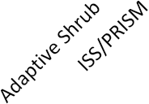
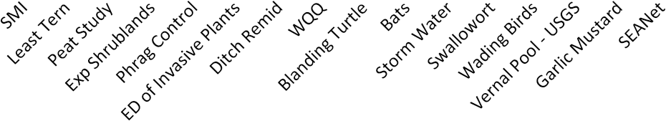

Preface and Acknowledgements

This tool was originally developed by a small group of staff from the Inventory and Monitoring (I&M) Initiative for the National Wildlife Refuge System. The purpose of the tool was to provide support for decisions about I&M activities (surveys) that would be identified in an Inventory and Monitoring Plan (IMP) as priorities for implementation. Kevin Kilbride (R1), Jared Underwood (R1), and Sean Blomquist (R3) formed the nucleus of team that produced and tested the initial versions of the spreadsheet and criteria that comprise the support tool and process. Benjamin Schlifer (USGS, Upper Midwest Environmental Science Center) programed the spreadsheet. The first version resulted from pilot use with 3 refuges and several rounds of review and editing by this team and other I&M Regional Coordinators. Version 1 was released for use in October 2012.

After using the tool at several pilot IMP workshops, the criteria and tool were revisited. Both were revised by expanding the number and variety of criteria (from 17 to 24), clarifying the wording on existing criteria, and incorporating the changes into a second version of the spreadsheet. The original Visual Basic macro language was retained in the tool but subtables were added to allow group values to be calculated from scores provided by individual participants. Thus, this second version allowed additional flexibility for a refuge to choose and customize the criteria for evaluating and prioritizing its surveys and provided an option to aid consensus when large groups (>3 staff) participated in the process.

Version (2.1) was released for use in January 2014, with the intent of identifying after a period of use, a core set of criteria for all refuges and a set of optional choices that can be used to make the prioritization process applicable to a specific refuge. Cobb McCrea (R7), Sean Blomquist (R3), Peter Dratch (NRPC) revised the criteria and Keenan Adams (NRPC) helped edit and format the criteria. Pat Ward and Sarah Shultz (NRPC) revised the spreadsheet and user’s guide to accommodate the revised criteria. The draft Version 2 was reviewed by Kevin Kilbride, Melinda Knutson (R3), Diane Granfors (R7), Peter Dratch, Janet Ertel (R4), and several I&M staff from Region 5.

Following use and comments by I&M staff in R8, R3, and Jennifer Casey (R5) this version (2.2) was expanded to increase the default number of surveys in the tool from 40 to 50. Fewer or more surveys can still be entered in the tool. The initial question about having entered PRIMR data was disabled and the metric for judging consensus was changed from a coefficient of variation (%) to percent of maximum possible deviation among participant scores (% Max SD). A function for rounding mean scores among participants was also included to return the group scores to the same precision as the original assigned values, which increases the spread of final prioritization scores among surveys. Finally, the default formatting of the output graph and table now shows the final scores sorted from highest to lowest.
Table of Contents

Preface and Acknowledgements i
A Tool For Prioritizing Refuge Surveys 1
Introduction 1
Overview of Survey Prioritization with a SMART Tool 1
Preparing for Survey Prioritization 2
Populate the PRIMR database with proposed surveys 2
Assemble a Team 2
Assemble Resources 2
Using the Tool to Prioritize Surveys 3
Step 1. Weighting the Prioritization Criteria 3
Step 2. Evaluating Surveys in the SMART Tool 4
Step 3. Calculations and Results: Final Prioritization Scores 4
Literature Cited 5
Appendix 1: Criteria and Terms for Prioritizing Refuge Surveys 6
Appendix 2: Weighting the Criteria 15
Appendix 3: Tool Technical Guide 18

A Tool
For Prioritizing Refuge Surveys

Introduction

The newly revised I&M policy (701 FW 2.4 and 2.11B) calls for all refuges in the National Wildlife Refuge System to develop an Inventory and Monitoring Plan (IMP) to guide inventory and monitoring activities on a refuge. In the IMP, all of the surveys that could be conducted at a refuge are evaluated and prioritized. Ultimately, a subset of the prioritized surveys is selected for implementation. This guide describes a process and a tool that can be used to prioritize surveys.

The prioritization tool uses a simple, multi-attribute ranking technique (SMART; Goodwin and Wright
2011) which can be used for the IMP decision making process for refuge surveys. The technique has been taught in courses such as Introduction to Structured Decision Making at the National Conservation Training Center.

The Survey Prioritization Tool has been developed to provide a standard approach with structure and transparency, while also allowing the flexibility essential to provide utility to the variety of refuges in the NWRS. The ability to modify or eliminate criteria allows refuge-specific flexibility while retaining the standard approach and transparency of the method. This tool will continue to be refined with experience to promote its effectiveness.

Overview of Survey Prioritization with a SMART Tool

Unless directed by your region, it is not mandatory to use the prioritization tool. However, the main benefits of using the prioritization tool are the transparency, consistent application of the criteria, and ease of writing the IMP justification narrative. The prioritization tool can be used to help resolve differing opinions regarding the relative importance of each survey. The discussion surrounding the scores to enter into the prioritization tool for each criterion will require survey evaluators to think carefully about the details of each survey and provide a means for attaining a group decision. Prioritizing surveys with this tool entails three basic steps:

1. Decide which criteria, scoring values, and weights are appropriate for evaluating proposed surveys;
2. Evaluate each survey using the agreed upon criteria and input the evaluation scores into the tool spreadsheet;
3. Review the final priority scores calculated and summarized by the tool.

The output from the Tool is a table and bar graph of final priority scores for each evaluated survey. This information should be used as the basis to discuss and select the surveys that refuge staff plans to conduct during the timespan of the IMP. Selection entails more than generating a list of priority scores for each survey and includes consideration of refuge capacity to complete the survey (see the IMP Workbook: Chapter 6, in prep.).

It is important to recognize that this tool provides support in making a final decision regarding survey selection. Additional information and discussion is also appropriate to complete the survey selection process for an IMP. The procedure, materials and decision rules for prioritizing and selecting surveys is required to be documented in the IMP Methods Section. If this tool is not used for prioritizing surveys, then the procedures that are used must be documented in the Methods Section of the IMP. The included rationale will be valuable to inform IMP revisions (e.g., adding new surveys) and future planning efforts, particularly whenever staffing changes occur.

Preparing for Survey Prioritization

Populate the PRIMR database with proposed surveys
To ensure the prioritization process is conducted as efficiently as possible, it is recommended that the refuge, Regional Refuge Biology or I&M staffs enter information into PRIMR for all surveys to consider in the prioritization process. Output from PRIMR will help survey evaluators remember the purpose and other characteristics of each survey.

Assemble a Team
A team consisting of Regional and Refuge Biology or I&M staff (e.g., Zone I&M Biologist), other staff planning and conducting surveys, and refuge manager(s) or assistant manager(s) will work together to prioritize surveys using the SMART Survey Prioritization Tool. Including these team members and/or obtaining feedback from the management staff on the final selection of surveys for the IMP and rationale for this decision making will facilitate approval of the IMP at the local and regional levels.

Assemble Resources
Access to the following resources will ensure a smooth process and efficient use of participant’s time:

● I&M Policy (701 FW 2) and IMP Workbook (in prep.; an active link will indicate it is available).
● The survey prioritization tool and this guide for each staff member participating in the process.
● Comprehensive list of surveys to evaluate (including cross-programmatic surveys the refuge may help conduct) with enough descriptive information about each survey to inform the evaluation.
● A computer and LCD projector to display the prioritization tool and criteria.
● A briefing on the background behind tool and ranking/rating rules to help explain the weighting and scoring process (if needed).
● IUCN lists and G-ranks for each species on the refuge.
● Range maps for each species on the refuge (where available) or internet availability to access NatureServe.
● Refuge and regional management plans applicable to the refuge (e.g., CCP, HMP, NRMP, etc.).
● Individual computers (loaded with the prioritization tool) or hard copy score sheets for assigning criteria weights and evaluation ratings independently from group discussion.

Using the Tool to Prioritize Surveys

Step 1. Weighting the Prioritization Criteria

To use this tool, team members need to first agree on the criteria and their relative importance weights for evaluating the refuge’s survey priorities. I&M or Regional Biology staff can facilitate the process, while the refuge staff choose the criteria and scoring values. Assigning weights familiarizes survey evaluators with the criteria, customizes the prioritization process for a given refuge and can reduce the number of criteria (and hence time) used to prioritize surveys. This step can take as little as a few hours or up to a full day, depending on how familiar the evaluators are with the criteria and the amount of group discussion on making decisions on weighting values. With larger (>3) groups, starting the process by identifying criteria that have no relevance (i.e. giving a 0 weight) and then letting individuals determine the weights of the remaining criteria on their own, can expedite the process and reserve discussion for finalizing results for the group. To determine which criteria to use and assign their weights, team members should:

A. Review the criteria: Each evaluator should review the twenty-four criteria and scoring values in Appendix 1.
B. Identify criteria to be dropped: Some of the criteria may not be considered useful for prioritizing surveys. These criteria will be assigned a Rating (and hence a weight) of zero to exclude them from consideration.
C. Modify criteria to improve applicability to the Refuge: Alternative criteria can be incorporated into the Tool. It is easiest to edit an existing criterion to reflect the more applicable wording or characteristic because deleting or inserting rows in the spreadsheet will require reprogramming of the tool.
D. Assign ratings (weights) for all criteria: Rate all criteria according to relative importance of that particular criterion to the refuge. Participating team members can start the process by assigning a Rank (unique integer) to each criterion, whereby 1 is the most applicable criterion. The ranks are then used as a reference to assign Ratings of relative importance. Rating values are like percentages, with the most important criterion = 100. Ratings can share the same value but providing different values (e.g., in increments of 5) will improve the spread and interpretation of final prioritization scores. Criteria Weights are auto-calculated from the ratings in the tool worksheet labeled 1_weight_criteria. Ranks and ratings can be entered for each individual (optimal for groups > 3) into a subtable, which will auto-calculate a mean value and store it for the group value. Otherwise, enter the group value arrived at through discussion, directly into the main table. A brief set of instructions is also included at the head of this worksheet.

For those interested, Appendix 2 shows additional details on the weighting procedure and provides an example step-wise process determining ranks, ratings and weights. Graphic, stepwise instructions for using the spreadsheet during all steps are provided in Appendix 3.

Step 2. Evaluating Surveys in the SMART Tool

The evaluation process is the step in which each survey is scored according the criteria agreed upon in Step 1 (i.e., those with rating > 0). The evaluation process takes approximately 30–45 minutes of initial orientation with the scoring for each criterion to evaluate the first survey and then 5–10 minutes for each subsequent survey. This time estimate assumes that the evaluators have enough knowledge about the survey to answer the questions posed in the evaluation criteria. The exercise can be completed by each individual separately, or through group discussion and voting.

- Open the Survey Prioritization Tool: Enable editing (Appendix 3) and enter the number of surveys (n) that will be evaluated. It is wise to save this spreadsheet immediately and then periodically. Put the station name and or date in the file name so that the original tool is maintained.
B. Enter proposed survey names: Go to worksheet 2_evaluate_surveys and enter the names of the surveys to be evaluated as headers of the columns labeled Survey 1 through Survey n, where n is the number entered in the query encountered when opening the spreadsheet.
C. Assign scores: Review and assign a single score for each survey using the first agreed-upon criterion and enter in worksheet 2_evaluate_surveys. Repeat this process for each proposed survey before moving to the next criterion. Evaluation scores can be entered for each participant in subtables (optimal for groups > 3) or as group values decided through discussion and added directly into the main table. If entered for each participant in a subtable, then a mean value across all participants will automatically be calculated and stored in the main table. Large (> 50%) values of SD among participant scores indicate lower consensus and may need to be revisited.
D. Generate Tool output: Tool outputs are generated in worksheet 5_prioritization_output. Note,
Intermediary calculation steps 3 and 4 are generated automatically in a separate worksheet labeled background_calculations (Appendix 3).

Step 3. Calculations and Results: Final Prioritization Scores

The third step is reviewing the results shown in the worksheet labeled 5_prioritization_output. This process allows the decisions to move from priority scores to final selection of surveys for the IMP (see IMP Workbook: Chapter 6, in prep.).

A. Review final scores: See worksheet 5_prioritization_output for final scores. Scrutiny and discussion by the group of evaluators should first focus on where and why results deviate from expectations. The final score for a survey is a normalized and weighted sum of the evaluation scores for all used criteria. The first calculation normalizes all the scores to a 0–1 scale (Step 3 on the background_calculations worksheet). This normalized score is then multiplied by the weight assigned to the criterion in the worksheet 1_weight_criteria. These normalized and weighted scores are shown in Table 1 of the tool output (5_prioritization_output worksheet) and Step 4 of the background_calculations worksheet. The final score is a sum of these normalized, weighted scores.

B. Review and discuss the score tables and bar graph: After the final prioritization scores are
understood and the group is satisfied, then the group should focus on a bar graph produced
from prioritization scores arranged from highest to lowest (e.g., like that on the cover of this user’s guide).

C. Modify prioritization: If the group is not satisfied with the prioritization tool outcomes, users
should reexamine the criteria weights and scores assigned to the surveys that have questionable final scores. If changes are made to the initial scoring, to produce a different final score, then this process and reasons for the changes should be documented as comments in the tool. After the final prioritization scores are understood and the group is satisfied, then the group should focus on a bar graph produced from prioritization scores arranged from highest to lowest (e.g., like that on the cover of this user’s guide). The group can use the bare graph to identify natural breaks in the final priority scores that form three groups of surveys with high, medium, and low scores. This process allows the decisions to move from priority scores to selection of surveys for the IMP (see IMP Workbook: Chapter 6, in prep.).

Literature Cited

Bottomley, PA and Doyle, JR. 2001. A comparison of three weight elicitation methods: good, better, and best. Omega 29:553–560.

Bottomley, PA, Doyle, JR and Green, RH. 2000. Testing the reliability of weight elicitation methods: direct rating versus point allocation. Journal of Marketing Research 37:508–513.

Goodwin, P and Wright, G. 2011. Decision analysis for management judgment (4th edition). Wiley,

Larichev, O. 1992. Cognitive validity in design of decision-aiding techniques. Journal of Multi-Criteria Decision Analysis 1:127–138.

Appendix 1
Criteria and Terms for Prioritizing Refuge Surveys

This section describes the 24 criteria that can be used alone or in conjunction with a SMART Tool to help refuge staff prioritize its surveys. Each criterion is grouped under one of eight themes that describe a survey’s general contribution to a refuge’s or broader needs. Rating values (1—2, 1—3, or 1—4) that are used to score each survey are also given for each criterion. Users should confer with I&M staff to determine if a standard set of criteria exist for their Region and if specific interpretations of those criteria are required. Clarification and examples for interpreting the posed questions of each criterion are shown in blue italicized font. Some criteria may reference a Natural Resources Management Plan (NRMP; analogous to an HMP, e.g., in R8), and the pertinent scores that can be incorporated into the IMP prioritization process, within parentheses. If you are not working from an NRMP, you can disregard that information.

- Refuge Priorities and Management Needs

A. Refuge Purpose
Does the survey provide information to evaluate if the refuge is achieving its purpose(s)?
Note: Surveys that provide information to either directly evaluate or serve as indicators of refuge purpose(s) can be considered as meeting this criterion. Refuge purposes are generally those defined under the Refuge’s founding legislation (Executive Order) or under ANILCA in Alaska. A survey addressing wilderness character addresses purpose for a refuge with proposed or designed wilderness.
Example: Kodiak NWR was founded to protect the breeding and feeding grounds of brown bears. A brown bear survey directly relates to this purpose.
1. No
2. Yes, one purpose
3. Yes, two purposes.
4. Yes, three or more purposes

B. CCP or Other Management Plan Objectives
How many refuge CCP or other management plan objectives (e.g., HMP, NRMP, Fire
Management Plan, Recovery Plan, Integrated Pest Management Plan) are met by the focus of
this survey?
Example 1: A survey of staff gauge readings for water levels in representative units can be
used to evaluate a range of wetland habitat objectives including seasonal, emergent, and
permanent types.
Example 2: An Early Detection Rapid Response survey can be used to discover the presence of
highly invasive plant species in multiple refuge habitats.
1. Does not address an objective
2. Addresses one objective
3. Addresses two objectives
4. Addresses three or more objectives

C. NWRS Objectives
Does the survey provide information to evaluate if the refuge is achieving regional or national
objectives of the NWRS such as Biological Integrity, Diversity, and Environmental Health
(BIDEH); NWR Resources of Concern (e.g., migratory birds, anadromous fishes, marine
mammals); and compatibility of refuge uses especially wildlife-dependent recreation)?
Federally listed species are addressed under criterion 4A so they should not be considered as
a NWR Resources of Concern under this criterion. For BIDEH, only consider surveys
addressing the highest measure of biological integrity, which is viewed as those intact and
self-sustaining habitats and wildlife populations existing during historic conditions (see 601
FW 3.10).
1. No
2. One objective
3. Two objectives
4. Three or more objectives

D. Management Utility (Decision Support) for the Refuge
Does the survey provide data for recurring management decisions, especially as part of
an existing decision framework that is implemented on a regular basis?
Surveys providing information to either directly evaluate or serve as indicators of high- priority
management actions can be considered as earning a 3 or 4 rating for this criterion.
1. No set application for the refuge
2. May have management implications, but they are not explicitly defined
3. Has management implications, but no current decision framework
4. Part of an existing adaptive management decision framework

- Partner Priorities and Management Needs

A. FWS Programs
Does the survey provide information that directly contributes to evaluating the status
and trends of resources that are a priority for another FWS regional or national program
(e.g., Migratory Birds, Fisheries, Water Resources/Hydrology other than ESA species)?
Example 1: North American Breeding Bird Survey, North American Amphibian Monitoring
program, Mid-Winter Waterfowl Survey, and Circumpolar Biodiversity Monitoring Network are
priority surveys for regional or national FWS programs.
1. Does not address a management priority identified by a FWS regional or national program or initiative
2. Addresses a management priority identified by 1 FWS regional or national program or initiative
3. Addresses a management priority identified by 2 FWS regional or national programs or initiatives
4. Addresses a management priority identified by ≥3 FWS regional or national programs
or initiatives

B. FWS Partners
Does the survey address an identified priority of a conservation partner, such as a
Landscape Conservation Cooperative(s) (LCC), state agencies, or other conservation
partner?
These priorities should be obtained from documents such as the State Wildlife Action and
Joint Venture plans. The staff should document where they obtained these priorities and if
they were high- or medium-level priorities. The refuge itself does not count as a partner.
1. Does not focus a management priority identified by FWS partners (e.g., LCC, state agency)
2. Focus on a management priority identified by one FWS partner (e.g., LCC, state
agency)
3. Focus on a management priority identified by two FWS partners (e.g., LCC,
state agency)
4. Focus on a management priority identified by three or more FWS partners (e.g.,
LCC, state agency)

3. Ecological Applications

A. FWS Surrogate Species
Does the survey focus on a surrogate species selected by the FWS?
1. No
2. Yes, one FWS surrogate species
3. Yes, two FWS surrogate species
4. Yes, three or more FWS surrogate species

B. Refuge Processes
Does the survey focus on an ecological process (e.g., fire, water temperature, climate) that
Is changing at a rate that is important to the refuge or an indicator species associated with
that process?
1. No
2. Yes, one significant ecological process or species
3. Yes, two or more significant ecological processes or species

C. Survey Breadth
The focus of the survey is:
1. A single species or abiotic parameter
2. Multi-species or multi-abiotic parameters
3. A community – multi-trophic level or biota
4. An ecosystem – biotic community and abiotic parameters

4. Additional Legal Mandates

A. Listed species or vegetation communities
Is the objective of the survey a species or vegetation community federally listed under ESA,
state listed (threatened or endangered only), ranked by the state’s natural heritage program
(S1 or S2 rank only), globally ranked by NatureServe (G1 or G2 rank only), or globally listed on
the IUCN Red List of Threatened Species (Critically Endangered, Endangered, or Vulnerable
only)?
1. Not state, federally or globally ranked
2. Yes, state listed or ranked by state’s natural heritage program
3. Yes, globally listed by NatureServe or IUCN
4. Yes , federally listed under the ESA as threatened or endangered

B. Non-ESA or Refuge Purpose Mandate(s)
Is the survey required to meet a legislated mandate other than the federal ESA or those
that stipulated Refuge Priorities or Management Needs (Item 1, above)?
1. No
2. Yes, one mandate
3. Yes, more than one mandate

5. Immediacy of Need

A. Controversy
Does the survey support decision-making to address an action or management decision
related to refuge resources that is controversial to an external party?
Note: Document why the refuge staff knows or suspects an action is controversial because the interpretation can vary from person to person. Controversy can be associated with the general public, specific interest group(s) (e.g., animal rights activist, cooperative farmers), or one or more conversation partners. This criterion is focused on a high level of known or suspected controversy from outside interests where the Service could be litigated, refuge actions that could result in a precedent setting action, or severely damage a working relationship with the state or other conversation partner. This criterion does not pertain to suspected or known issues among refuge staff members and/or other FWS employees. Examples of controversy include changes to livestock grazing, predator control, and changes to harvest regulations or water allocation.
1. Not controversial and little to no potential for controversy
2. Not currently controversial, but potentially or suspected of controversy
3. Known controversy, but data or immediate management action is not currently needed but may be in the near future
4. Pressing controversy; data required to support immediate management action

B. Threat
Does the survey support decision-making to monitor and mitigate a known or suspected
threat to refuge resources?
Note: This criterion scores surveys addressing known or suspected threats. It does not apply to baseline monitoring intended to detect new (i.e., unknown) threats or changes. If surveys are determined from a Natural Resources Management Plan (e.g., R8), focus on the threat reduction strategies identified in that plan and use adopt the scoring strategy shown in parentheses. Examples of threats may include invasive species, pollutants or toxins, and climate change.
1. No existing threat or potential for a threat to Refuge resources (the survey does not relate
to threat reduction strategies)
2. No known threat, but potential for a threat to Refuge resources (Yes, supports decision making to address a threat reduction strategy with a score of [e.g. 2.5])
3. Known threat to Refuge resources, but immediate management action is not currently needed but may be in the near future (Yes, supports decision making to address a threat reduction strategy with a score of [e.g. 3.0])
4. Urgent threat to Refuge resources; immediate data are needed to support management action (Yes, supports decision making to address a threat reduction strategy with a score of [e.g. 3.5])

6. Scope and Scale

A. Baseline data
Does the survey provide high-priority information that contributes to baseline data needs?
Example: Inventories of species guilds (e.g., invertebrates, plants, reptiles) or abiotic parameters (soils, waters).
1. No
2. Yes

B. Survey Scope
What proportion (%) of the species’, subspecies’, or communities’ (i.e., vegetation) geographic
range under U.S. jurisdiction will be covered by the survey on the refuge?
Note: Surveys of abiotic factors affecting these species or vegetation communities should also
be considered for this criterion. Example 2: 60% of the wintering waterfowl in the Pacific
Flyway use wetlands in the Central Valley of California including the San Luis NWRC.
Monitoring water levels by reading staff gauges weekly from October to March in managed
wetlands is an important abiotic survey to indicate if there are sufficient acres of suitable
foraging habitat to support 60% of the wintering waterfowl. Because water is essential to
maintain refuge wetlands for wintering waterfowl, “survey coverage” would equate to
waterfowl population surveys and score 3.
Example: 75% of Laysan Albatross population nest on Midway NWR. Conducting a survey to
monitor the breeding population size on the refuge would cover >10% of the entire species’
population and score 3.
1. Low: Survey covers <1% of the species’ or communities’ population/range
2. Medium: Survey covers 1-10% of the species’ or communities’ population/range
3. High: Survey covers ≥10% of the species’ or communities’ population/range

C. Spatial Scale
What is the largest scale at which survey results will be applied for resource management?
Note: Only surveys with a protocol that establishes methods for data management and analysis are scored higher than a 1. The area of inference for larger-scale surveys (e.g., North American Amphibian Monitoring Program) should be considered from the refuge perspective unless the refuge directly contributes to analyses at a larger scale. This criterion is applicable to surveys covering areas on and adjacent to the refuge. Example: If a refuge participates and contributes to a regional survey involving neighboring US Forest Service lands, then this criterion would apply.
1. Small scale: Applicable to only a single refuge or sites on a refuge
2. Medium scale: Applicable to a few refuges, a refuge complex, or includes the refuge and a small area beyond the refuge boundary
3. Large scale: Applicable to multiple refuges/complexes across an entire ecoregion,
LCC, or region
4. Continental scale: Component of a large landscape level survey (e.g., North American Breeding Bird Survey, North American Amphibian Monitoring Program, and Circumpolar Biodiversity Monitoring Network)

D. Integration
Is the survey conducted in conjunction with, reliant on, or required by another survey to
provide a more complete picture of the targeted resource?
Note: if surveys are based on priorities established by a Natural Resources Management
Plan (e.g. R8), then consider the following question and use the scoring language in
parentheses— (Are survey results used to inform one or more priority management
strategies identified in the NRMP? [Refer to NRMP results chains]).
Example 1: Habitat parameters and avian population counts are collected for the
Integrated Waterbird Management and Monitoring project.
Example 2: Berry density data and salmon spawning data work in conjunction with bear
density and habitat use data to predict salmon escapement goals required to maintain bear
populations.
1. No
2. Yes, survey is conducted in conjunction with another survey, but the results are independent (Yes, the survey results are used to inform 1 priority management strategy in the NRMP)
3. Yes, the results from this survey are reliant on, or required by, another survey for a complete picture of the targeted resource (Yes, the survey results are used to inform
≥2 priority management strategies in the NRMP)
4. Yes, the results from this survey are reliant on, or required by, more than one other survey for a complete picture of the targeted resource. (Not used)

E. Data Quality and Scope
Which of these will characterize the survey results?
1. Raw counts with unknown measurement error or accuracy
2. Index or surrogate values without known statistical properties
3. Estimates of attribute values with known statistical properties and measures of reliability
4. Exact measures from calibrated equipment (minimal measurement errors, as in automated sensors)

7. Protocol

A. Sampling Design
At what stage of development is the sampling design?
Note: The I&M initiative has a standardized format for survey protocols that contain 8 critical
elements. A survey protocol with all elements and has been peer-reviewed meets this criterion.
1. Survey has no written sampling design
2. The sampling design is in development (drafted)
3. The sampling design is in formal review
4. There is a published or I&M-approved sampling design

B. Field Methods
At what stage of development is the field method protocol?
1. Survey has no written field methods
2. The field methods are in development (drafted)
3. The field methods are in formal review
4. There is a published set or I&M approved protocol for field methods

C. Data management, analysis, and reporting
At what stage of development is the data management, analysis, and reporting?
1. Survey has no written protocol for data management, analysis, and reporting
2. Written protocol for data management, analysis, and reporting is in development
(drafted)
3. Written protocol for data management, analysis, and reporting is in formal review
4. There is a published record or I&M approved protocol guiding data management, analysis, and reporting

8. Cost

A. Monetary
What is the estimated annual non-personnel cost to complete the survey?
This includes startup costs to the refuge, and any contracts, facility, and equipment cost.
Be sure to adjust the cost of surveys that do not occur every year to an annual estimate.
Regional Biology or I&M staff assisting the refuge with the prioritization process should note
this scale is reversed from those used for the other criteria (higher values are given to surveys
that cost less operating to conduct). It is recommended that this criterion be given a low
weight in the criteria ranking and rating process (the first step of using the prioritization tool)
in cases where a refuge has a large number of surveys that are not currently being conducted.
In these cases, the details of the protocol, and hence the costs will be poorly known for planned
surveys. Similarly, if selection is based on assignment of survey status that factors in a
refuge’s capacity after the prioritization process, then evaluators may wish to assign 0 ratings
to this criterion to avoid overemphasizing refuge capacity.
1. >$10,000
2. >$5,000–$10,000
3. >$1,000–$5,000
4. Up to $1,000
5. No cost

B. Personnel
What is the estimated refuge personnel time required to complete the survey?
This estimate needs to include time for field work, data analysis, and reporting.
Note: as with monetary costs, the scale is reversed (higher values represent less time to
complete surveys). It is recommended that this criterion be given a low weight in the criteria
ranking and rating process in cases where a refuge has a large number of surveys that are
not currently being conducted. In these cases, the details of the protocol, and hence the time
and personnel requirements will be poorly known for planned surveys. Similarly, if selection is
based on assignment of survey status that factors in a refuge’s capacity after the
prioritization process, then evaluators may wish to assign 0 ratings to this criterion to avoid
overemphasizing refuge capacity.
1. >240 hrs
2. >80–240 hrs
3. >40–80 hrs
4. 0–40 hrs

C. Security/Source of Funding
How is this survey funded?
Note: as with criteria 8A and B, if selection is based on assignment of survey status that factors
in a refuge’s capacity after the prioritization process, then evaluators may wish to assign 0
ratings to this criterion to avoid overemphasizing refuge capacity in the selection process.
- Require full support from a non-Refuge funding source for completion, and source has
not been identified or is not secure
2. Requires partial support from a non-Refuge funding source that is not secure and reliable
3. Requires partial support from a non-refuge funding source, but the funding source is consistent and secure for the expected duration of the survey (high level of confidence that funding will remain)
4. Could be fully supported using Refuge base funds, or has no monetary cost to the Refuge

Terms Used in the Prioritization Criteria

For Criterion #1, refuge purpose is defined within the National Wildlife Refuge System Mission and Goals and Refuge Purposes policy (601 FW 1).

The NWRS Improvement Act defines “purposes of the refuge” as the “purposes specified in or derived from the law, proclamation, Executive order, agreement, public land order, donation document, or administrative memorandum establishing, authorizing, or expanding a refuge, refuge unit, or refuge subunit.”

Refuges acquired under the authority of general conservation laws take on the purpose of the law. Examples of such laws include the Endangered Species Act of 1973, as amended; the Migratory Bird Conservation Act; the Fish and Wildlife Act of 1956, as amended; the Fish and Wildlife Coordination Act, as amended; the Emergency Wetlands Resources Act of 1986; and the Alaska National Interest Lands Conservation Act of 1980. Executive orders and proclamations, Secretary’s Orders, public land orders, and refuge-specific legislation generally declare the purpose(s) of the refuge, sometimes broadly (e.g., “as a preserve and breeding ground for native birds”) and sometimes very specifically (e.g., “to protect and preserve in the national interest the Key deer and other wildlife resources in the Florida Keys”).
As written in the Wilderness Act of 1964, the purposes of the Act are to be “within and supplemental” to the purpose(s) of those refuges with designated wilderness. We interpret this to mean the wilderness purposes become additional purposes of the refuge, yet apply only to those areas of the refuge designated as wilderness. Wilderness designations provide additional considerations for determining the administrative and management actions we need to take to achieve a refuge’s purpose(s) on designated wilderness areas within the Refuge System.

Throughout the criteria, the term refuge refers to one or more refuges in the NWRS. Based upon 601
FW 1, a refuge is defined as “…all lands, waters, and interests therein administered by the Service as wildlife refuges, wildlife ranges, wildlife management areas, waterfowl production areas, and other areas managed by the Refuge System for the protection and conservation of fish and wildlife, including threatened and endangered species, as determined in writing by the Director of the Service, by Secretary’s Order, or so directed by the President.”

The following are definitions of refuge management activities and refuge uses from the Compatibility policy (603 FW 2.6) that apply to all refuges:

Refuge management activity—An activity conducted by the Service or a Service-authorized agent to fulfill one or more purposes of the national wildlife refuge, or the National Wildlife Refuge System mission. Service-authorized agents include contractors, cooperating agencies, cooperating associations, refuge support groups, and volunteers.

Refuge management economic activity—A refuge management activity on a national wildlife refuge that results in generation of a commodity which is or can be sold for income or revenue or traded for goods or services. Examples include: farming, grazing, haying, and timber harvesting.

Refuge use; use of a refuge. A recreational use (including refuge actions associated with a recreational use or other general public use), refuge management economic activity, or other use of a national wildlife refuge by the public or other non-National Wildlife Refuge System entity.

Appendix 2
Weighting the Criteria

General Process

The weighting process is based on a technique from the decision analysis literature called direct rating (Goodwin & Wright 2011). It is a modified Delphi technique for eliciting values from groups designed to avoid bias among the participants in a group decision making process. The process entails a two-steps that establishe an interval scale for attributes that cannot easily be compared or quantified by variables.

Generating importance weights is a cognitively challenging task (Larichev 1992) and multiple techniques for reliably eliciting importance weights from decision makers have been recognized. Compared to similar techniques such as point allocation, direct rating is considered more consistent in produced weights and has been preferred by the decision makers participating in the process because of its relative simplicity (Bottomley et al. 2000, Bottomley & Doyle 2001).

Within the Excel-based prioritization tool (1_weight_criteria), the refuge staff conducts the two-step weighting process specifically for the 24 criteria themselves. It entails assigning a rank and rating value to each of the criteria (see Table below). The rank is used to help establish the rating values, which are used to calculate weights of relative importance each criterion. These weights are used in conjunction with the criterion scores assigned to each survey to calculate a final survey prioritization score (see background_calculations and 5_prioritization_output worksheets).

The weighting process helps refuge staff members to explicitly and objectively consider the importance of the criteria before evaluating each survey they wish to prioritize for the IMP. The process can reduce the number of criteria used to prioritize surveys. One or more criteria not relevant to the refuge can be assigned a “0” value for the rating. By doing so, they are excluded from further use in the prioritization tool. For the remaining criteria (Rating > 0), the weighting process allows the refuge staff to assign a weight representing the importance of that particular criterion.

Considering the importance of each criterion at the refuge level allows the staff to customize the prioritization tool for their refuge. As a result, the weighting process accounts for the diversity in purposes, legal mandates, management objectives, and other site-specific considerations across the nation. Consequently, the weighting process also tailors the decision about prioritization of surveys to include in the IMP.

Rank

Users may start by assigning a unique rank to each criterion (yellow highlighted column in Table 1). A rank is an integer between 1 and 24, where 1 and 24 are the most and least important to the refuge, respectively. Each rank must be unique; no ties are allowed. This step is helpful for getting to a rating of each criterion (next section). However, the rank is not used in the calculations and therefore is not mandatory to complete the prioritization process. If the users are finding the ranking step difficult (e.g., when all 24 criteria need a rank) then skip this step and provide a rating for each criteria.

Rating

A rating is used in this tool to calculate a relative importance (weight) for each criterion. Ratings are integers that range from 0 to 100, whereby 100 is the most important criterion, 1 is the least important to the user, and 0 signifies the criterion has no relevance for evaluating the surveys conducted at the user’s refuge. A rating = 0 effectively excludes a criterion from further consideration. Though the principle of the rating is similar to ranking, the two systems differ in scale and in uniqueness of used values. Unlike ranks, criteria can have the same rating (i.e., tied values are acceptable).

If the refuge staff members are having difficulty in assigning ratings, it may be useful to first assign a general range of ratings to each of the previously mentioned high, medium, and low rank categories and then assign an actual rating to each criterion within that rating category. Alternatively, ask the evaluation team members to identify the criteria that are their top and bottom criteria and proceed by asking them to fill in each criterion relative to the top and bottom. The most important aspect of the rating step is to spread the rating values across the entire range of 1through 100 for all criteria the staff wish to consider.

Recommended Process to Assign Ranks and Ratings

Every staff member participating in the prioritization of the refuge’s surveys should independently rank and/or rate each of the survey prioritization criteria. Either provide a digital or hardcopy worksheet to the user’s and have them complete the rank and/or rating table based upon instructions listed in the next section. This should be done in advance of a face-to-face meeting of refuge and I&M staffs. Completed tables should be submitted to the IMP facilitator (Regional Refuge Biology or I&M staff member) who can transfer or input the independent values to the proper fields in
the survey prioritization tool. The tool automatically calculates average ranks or ratings with percent maximum deviations (% Max SD) and transfers the mean to the main table on the weighting worksheet. Larger SDs (typically > 50%) indicate less consensus of a rating that may need further group discussion. If the rating values were done solely through group discussion (usually efficient for groups < 4 members), then the group consensus value can be entered directly into the main table on the weighting worksheet. However, in this case, means and % Max SDs will not be calculated.

At a face-to-face meeting, discuss the analyses of ratings to attain consensus, where it may be needed. If the regional office has provided recommendations on rating values for each criterion, ensure the refuge staff has considered those recommendations. Once the consensus rating values are in the main table on the weighting worksheet, the prioritization tool will automatically calculate weights for each criterion. Staff members should review and agree with the distribution of weights prior to proceeding to evaluating the surveys. Unexpected values (see Appendix 3) may mean cell formulae have been
deleted or not entered correctly by the (hidden) macro code.

Example Elicitation Process

Prior to beginning the prioritization process, it is useful to describe the steps for assigning ranks and/or ratings to the 24 prioritization criteria in Appendix 1.

1. Rank the 24 criteria from most to least important in the provided worksheet under the Rank column. Assign a 1 to the most important and a 24 to the least important. Ties are not allowed.

2. Assign a rating of 0 to any criteria you think is not applicable for evaluating surveys at this refuge.

3. Assign a rating of 100 to the most important criterion in the handout under the Rating column.

4. Assign a rating 1 to the least important criterion that is applicable for evaluating refuge surveys.

5. Rate the remaining criteria by considering where they would they fall on the scale relative to the least and most important criteria. For example, relative to the most important criteria, which criteria is the next most important? Relative to the criteria with a value of 1, how different is it from this least important criterion? Continue to proceed like this until all criteria have a rating value.

6. Rating values may be given as quartiles (0, 1, 25, 50, 75, 100) with many criteria sharing the same value, or in increments of 5 or 10, whereby the ratings are more unique among the criteria. Finer increments will provide greater distinction among the final prioritization scores of the surveys.

Appendix 3
Tool Technical Guide

1. Download and open the file Revised Survey Prioritization
Tool_(0.0eRevised_Survey_Prioritization_Tool_20140408.xlsm) in Microsoft Excel.

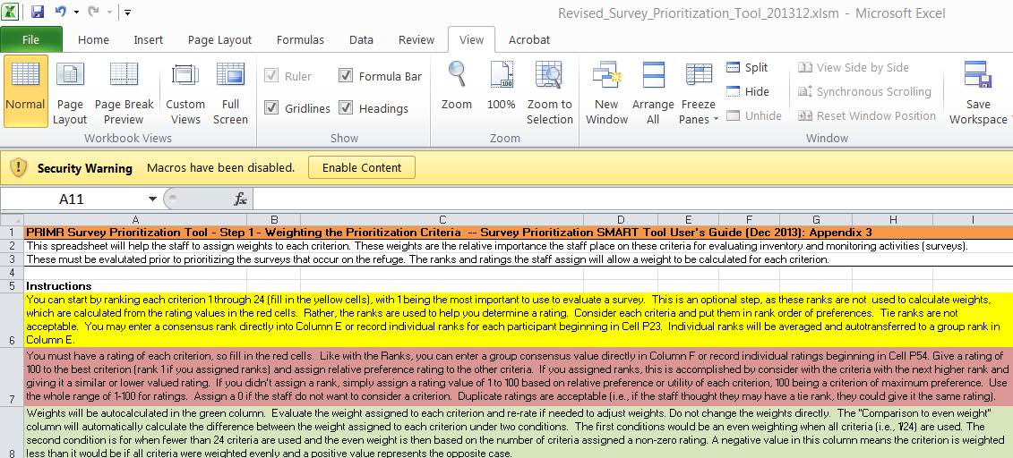
2. You may have to click Enable Content box to enable the functionality of the tool.

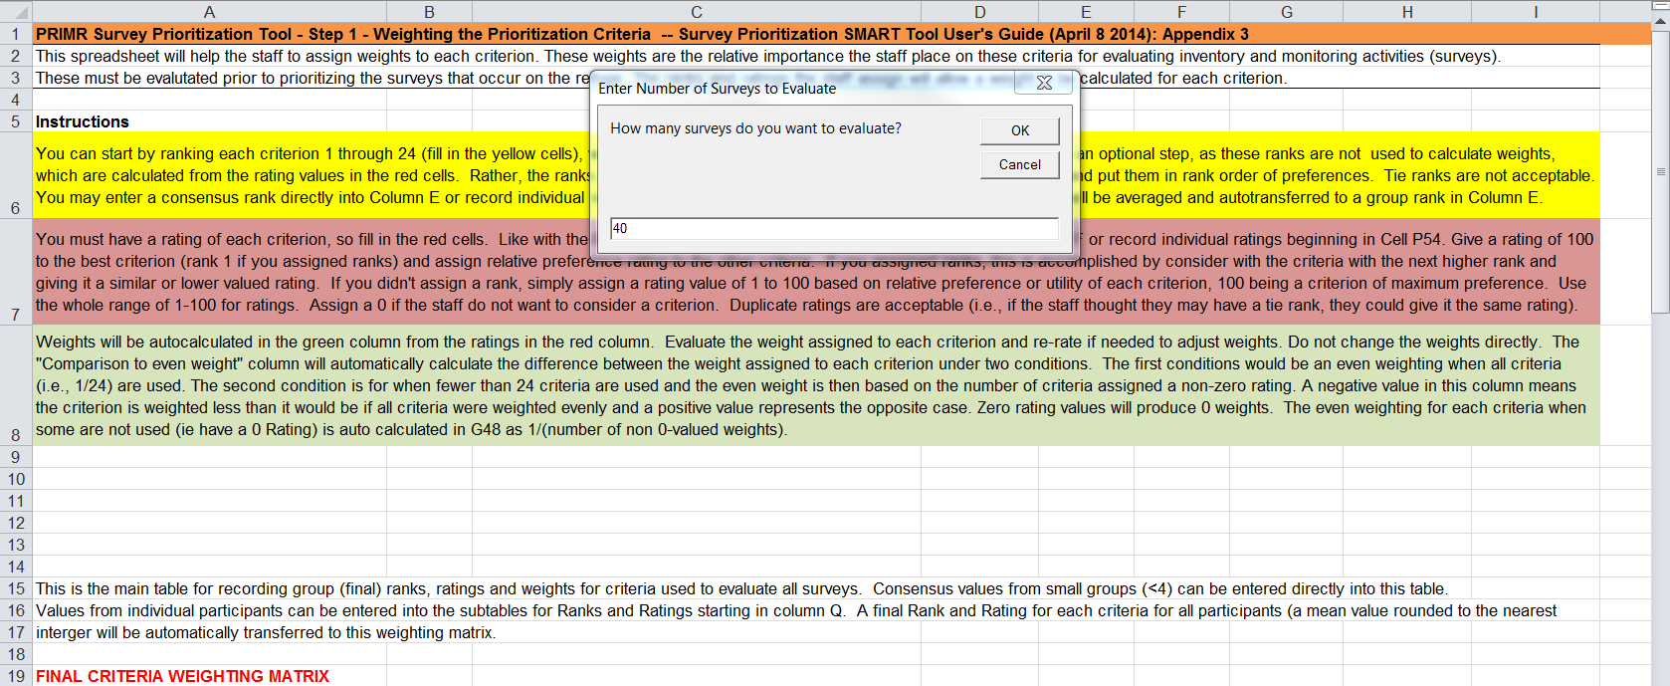
3. A second dialog box should appear asking how many surveys will be evaluated. Enter the number of surveys you will be prioritizing (see your comprehensive list). Example: 40.

The tool macros will create cells with formula for the entered number of surveys and you will be taken to the first worksheet (1_weight_criteria) for prioritizing your refuge’s surveys. These will be initially identified as Survey 1, Survey 2, etc. through to Survey n, where n = the number you entered in the dialog box. You can verify this by examining the second worksheet labeled 2_evaluate_surveys. Replace these generalized survey names with the formal name of each survey you will prioritize. It will be useful for someone (e.g., Refuge Biologist or IMP facilitator) to complete this step before the group begins the next steps. Save the file with refuge’s name and date in the file name (e.g., RachelCarsonNWR_Survey_Prioritization_20130318.xlsm). When reopening a saved version of the SMART Tool, click the x-box or answer ‘Cancel’ and ‘OK’ to any pop-up windows that ask about numbers of surveys. You will see a message box stating “No Surveys were Found”, which can disregard and cancel out.

4. The 1_weight_criteria tab allows users to rate the relative importance of the prioritization criteria. Follow the instructions at the top of the worksheet.

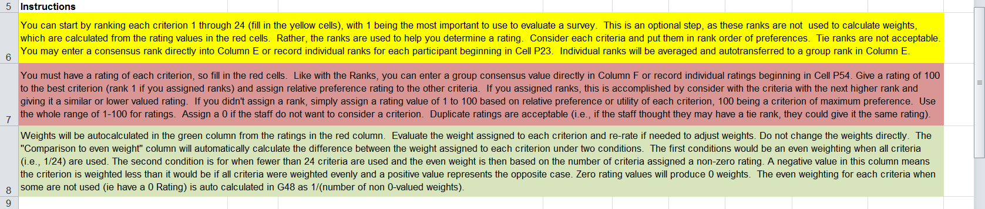

The criteria and survey scoring values are in Appendix 1. Additional guidance on assigning ranks, ratings and weights is in Appendix 2.

Note that you can fill out the cell values for Rank, Rating, or Weights columns in the Final Criteria
Weighting Matrix or by inputting participant values in the respective Consensus Helper subtables.
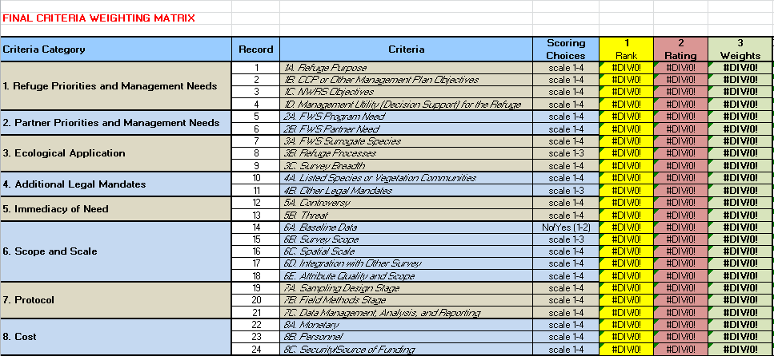

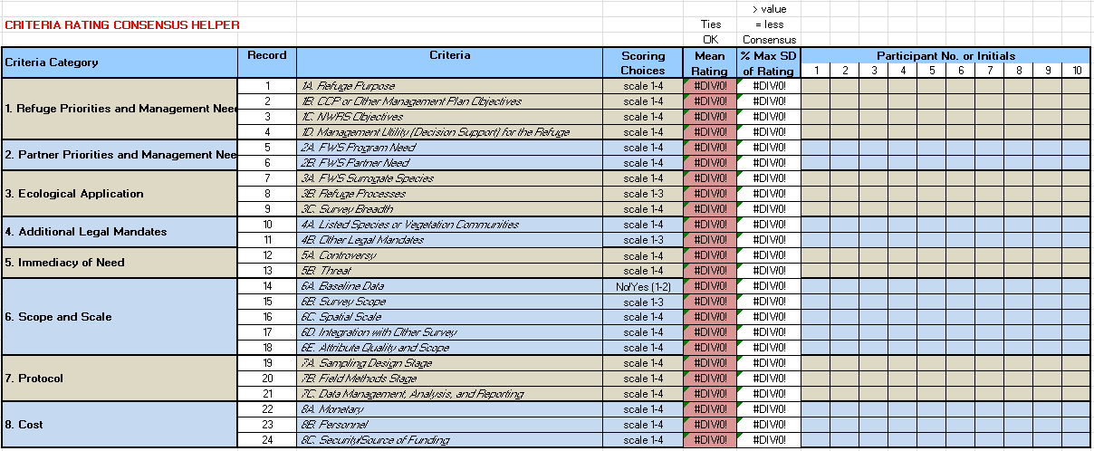
The formulas in the final matrix will retrieve the mean rank or rating from these subtables. The mean values are rounded to the nearest integer to match the precision of the participants original values. The subtables are set for a maximum of 10 participants. If more columns are needed, simply adjust the formula to calculate the rounded mean and SDs to include those additional columns.

You can use the % Max SD values to ascertain agreement in ranks or ratings among participants. A value of 50% or greater is a reasonable indication of less agreement and the possible need to revisit their scoring through open discussion.

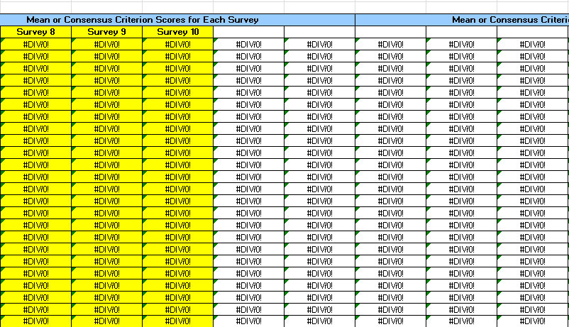
5. After the weights are determined and agreed upon, it may help users to gray-out the rows of the criteria that have a 0-weighted value on worksheets labeled 2_evaluate_surveys and 5_prioritization_output (Table 1). You may also delete the extra columns for unnamed, unneeded surveys, (i.e., not shaded yellow in the Evaluation Matrix) without influencing the calculations by the tool.

6. On the worksheets labeled 2_evaluate_surveys, see the Instructions and score each survey based on the written description of the non-zeroed criteria and scoring values described in Appendix 1.

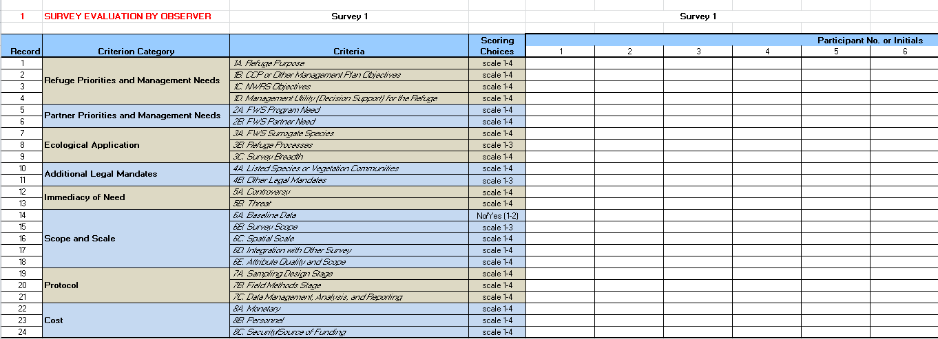
Note, as with ratings and ranks, individual participant scores can be recorded in subtables for each survey. Subtables can be found beneath the main Evaluation Matrix for All Surveys. Survey names should auto populate from the main matrix and rounded mean scores among participants will be calculated and transferred by the formula in the main matrix. You can replace participant numbers with names or initials on the first (or every) survey subtable if you want to record how each person scored a survey.

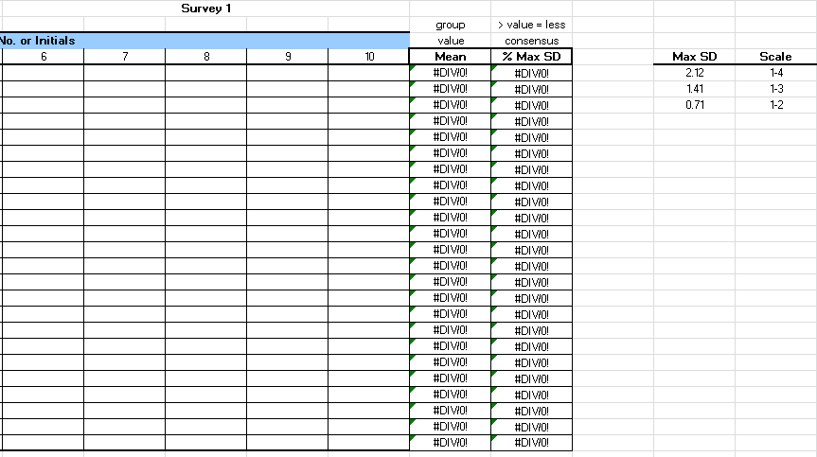
Percent maximum SDs can also be used to examine the variability within the group of evaluators (high values means less group consensus and scoring values > 50% of max SD are worth revisiting). These subtables are also set up for a maximum of 10 participants. If additional columns are needed for more participants, add them and then adjust the formulas for the mean and % Max SD in each subtable. Note that the maximum values are dependent on the scale of the criteria and are referenced to the right of the first survey subtable.

7. After the group is satisfied with the evaluation of all surveys go to the worksheet labeled 5_prioritization_output and view the final survey prioritization scores. Review the scores and discuss if they make sense given the weight and evaluation values assigned by the group.

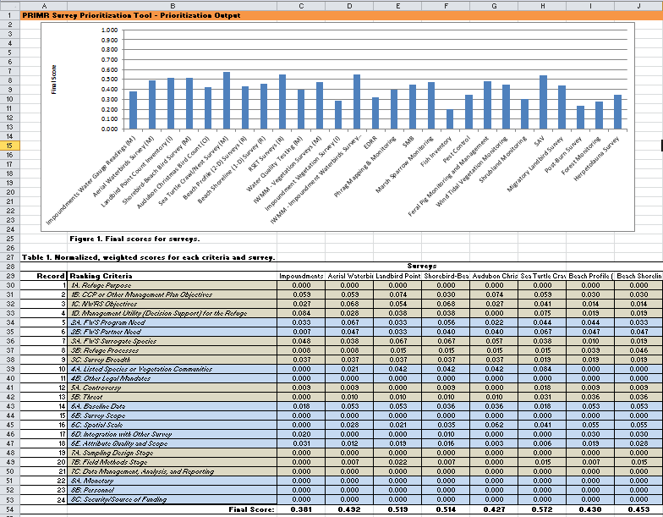

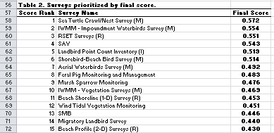

Scores sorted from highest to lowest values.

Final scores will be given in the output sorted from highest to lowest, producing a bar graph that is easier to interpret than earlier versions that were given by the order that the survey name was entered.
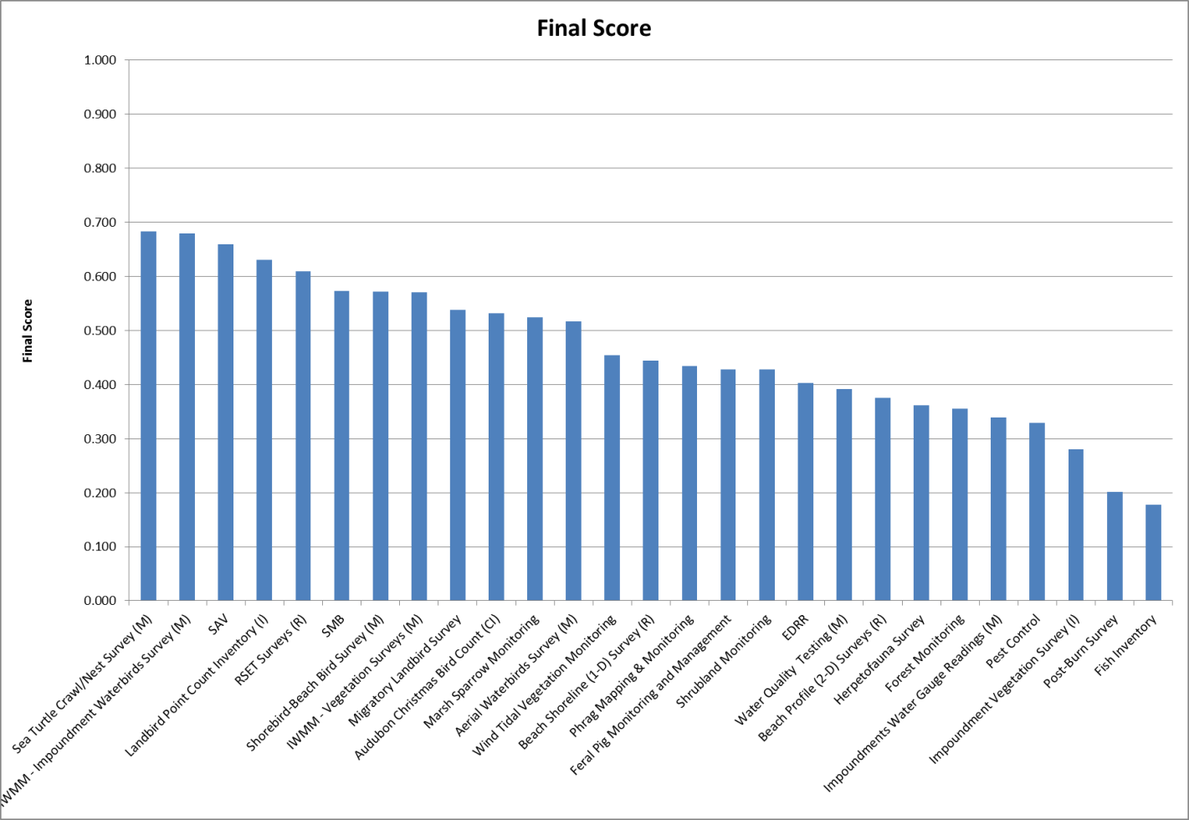

Strange values may signal corruption of formula values in the spreadsheet tool. Steps 3 and 4 are conducted in the background. To view these step products click on a new worksheet tab, then right- click on the tab, select unhide and then select background_calculations. Inspect the formula for used in each calculation table to determine if unusual values were caused by improper calculations.
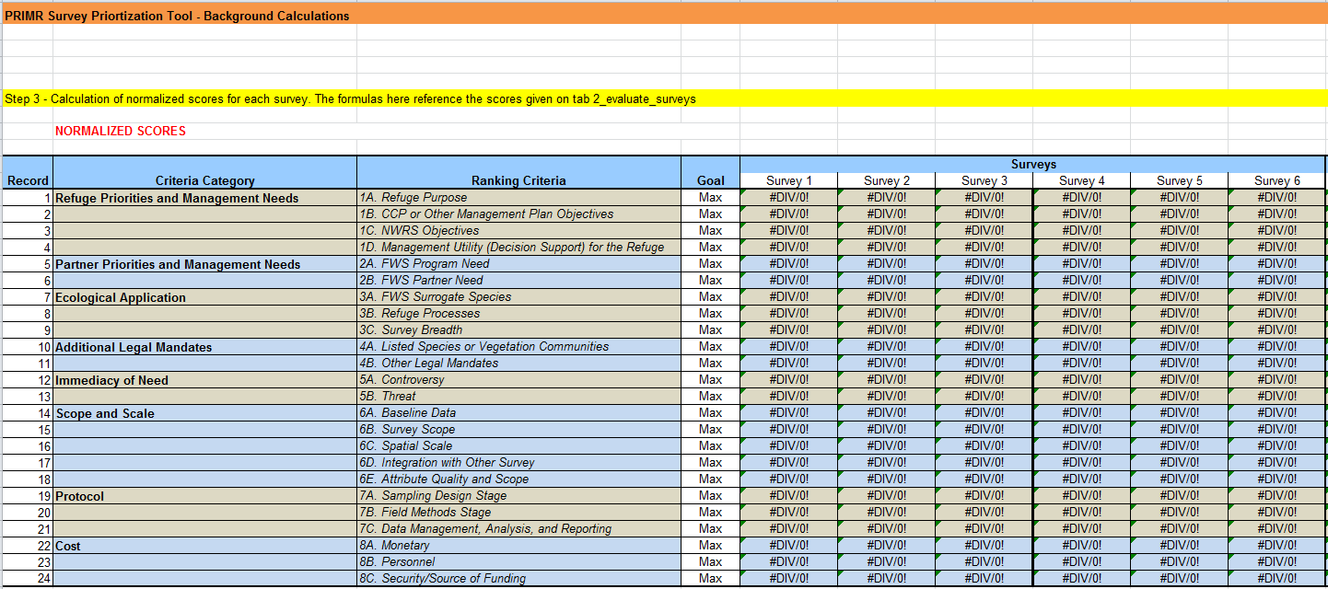

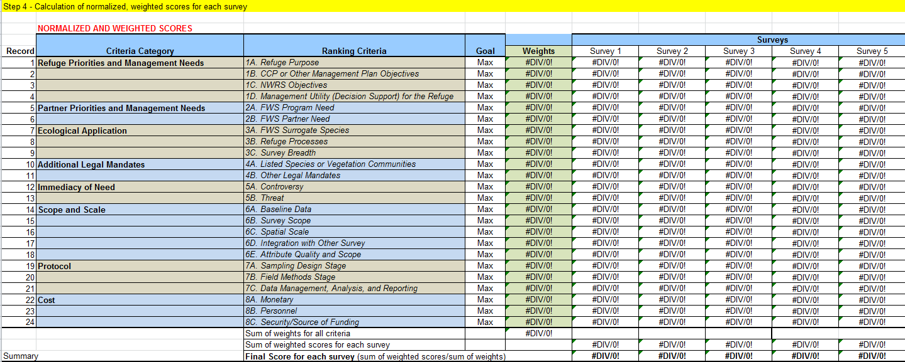

8. Save your work and progress to selecting surveys.
After prioritization scores have been accepted, the group will use the information to select surveys by assigning a survey status. The process may require an intermediate step whereby survey priority scores are assigned to three groups (high, medium, low). Once those groups are established, group members can assign the surveys to different Tiers by also considering the capacity (time, personnel, and money) to do the survey. The revised policy (701 FW 2: Exhibit 1, Section 2) gives an example of a 3-tiered classification based on priority and refuge capacity. The IMP Workbook (Chapter 6, in prep.) provides additional tips on selecting surveys after final priority scores have been calculated.

