The Effect of Water-Level Drawdown
on Methylmercury Production and Bioaccumulation
in the Agassiz Pool of the Agassiz National Wildlife Refuge

Final Report to the U.S. Fish and Wildlife Service

March 22, 2014

Daniel R. Engstrom
St. Croix Watershed Research Station
Science Museum of Minnesota
Marine on St. Croix, MN 55108

and

Kristofer R. Rolfhus
Department of Chemistry and Biochemistry
University of Wisconsin – La Crosse
La Crosse, WI 54601

ABSTRACT

The effects of water-level fluctuation on the production and bioaccumulation of methylmercury (MeHg) in a prairie-wetland ecosystem was investigated at the Agassiz National Wildlife Refuge in northwestern Minnesota, USA. MeHg concentrations in sediments and two bio-indicator organisms were followed for three years – before, during, and after management drawdown and re-flooding of the largest refuge wetland, the 40-km² Agassiz Pool. A nearby wetland not undergoing drawdown served as a control system. MeHg in brook sticklebacks (Culaea inconstans), amphipods (Gammarus lacustris), and surficial sediments of the Agassiz Pool rose markedly between 2009 (before water-level drawdown) and 2011 (after re-flooding), while the control pool showed no significant increases between years. The largest increases were observed in collections from shallow-water locations, presumably because microbial methylation following re-flooding was most active where sediments had dried and oxidized more completely during drawdown. The drying/wetting process likely altered the bioavailability of key reactants in the methylation process – principally sulfate, organic matter, and reactive inorganic mercury. This study, one of the first experimental evaluations of water-level effects on mercury cycling in a prairie wetland, demonstrates a risk for increased biotic mercury exposure that needs to be balanced against the habitat benefits of water-level management.

INTRODUCTION

Mercury (Hg) contamination of aquatic food webs is a widespread environmental problem linked in part to long-range atmospheric transport and deposition of Hg from industrial emission sources (Fitzgerald et al., 1998). A key step in the contamination process is the microbial conversion of inorganic Hg to its bioaccumulative form, methylmercury (MeHg) in lake and wetland sediments. Multiple environmental factors influence rates of methylation and biotic uptake such that Hg levels at higher trophic levels can vary widely among water bodies receiving similar regional inputs of atmospheric Hg (Wiener et al., 2006). Among factors known to increase MeHg production in lakes and wetlands are water-level fluctuations which alter chemical and microbial conditions in surface sediments by exposing them to drying and rewetting (Cowdery and Brigham, 2013; Gilmour et al., 2004; Munthe et al., 2007; Rumbold and Fink, 2006). This drying/wetting process alters the bioavailability of key reactants in the methylation process – principally sulfate, organic matter, and reactive inorganic Hg.

Although well documented in boreal systems (Porvari, 1998; Sorensen et al., 2005), the effects of water-level fluctuations on Hg methylation have received only limited attention in prairie regions where underlying hydrochemical conditions are quite different. Lakes and wetlands in mid-continental grasslands tend to undergo large seasonal oscillations in hydrologic water balance and are generally higher in dissolved solids than boreal lakes owing to a greater prevalence of easily weathered minerals in regional soils. Of particular relevance to MeHg production is the high concentrations of sulfate (from sulfide-mineral weathering) in surface waters and prairie wetlands of the northern Great Plains. At low concentrations sulfate can stimulate Hg methylation by increasing the metabolic activity of sulfate reducing bacteria (SRB) – an important group of Hg methylators – but inhibit it at higher concentrations by affecting Hg speciation and inter-cellular transport (Benoit et al., 1999; Gilmour et al., 1992). Fluctuating water levels have been shown to enhance the release of sulfate from bottom sediments, but in prairie wetlands with high ambient sulfate levels this process may not have the same stimulatory effect on Hg methylation observed in more sulfate-limited landscapes.

Water-level manipulation is a well-established management technique for habitat improvement for waterbird production at state and national wildlife refuges. However, there are concerns that enhanced mercury methylation and increased biotic exposure may be unintended consequences of such hydro-management. At the Agassiz National Wildlife Refuge in northwestern Minnesota, a water-level drawdown and re-flooding of the largest of the refuge wetlands, the Agassiz Pool (40 km²), allowed us to conduct a large-scale, multi-year experiment to evaluate the effects of water-level fluctuation on MeHg levels in key sectors of the aquatic food chain. A study of the previous drawdown of the Agassiz Pool, ten years prior, showed no measurable change in Hg levels in waterbirds or tree swallows (Custer and Custer, 2003; Custer et al., 2006). However, these higher trophic levels may be a less sensitive gauge of mercury exposure owing to their transitory use of the resource. Thus the current study focused on changing MeHg levels in bottom sediments and lower trophic levels (amphipods and forage fish) as potentially more responsive to local conditions and manipulation. Here we evaluate changes in MeHg levels in the Agassiz Pool over a three-year period (2009-2011), sampling before, during, and after water-table drawdown. A nearby wetland not undergoing drawdown served as a control system. The study represents one of the first experimental evaluations of water-level effects on mercury cycling in a prairie wetland ecosystem.

METHODS

Study Area
The Agassiz National Wildlife Refuge (ANWR) is a 250-km² wetland complex located ~70 km south of the US-Canadian border in northwestern Minnesota (48° 18’ N, 95° 59’ W). ANWR lies within the aspen parkland transition zone between tallgrass prairie to the west and boreal forest to the east and contains 26 impoundments (also referred to as pools or wetlands) and three natural lakes, comprising approximately 60% of the refuge area. Upland areas support a mosaic of woodland, shrubland, and prairie, while the surrounding landscape is given over to intensive row-crop agriculture. The refuge was established in 1937 and is managed primarily to support breeding and migratory waterfowl.

Field
Surface sediments and two bio-indictor organisms, amphipods and forage fish, were collected over a three year period, 2009-2011, from the Agassiz Pool and Headquarters Pool, a control wetland not undergoing drawdown. Each pool was sampled twice each year at four widely spaced locations – two at relatively deep-water sites (~ 1 m) and two in shallower water (~ 0.5 m) – during the summer season. Sampling sites were precisely relocated on each visit by GPS. Collection dates were largely dictated by the drawdown schedule for the Agassiz Pool. In 2009 and 2010 sampling occurred in mid and late summer, while in 2011, it was about one month earlier (Fig. 1). In 2010 during water-level drawdown of the Agassiz Pool (Oct. 2009- Oct. 2010), shallow-water sites were largely dry and biotic samples could be collected only from the deeper sites that retained some water.

Surface sediments (0-2 cm) were collected by push-corer, amphipods by dip net, and fish by baited minnow traps. On or about the same date as sediment/biotic sampling, a single grab sample of surface water for major ions, nutrients, and total organic carbon (TOC) was collected from each pool, and water temperature, dissolved oxygen (DO), turbidity, pH, and conductivity were measured by water-quality sonde. Sediment, amphipod, and fish samples were placed in polypropylene jars in the field and, together with the water samples, immediately frozen upon return to the ANWR field lab. Voucher specimens of amphipods were collected in 2009 and preserved in ethanol for later identification. Fifteen of these individuals were dissected and identified according to Holsinger (1976), and all were found to be Gammarus lacustris. There were no differences in species composition or size class distribution between the pools, though there were two distinct size classes represented in the collections. Brook stickleback (Culea inconstans), by far the most abundant forage fish caught in the minnow traps, were used as bio-indicators for fish-Hg.

Laboratory
Sediment: Organic content of sediments was estimated by mass loss on ignition (LOI) at 500° C (Heiri et al., 2001). Subsamples for Hg analysis were lyophilized in their plastic storage jars at -90 ºC until a constant mass was obtained, approximately four days. Sections were then homogenized with an acid-cleaned mortar and pestle, and frozen until analysis. Total mercury (Hg_{T}) in samples was measured with an adaptation of EPA Method 7473, utilizing approximately 0.2-0.3 g of lyophilized sample introduced into a Milestone DMA-80 automated analyzer. The instrument places the quartz sample boat into a combustion chamber in the presence of a catalyst, followed by purging of elemental Hg onto a gold-coated sand trap. The trap is then heated, releasing Hg into a cold vapor atomic fluorescence detector.

Methylmercury (MeHg) in sediment was determined by steam-distillation (removing possible matrix interferences), followed by cold vapor atomic fluorescence spectrophotometry (CVAFS). Approximately 0.3-0.6 g of lyophilized sediment, 90 mL water, 1.0 mL 25% (w/v) CuSO₄, 1.0 mL 50% (v/v) H₂SO₄, and 0.5 mL 25% (w/v) KCl was distilled at 120 ºC for approximately 5 hours in a temperature-controlled hot block, followed by collection of the distillate in a Teflon vial. Approximately 40 mL of the distillate, 30-50 μL of 1% (w/v) sodium tetraethylborate, and 400 μL of 2 M acetate buffer were added to a 40 mL autosampler vial and analyzed with a MERX-M Autosampler-analyzer (Brooks Rand). Briefly, the analytical method consists of purging the autosampler vial with N₂, releasing volatile ethylated Hg compounds into a GC column for separation, followed by thermal decomposition and analysis by CVAFS (Horvat et al., 1993; Olson et al., 1997).

For sediment Hg_{T}, method precision (relative standard deviation, RSD) based on triplicate analyses averaged 4.6%, recovery from spiked samples averaged 94%, and mean Hg_{T} concentration measured on MESS-3, a standard reference material (SRM), was within the certified range (91 ± 9 ng/g) (Table 1). For MeHg in sediments the mean RSD for three duplicate samples was 4.3%, while the RSD for a single triplicate sample near the detection limit was 25.2%. Mean recovery of MeHg from samples spiked prior to analysis was 109%.

Fish: Fish samples were processed and analyzed in a manner identical to sediments, except that the analytical mass was 0.020-0.050 g. Only total Hg was analyzed, as it is widely assumed that nearly 100% of fish-Hg is present as MeHg. Data are reported as whole-body concentrations (wet weight). Method precision (RSD) from triplicate analyses of homogenized fish averaged 3.9%, mean recovery of Hg from spiked samples was 91%, and average Hg_{T} concentrations measured on two SRMs (368 ng/g dw DORM-3 and 2636 ng/g dw DOLT-4) were well within the certified 95% confidence interval ranges (382 ± 60 and 2636 ± 220 ng/g dw, respectively) (Table 1). All concentrations exceeded the method detection limits for Hg_{T} and MeHg.

Amphipods: Both Hg_{T} and MeHg were determined in amphipod samples. For MeHg, 0.010-0.060 g of lyophilized, homogenized sample was added to a 22 mL Teflon vial, followed by 7.0 mL of 4.5 M HNO₃ (adapted from Hammerschmidt and Fitzgerald, 2005). Samples were then digested at 60 ºC for 12 h and allowed to cool. A 200-µL aliquot of sample, 200 µL of 4.5 M KOH, 30-50 μL of 1% (w/v) sodium tetraethylborate, 400 μL of 2 M acetate buffer, and deionized water were added to fill a 40 mL autosampler vial and analyzed with a MERX-M Autosampler-analyzer as described above.

Hg_{T} was determined by analyzing a sub-sample of the same digestate used for MeHg analysis. The digestate was oxidized by adding 2.0 mL of 0.2 M BrCl to the vial, followed by heating at 40 ºC for 12 h. After cooling, 1.0 mL of 12% w/v hydroxylamine hydrochloride was added and the digestate gently swirled until a color change was observed. A 1.0-mL aliquot was then added to a 40 mL MERX-T autosampler vial, followed by 100 µL of 12% w/v stannous chloride, and enough deionized water to fill the vial approximately half-full. The samples were then analyzed with a MERX-T autosampler instrument (Brooks Rand). Briefly, the elemental Hg liberated by Sn reduction is purged onto gold-coated sand traps, followed by CVAFS analysis.

Analytical results for analysis of Hg in amphipods was of similar quality to that for sediments and fish. Mean RSD on triplicate analyses was 1.2% for Hg_{T} and 9.8% for MeHg, recovery on spiked samples averaged 102% for Hg_{T} and 116% for MeHg, and mean concentrations on two SRMs (MUSS-2976 and TORT-2) were within the certified range for both Hg_{T} (61.0 ± 3.6 and 279 ± 60 ng/g dw, respectively) and MeHg (27.8 ± 1.1 ng/g dw and 152 ± 13 ng/g, respectively). All concentrations exceeded our calculated detection limits (Table 1).

Water chemistry: Unfiltered, whole water samples were measured for major cations (Ca, Mg, Na, K), total-Si, and minor elements (Sr, Ba), by inductively coupled plasma mass-spectrometry (ICP-MS). Filtered subsamples for anions (SO₄²⁻, Cl⁻, F⁻, PO₄³⁻, NO₃⁻) were measured by ion chromatography, and TOC was measured on a UV-persulfate carbon analyzer. Alkalinity was determined by fixed end-point titration. Method precision (mean RSD) was less than 1% for all anions except phosphate (3%), and less than 1% for TOC measurements and all elements measured by ICP-MS. RSD on duplicate alkalinity measurements averaged 5%.

RESULTS

Site Conditions
Four sampling stations established in each of the two pools were visited twice in each of the three study years for collection of samples for Hg analysis. At the same time, field parameters were measured and water samples collected to assess background environmental conditions. The study design called for two replicate sites to be established at “deep” and “shallow” locations in each pool. Water depths (prior to drawdown of the Agassiz Pool) were between 0.75 and 0.95 m at the deep sites, and between 0.5 and 0.6 m at the shallow sites (Fig. 1), with the exception of one shallow site in Headquarters (HQ) Pool which was moved into deeper water on the second sampling date in 2009. With the drawdown of the Agassiz (AG) Pool in 2010, the two shallow sites became effectively dry (though the mud surface remained wet at times), while the two deep sites saw water levels drop to 0.2-0.3 m. Water levels rebounded at the AG sample sites when the pool was re-flooded in 2011, but to shallower depths than present in 2009 prior to drawdown. Water temperature at the time of each sampling was similar between the two pools, but varied seasonally, with warmest conditions in early August-2010 (26-27° C) and coolest during site visit in September-2010 (13.4-16.6° C) (Fig. 1). Dissolved oxygen followed a generally opposite trend with temperature, with lowest values in August 2010 and late July 2011 (Fig. 1). The 2011 DO values were especially low at the shallow AG sites (~1 ppm), possible reflecting increased oxygen demand associated with re-flooding.

Water chemistry showed some differences between the two pools, with HQ having higher dissolved solids overall (Table 2, Fig. 1). Conductivity, representing general ionic strength, was 400 ± 67 µS/cm (mean ± 1 s.d.) in AG and 652 ± 105 µS/cm in HQ, but varied from year to year such that on some sampling dates the two pools were more similar (e.g. 9/16/10). Alkalinity and other major ions showed parallel trends with conductivity, rising in AG with the drawdown in 2010 and declining in HQ that same year. The average alkalinity during the entire study period was 115 ± 21 mg CaCO₃/L in AG and 159 ± 24 mg CaCO₃/L in HQ. Among major ions, Ca⁺² in HQ was about twice that in AG (94 vs. 46 ppm), while SO₄⁻², an important control on mercury methylation, was 80 ± 30 ppm in AG and 182 ± 59 in HQ. These sulfate levels are typical of surface waters in western Minnesota but more than order of magnitude greater than those in boreal lakes and wetlands immediately to the east (Gorham et al., 1983).

Mercury Trends
Concentrations of methylmercury (MeHg) in brook sticklebacks (Culaea inconstans), amphipods (Gammarus lacustris), and sediments differed between the two pools and showed marked trends over time, especially in AG where changes appear to be associated with management drawdown and re-flooding. MeHg levels were generally higher in HQ as compared to AG for all three compartments, but showed no significant changes between years. In contrast, MeHg levels in AG increased markedly in sediments, amphipods, and fish between 2009 and 2011, before and after water-level drawdown.

Sediments: Concentrations of total-Hg (Hg_{T}) and MeHg in the surface sediments of both of the two pools showed substantial variability over time at each sampling station and on any given sampling date (Table 3). Part of this variability is a function of differences in sediment composition, particularly organic matter content, which varies with water depth, wave exposure, and other factors that affect the transport and deposition of sediments. Mercury is generally bound to fine-grained organic matter and is thus depleted in sediments that are high in coarse-grained mineral matter. This condition is illustrated for the ANWR pool sediments by the strong correlation between % loss-on-ignition (LOI) and Hg_{T} and MeHg concentrations for each of the three study years (Fig. 2). The relationship is weaker for %MeHg (the fraction of Hg_{T} present as MeHg), which tends to normalize differences due to sediment matrix, and for MeHg in 2009, a year with less overall variability.

In order to factor out differences in Hg concentrations owing to sediment composition, MeHg and Hg_{T} concentrations were normalized to %LOI and expressed as ng/g organic matter. While this convention removes some of the effects of sediment-matrix differences, there remains substantial variation in Hg concentration, even among sites within a given pool (Table 3). Nonetheless, some clear patterns emerge from the data. First, there is little difference between pools or among years in the Hg_{T} concentrations in sediments (Fig. 3). Mean Hg_{T} concentrations for each of the three study years ranged between 213 and 268 ng/g OM in HQ and from 218 to 254 ng/g OM in AG (Table 3). These concentrations, expressed on a dry-weight basis (28-36 ng/g), are in the same range as those reported for five prairie wetlands in the nearby Glacial Ridge National Wildlife Refuge (GRNWR) (range of 11-86 ng/g, Cowdery and Brigham, 2013) and 44 wetlands in the Lostwood National Wildlife Refuge (LNWR) of North Dakota (range of 7-99 ng/g, Sando et al., 2007).

Second, MeHg concentrations (and %MeHg) show some differences between pools owing to higher values in the shallow-water sites in HQ, although pool-wide averages are not significantly different for any of the study years owing to high variability (Fig. 3). Mean values for MeHg concentration range from 3.31 to 5.01 ng/g OM in HQ and 1.16 to 2.30 ng/g OM in AG, while means for %MeHg range between 1.51 and 2.07% in HQ and 0.45 and 1.74% in AG (Table 3). MeHg concentrations and %MeHg are also similar to those reported for the LNWR (Sando et al., 2007), but slightly lower than for the GRNWR) (median of 3% MeHg, Cowdery and Brigham, 2013). The high variability in HQ sediments is largely a result of large differences between shallow- and deep-water sites (Fig. 4). Shallow HQ sediments have higher MeHg concentrations than those from deep sites in all years, and while variability is high, this difference is statistically significant in 2010 (t = 3.66, p = 0.01) and nearly so in 2011 (t = 2.03, p = 0.88). In contrast, deep and shallow sites in AG have similar MeHg concentrations, which are also in the same range as deep sites in HQ. A similar pattern is evident when MeHg concentrations are normalized to Hg_{T} (%MeHg) (Fig. 3, 4).

Third, there is a significant uptick in MeHg in the Agassiz Pool sediment between 2009 (before drawdown) and 2011 (after re-flooding) (Fig. 3). MeHg concentrations increase from 1.16 ± 0.98 ng/g OM (mean ± 1 s.d.) in 2009 to 3.50 ± 1.89 ng/g OM in 2010, and then decline slightly in 2011 (2.30 ± 1.43 ng/g OM). The increase between 2009 and 2010 is highly significant whether MeHg is expressed as a concentration or as %MeHg (t = 3.4, p = 0.004 for both metrics). The difference between 2009 and 2011 is just significant at the 95% confidence level. In contrast, HQ sediments show no significant differences among years in either MeHg concentration or %MeHg, whether considering whole-pool averages or shallow and deep sites separately.

Amphipods: Mercury was present in amphipods (G. lacustris) largely as MeHg, and there was little difference in %MeHg between pools or among years. Over the three study years MeHg ranged between 72% and 82% and 71% and 94% of Hg_{T} in HQ and AG, respectively (Table 3). Hence, patterns for Hg_{T} follow closely those of MeHg, and only MeHg concentrations are discussed further. Mean values for MeHg in each of the three study years ranged between 23 and 69 ng/g in HQ and 27 and 54 ng/g in AG. These values are similar to those reported for gastropods (45 ± 30 ng/g) from prairie wetlands in Saskatchewan, but substantially lower than MeHg concentrations in predaceous invertebrates (dragonfly nymphs, diving beetles, and backswimmers; ~ 200 ± 100 ng/g) from the same systems (Bates and Hall, 2012). Such differences likely reflect the lower trophic position occupied by amphipods and snails.

The primary trend observed for amphipods was an increase in MeHg concentration in AG and a concurrent decline in collections from HQ (Fig. 3). The AG increase between 2009 and 2011 was not significant in whole-pool averages (t = 1.76, p = 0.10, but was so in collections from the shallow-water sites (t = 2.59, p = 0.05) (Fig. 4). Although MeHg in 2010 collections from AG showed no change over 2009 values, only deep-water sites (where water depth was reduced to 0.2-0.3 m) were visited in that year, as the shallow sites were dry at the time. The opposing trend in HQ – a statistically significant decline in the pool-wide average (t = 2.54, p = 0.02) – was manifested largely as a decrease in MeHg in shallow-water collections between 2009 and 2010 (Fig. 4). The reasons for this decline in HQ are uncertain.

Fish: Concentrations of Hg_{T} in sticklebacks (C. inconstans) showed the clearest trends of any of the three indicators over the study. Collections from the control site, HQ, showed no significant change among years, while those from AG doubled between 2009 and 2011 from 94 ± 31 ng/g to 188 ± 53 ng/g wet weight, an increase that was highly significant (t = 5.33, p < 0.0001) (Table 3, Fig. 3). While Hg_{T} concentrations in AG also appeared to rise between 2009 and 2010, few fish were collected during drawdown in 2010 (only two samples), and the increase was not significant. In 2009, prior to drawdown, AG fish were substantially lower in Hg than those in HQ (t = 5.16, p <0.0001), while following re-flooding in 2011, they were higher, though the difference was not quite significant (t = 2.08, p =0.06) (Table 3). And the most striking change in AG occurred in the fish collections from the shallow-water sites. In 2009 fish from shallow sites were significantly lower in Hg than those from deeper sites (t = 2.12, p = 0.05), while the situation was reversed in 2011 (t = 3.45, p = 0.02) (Fig. 4).

Hg_{T} levels in ANWR sticklebacks were at the high end of the range reported for 1-year old yellow perch (Perca flavescens) in lakes from Voyageurs National Park, Minnesota (98 ± 40 ng/g) (Wiener et al., 2006). Sticklebacks and 1-year old yellow perch occupy similar trophic positions, feeding on zooplankton and small benthic invertebrates. However, stickleback age was not determined, and older individuals with greater accumulated body burdens were likely included in the collections. Concentrations of Hg_{T} in sticklebacks have not been systematically measured in other systems to our knowledge.

DISCUSSION

All three sampled compartments, sediments, amphipods, and fish, showed measurable increases in MeHg concentration following drawdown and re-flooding of the Agassiz Pool (AG). Despite high variability among sampling dates and sites within the pool, the changes were statistically significant and most strongly expressed at shallow-water sites where aerial exposure of the sediment surface was more effective. In contrast, Headquarters Pool (HQ) showed no increases in any of the compartments between 2009 and 2011, and in the amphipod samples, MeHg actually declined substantially over the course of the study. Although HQ is not a perfect control for AG – it has higher dissolved solids, alkalinity, and sulfate – average MeHg concentrations in sediments, amphipods, and fish were largely similar between the two pools, suggesting similar potential for Hg methylation and its response to year-to-year environmental variability. Thus the striking difference in trends between the pools and the consistency of the increase among compartments in AG strongly suggest that water-level manipulation was responsible for the observed rise in MeHg levels in the Agassiz Pool.

Water-level fluctuations are known to enhance Hg methylation in other aquatic systems, most notably reservoirs with seasonal drawdowns for hydropower generation (Porvari, 1998; Sorensen et al., 2005) and wetlands with climate-driven changes in water-table elevation (Orem et al., 2011). These effects have been observed at multiple levels in the aquatic food chain and verified by water-level manipulations in experimental systems (Gilmour et al., 2004; Rumbold and Fink, 2006). The mechanisms thought to be responsible for enhancing Hg methylation include regeneration of sulfate by oxidation of reduced sulfur species (inorganic and organic) with aerial exposure of previously saturated (and anoxic) sediments or peat (Orem et al., 2011). The released sulfate is needed for metabolism by sulfate-reducing bacteria (SRB), which are thought to be the chief Hg methylators in most aquatic systems (Benoit et al., 1999; Branfireun et al., 1999; Gilmour et al., 1992), although other groups of bacteria, including iron reducers, have the potential to methylate Hg (Parks et al., 2013). A similar mechanism for increased Hg methylation involves the release of inorganic Hg from the sediments (Gilmour et al., 2004), possibly driven by oxidation of organic matter or sulfides that otherwise bind Hg. The bioavailability of inorganic Hg exerts a first-order control on microbial methylation rates (Munthe et al., 2007). A third possible mechanism involves aerobic decomposition of recalcitrant organic matter with sediment exposure and release of more labile forms upon re-flooding. Hg methylation by SRB has been shown to be limited by the availability of organic carbon in some systems (Mitchell et al., 2008). Exactly which process was most critical for the observed rise in MeHg in the Agassiz Pool is not clear. However, the moderately high sulfate levels in ANWR surface waters would suggest that sulfate itself may not limit MeHg production and that increased availability of either labile organic matter or reactive inorganic mercury may be responsible.

Regardless of the process(es) involved, the rise in MeHg levels with water-table manipulation of the Agassiz Pool represents an important documentation of water-level effects on Hg methylation and biotic uptake in a prairie-wetland ecosystem. High surface-water concentrations of MeHg (upwards of 20 ng/L) were reported recently from newly created prairie wetlands in the nearby Glacial Ridge National Wildlife Refuge, although, biotic indicators were not measured in that study (Cowdery and Brigham, 2013). Most prior studies of water-level effects have involved systems located in low-sulfur landscapes such as ombrotrophic wetlands and boreal lakes. The observation that water-level fluctuations in prairie wetlands can increase biotic exposure to MeHg is important for understanding the effects of natural hydrologic variation as well as those associated with wetland management.

Increased Hg methylation over a relatively short time span, as documented here for the ANWR, is an unintended consequence of well-accepted management techniques for controlling invasive vegetation and enhancing overall wetland quality for support of waterfowl populations. The fact that it manifests in higher Hg levels in amphipods and small fish, which are important food organisms for waterbirds, might be initially alarming. However, the study reported here was of short duration and includes but a single post-drawdown year. It is quite possible that the observed rise in MeHg is very transitory and that MeHg levels in biota will return to pre-drawdown conditions in just a few more seasons as limiting reactants (sulfate, organic matter, reactive-Hg) are gradually depleted. A previous study of Hg levels in waterbirds and tree swallows at ANWR showed no measurable increases following an earlier drawdown of the Agassiz Pool in 2000 (Custer and Custer, 2003; Custer et al., 2006). Such results suggest that the effects of water-level drawdown are either short lived or that the MeHg increases are rather small and do not register in wildlife that can forage over multiple wetlands. Indeed, the MeHg increases observed in sediments and food organisms in the Agassiz Pool, while statistically significant, are relatively modest and do not greatly exceed concentrations measured in the Headquarters control pool over the course of the study. Overall, results of this investigation confirm the anticipated risk that water-level manipulations might increase biotic mercury exposure, a concern that needs to be balanced against the habitat benefits associated with water-level management.

ACKNOWLEDGEMENTS

Field sampling for this project was carried out by Gregg Knutsen and staff of the Agassiz National Wildlife Refuge. Toben LaFrancois (SCWRS) assisted in the development of field protocols and provided taxonomic identification of amphipod collections, and Jill Coleman Wasik coordinate water-chemistry analyses at the SCWRS. Funding for the research was provided by the U.S. Fish and Wildlife Service.

REFERENCES

Bates, L.M., Hall, B.D., 2012. Concentrations of methylmercury in invertebrates from wetlands of the Prairie Pothole Region of North America. Environ. Pollut. 160, 153-160.
Benoit, J.M., Gilmour, C.C., Mason, R.P., Heyes, A., 1999. Sulfide controls on mercury speciation and bioavailability to methylating bacteria in sediment pore waters. Environ. Sci. Technol. 33, 951-957.
Branfireun, B.A., Roulet, N.T., Kelly, C.A., Rudd, J.W.M., 1999. In situ sulphate stimulation of mercury methylation in a boreal peatland: toward a link between acid rain and methylmercury contamination in remote environments. Glob. Biogeochem. Cycles 13, 743-750.
Cowdery, T.K., Brigham, M.E., 2013. Mercury in wetlands at the Glacial Ridge National Wildlife Refuge, northwestern Minnesota, 2007-9: Scientific Investigations Report 2013-5068. U.S. Geological Survey, Reston, VA.
Custer, C.M., Custer, T.W., 2003. Exposure and effects of metal accumulations by wildlife on Agassiz National Wildlife Refuge. U.S. Geological Survey, Upper Midwest Environmental Sciences Center, La Crosse, WI, pp. 1-107.
Custer, C.M., Custer, T.W., Warburton, D., Hoffman, D.J., Bickham, J.W., Matson, C.W., 2006. Trace element concentrations and bioindicator responses in tree swallows from northwestern Minnesota. Environ. Monit. Assess. 118, 247-266.
Fitzgerald, W.F., Engstrom, D.R., Mason, R.P., Nater, E.A., 1998. The case for atmospheric mercury contamination in remote areas. Environ. Sci. Technol. 32, 1-7.
Gilmour, C., Krabbenhoft, D., Orem, W.H., Aiken, G., 2004. Appendix 2B-1: Influence of drying and rewetting on mercury and sulfur cycling in everglades and STA soils. Everglades Consolidated Report. South Florida Water Management District, West Palm Beach, FL.
Gilmour, C.C., Henry, E.A., Mitchell, R., 1992. Sulfate stimulation of mercury methylation in freshwater sediments. Environ. Sci. Technol. 26, 2881-2887.
Gorham, E., Dean, W.E., Sanger, J.E., 1983. The chemical composition of lakes in the north-central United States. Limnol. Oceanogr. 28, 287-301.
Hammerschmidt, C.R., Fitzgerald, W.F., 2005. Methylmercury in mosquitoes related to atmospheric mercury deposition and contamination. Environ. Sci. Technol. 39, 3034-3039.
Heiri, O., Lotter, A.F., Lemcke, G., 2001. Loss on ignition as a method for estimating organic and carbonate content in sediments: reproducibility and comparability of results. J. Paleolimnol. 25, 101-110.
Holsinger, J.R., 1976. The Freshwater Amphipod Crustaceans (Gammaridae) of North America, 2nd ed. WPCRS 18050 ELD04/72. U.S. Environmental Protection Agency.
Horvat, M., Liang, L., Bloom, N.S., 1993. Comparison of distillation with other current isolation methods for the determination of methyl mercury compounds in low level environmental samples. Part II. Water. Anal. Chim. Acta 282, 153-168.
Mitchell, C.P.J., Branfireun, B.A., Kolka, R.K., 2008. Assessing sulfate and carbon controls on net methylmercury production in peatlands: an in situ mesocosm approach. Appl. Geochem. 23, 503-518.
Munthe, J., Bodaly, R.A., Branfireun, B.A., Driscoll, C.T., Gilmour, C.C., Harris, R., Horvat, M., Lucotte, M., Malm, O., 2007. Recovery of mercury-contaminated fisheries. Ambio 36, 33-44.
Olson, M.L., Cleckner, L.B., J.P., H., Krabbenhoft, D.P., Heelan, T.W., 1997. Resolution of matrix effects on analysis of total and methyl mercury in aqueous samples from the Florida Everglades. Fresenius J. Anal. Chem. 358, 392-396.
Orem, W.H., Gilmour, C., Axlelrad, D., Krabbenhoft, D., Scheidt, D., Kalla, P., McCormac, P., Gabriel, M., Aiken, G., 2011. Sulfur in the south Florida ecosystem: distribution, sources, biogeochemistry, impacts, and management for restoration. Crit. Rev. Environ. Sci. Technol. 41(S1), 249-288.
Parks, J.M., Johs, A., Podar, M., Bridou, R., Hurt, R.A., Smith, S.D., Tomanicek, S.J., Qian, Y., Brown, S.D., Brandt, C.C., Palumbo, A.V., Smith, J.C., Wall, J.D., Elias, D.A., Liang, L., 2013. The genetic basis for bacterial mercury methylation. Science 339, 1332-1335.
Porvari, P., 1998. Development of fish mercury concentrations in Finnish reservoirs from 1979 to 1994. Sci. Tot. Environ. 213, 279-290.
Rumbold, D.G., Fink, L.E., 2006. Extreme spatial variability and unprecedented methylmercury concentrations within a constructed wetland. Environ. Monit. Assess. 112, 115-135.
Sando, S.K., Krabbenhoft, D.P., Johnson, K.M., Lundgren, R.F., Emerson, D.G., 2007. Mercury and methylmercury in water and bottom sediments of wetlands at Lostwood National Wildlife Refuge, North Dakota, 2003-04: Scientific Investigations Report 2007–5219. U.S. Geological Survey, Reston, VA.
Sorensen, J.A., Kallemeyn, L.W., Sydor, M., 2005. Relationship between mercury accumulation in young-of-the-year yellow perch and water-level fluctuations. Environ. Sci. Technol. 39, 9237-9243.
Wiener, J.G., Knights, B.C., Sandheinrich, M.B., Jeremiason, J.D., Brigham, M.E., Engstrom, D.R., Woodruff, L.G., Cannon, W.F., Balogh, S.J., 2006. Mercury in soils, lakes, an fish in Voyageurs National Park (Minnesota): importance of atmospheric deposition and ecosystem factors. Environ. Sci. Technol. 20, 6281-6286.

Table 1. Quality assurance (QA) summary for mercury analyses

Sediment Hg_{T} QA |  | n | Mean | Cert. Range
Detection Limit (ng/g dw) |  | 6 | 3.0
% Recovery on spiked samples |  | 18 | 94.5
% CV on Triplicates |  | 6 | 4.6
Standard Reference Materials
ng/g dw | MESS-3 | 9 | 90.0 | 91 ± 9
Sediment MeHg QA |  | n | Mean
Detection Limit (ng/g dw) |  | 3 | 0.007
% Recovery on spiked samples |  | 4 | 109
% Difference on Duplicates |  | 3 | 4.3
% CV on Triplicates |  | 1 | 25.2* | *sample near detection limit
Fish Hg_{T} QA |  | n | Mean | Cert. Range
Detection Limit (ng/g dw) |  | 6 | 10.8
% Recovery on spiked samples |  | 21 | 91.4
% CV on Triplicates |  | 6 | 3.86
Standard Reference Materials
ng/g dw | DORM-3 | 6 | 368 | 382 ± 60
ng/g dw | DOLT-4 | 6 | 2636 | 2580 ± 220
Amphipod Hg_{T} QA |  | n | Mean | Cert. Range
Detection Limit (ng/g dw) |  | 2 | 8.0
% Recovery on spiked samples |  | 2 | 115.7
% CV on Triplicates |  | 1 | 1.2
Standard Reference Materials
ng/g dw | MUSS 2976 | 5 | 59.9 | 61.0 ± 3.6
ng/g dw | TORT-2 | 5 | 295.0 | 270 ± 60
Amphipod MeHg QA |  | n | Mean | Cert. Range
Detection Limit (ng/g dw) |  | 2 | 1.1
% Recovery on spiked samples |  | 2 | 102.5
% CV on Triplicates |  | 5 | 9.8
Standard Reference Materials
ng/g dw | MUSS 2976 | 6 | 24.6 | 27.8 ± 1.1
ng/g dw | TORT-2 | 6 | 148.6 | 152 ± 13

Table 2. Average water quality conditions in Headquarters Pool (control) and Agassiz Pool (drawdown) during summer sampling, 2009-2011.

 |  | Headquarters |  | Agassiz
Measure | Units | Mean | SD | Mean | SD
pH |  | 8.36 | 0.76 | 8.11 | 1.04
Cond | µS/cm | 652 | 105 | 400 | 67
Temp | °C | 21.7 | 4.8 | 21.3 | 2.9
DO | mg/L | 8.3 | 1.7 | 8.6 | 3.1
Turbidity | NTU | 17.7 | 7.4 | 8.6 | 8.2
TOC | mg C/L | 21.7 | 2.1 | 19.0 | 3.1
Alkalinity | mg CaCO₃/L | 158.9 | 23.8 | 115.0 | 21.2
SO₄ | ppm | 181.9 | 58.9 | 79.7 | 30.5
Cl | ppm | 5.5 | 1.7 | 7.7 | 5.8
F | ppb | 139.1 | 15.1 | 137.8 | 42.0
PO₄-P | ppb | 47.1 | 21.6 | 15.2 | 3.2
NO₃-N | ppb | 263.8 | 160.0 | 63.1 | 52.8
Ca | ppm | 93.8 | 17.9 | 46.2 | 17.6
Mg | ppm | 33.3 | 7.5 | 20.4 | 3.9
Na | ppm | 5.5 | 1.3 | 3.2 | 0.9
K | ppm | 6.9 | 1.8 | 2.0 | 0.3
Si | ppm | 3.76 | 1.49 | 1.70 | 1.26
Sr | ppb | 211.0 | 40.8 | 108.9 | 29.1
Ba | ppb | 43.6 | 7.7 | 24.8 | 8.7

Table 3. Annual means (± 1 s.d.) and medians for mercury levels in sediments, amphipods (Gammarus), and fish (sticklebacks) in the Headquarters and Agassiz pools, 2009 – 2011.

Sediments | Headquarters Pool |  |  | Agassiz Pool
Hg_{T} (ng/g DM) | mean | s.d. | median | mean | s.d. | median
2009 | 28.0 | 18.4 | 24.0 | 34.6 | 11.3 | 33.7
2010 | 35.3 | 28.6 | 21.8 | 34.9 | 15.1 | 38.1
2011 | 36.1 | 21.2 | 28.1 | 31.4 | 10.4 | 33.3
Hg_{T} (ng/g OM)
2009 | 213 | 88 | 235 | 218 | 39 | 208
2010 | 218 | 47 | 213 | 243 | 103 | 211
2011 | 268 | 138 | 230 | 254 | 101 | 211
MeHg (ng/g DM)
2009 | 0.46 | 0.44 | 0.33 | 0.14 | 0.11 | 0.12
2010 | 1.15 | 1.70 | 0.33 | 0.71 | 0.57 | 0.79
2011 | 1.02 | 1.61 | 0.17 | 0.37 | 0.36 | 0.20
MeHg (ng/g OM)
2009 | 3.31 | 2.73 | 2.62 | 1.16 | 0.98 | 0.75
2010 | 5.01 | 5.09 | 2.91 | 3.50 | 1.89 | 3.58
2011 | 3.86 | 4.27 | 2.38 | 2.30 | 1.43 | 2.02
%MeHg
2009 | 1.74 | 1.51 | 1.03 | 0.45 | 0.41 | 0.35
2010 | 2.07 | 1.96 | 1.46 | 1.74 | 1.10 | 1.95
2011 | 1.78 | 2.14 | 0.77 | 1.04 | 0.81 | 0.63
Amphipods | Headquarters Pool |  |  | Agassiz Pool
Hg_{T} (ng/g) | mean | s.d. | median | mean | s.d. | median
2009 | 99.7 | 51.5 | 84.2 | 45.9 | 18.0 | 40.9
2010 | 51.0 | 27.3 | 46.9 | 28.8 | 12.3 | 28.9
2011 | 36.7 | 15.3 | 36.1 | 64.6 | 50.4 | 42.4
MeHg (ng/g)
2009 | 69.3 | 48.8 | 55.8 | 29.8 | 8.6 | 30.0
2010 | 39.6 | 22.3 | 27.2 | 27.1 | 13.3 | 23.6
2011 | 23.2 | 15.8 | 21.7 | 53.5 | 37.2 | 40.3
%MeHg
2009 | 72.1 | 31.3 | 77.4 | 70.7 | 24.1 | 73.7
2010 | 81.9 | 7.5 | 84.9 | 94.5 | 19.0 | 95.5
2011 | 62.6 | 27.4 | 67.4 | 86.2 | 14.3 | 93.7
Sticklebacks | Headquarters Pool |  |  | Agassiz Pool
Hg_{T} (ng/g) | mean | s.d. | median | mean | s.d. | median
2009 | 167 | 47 | 175 | 94 | 31 | 87
2010 | 172 | 44 | 180 | 127 | 26 | 127
2011 | 136 | 43 | 125 | 188 | 53 | 193

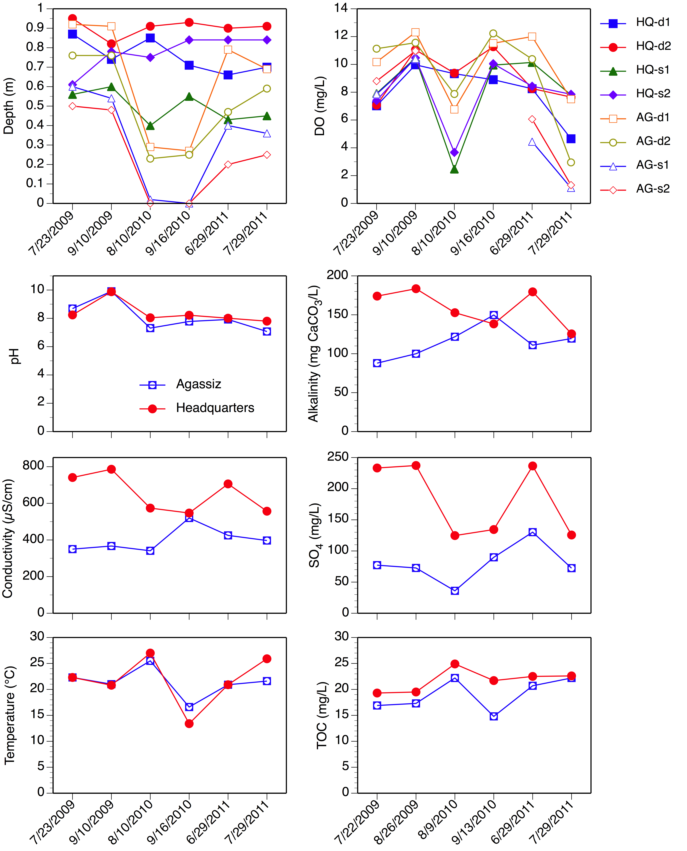

Figure 1. Pool depth, temperature, and water chemistry on dates of mercury sampling in the Agassiz and Headquarters pools. Individual sampling sites are identified in the upper panels for depth and dissolved oxygen (DO); d = deep, s = shallow.
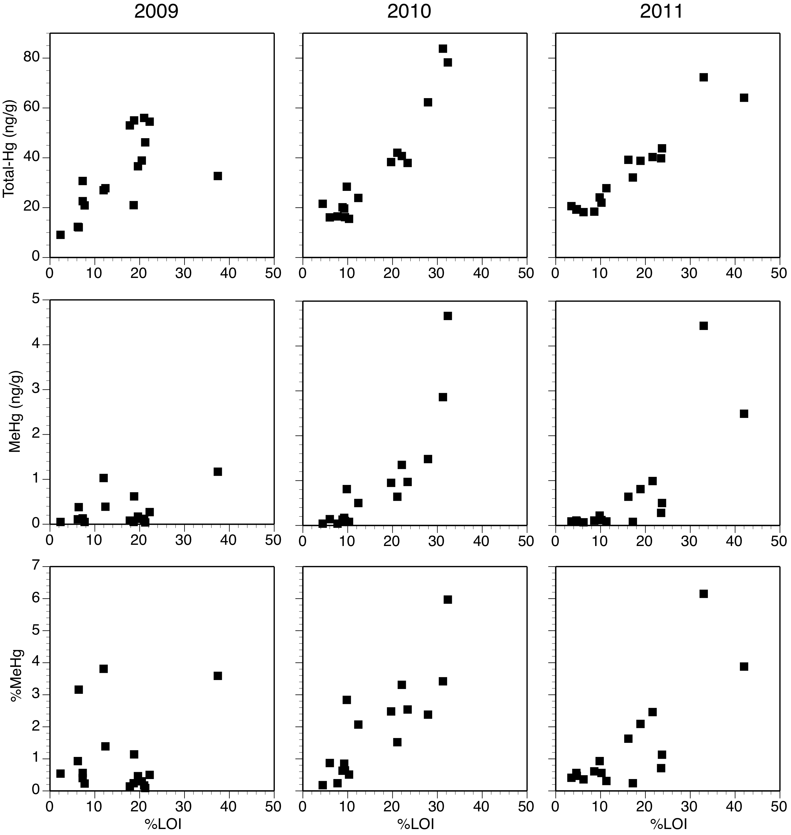

Figure 2. Relationship between concentrations of total mercury (Hg_{T}), methylmercury (MeHg), and %MeHg (percentage of Hg_{T} as MeHg) and organic content of sediments as measured by loss-on-ignition (%LOI). Results from Agassiz and Headquarters pools are combined.

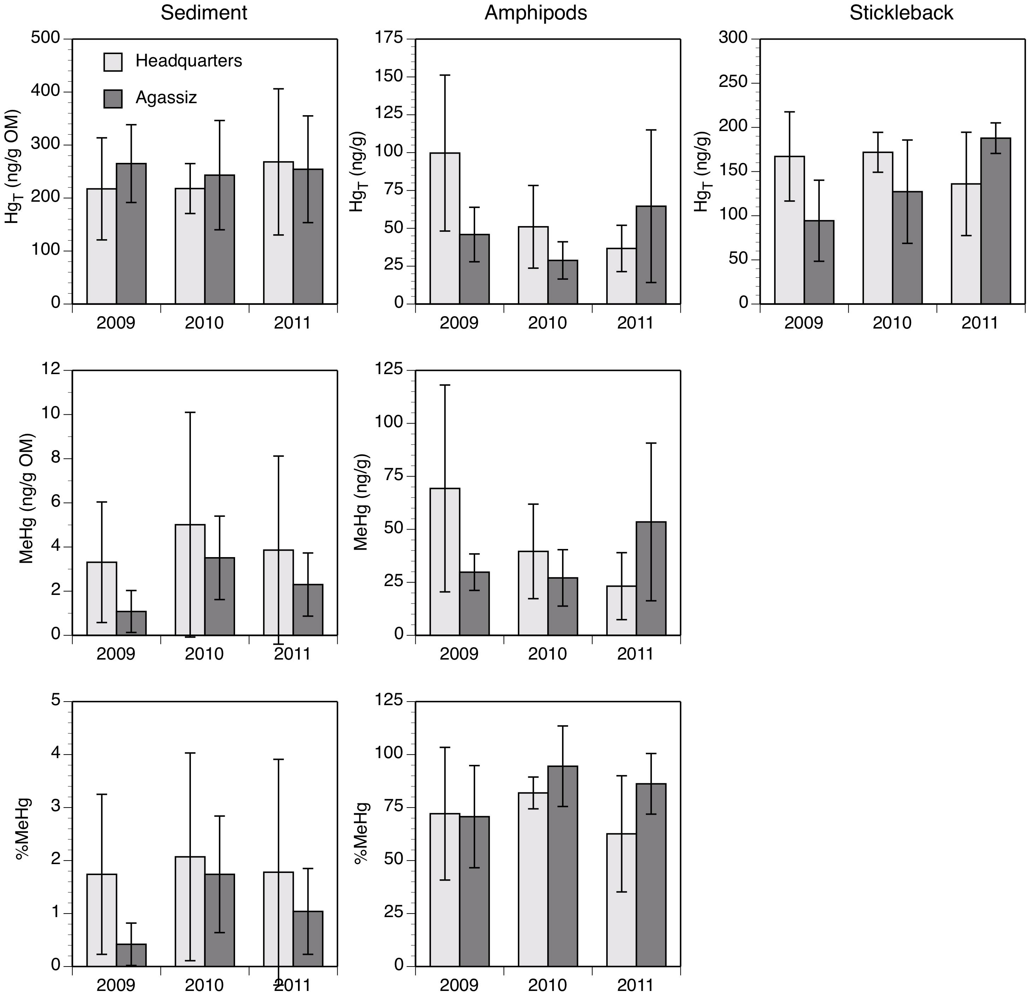

Figure 3. Average mercury concentrations and % methylmercury in sediments, amphipods (Gammarus), and fish (stickleback) in the Headquarters and Agassiz pools in each of the three study years. The Agassiz Pool was drained in 2010 and re-flooded in 2011. Error bars represent ± 1 s.d.
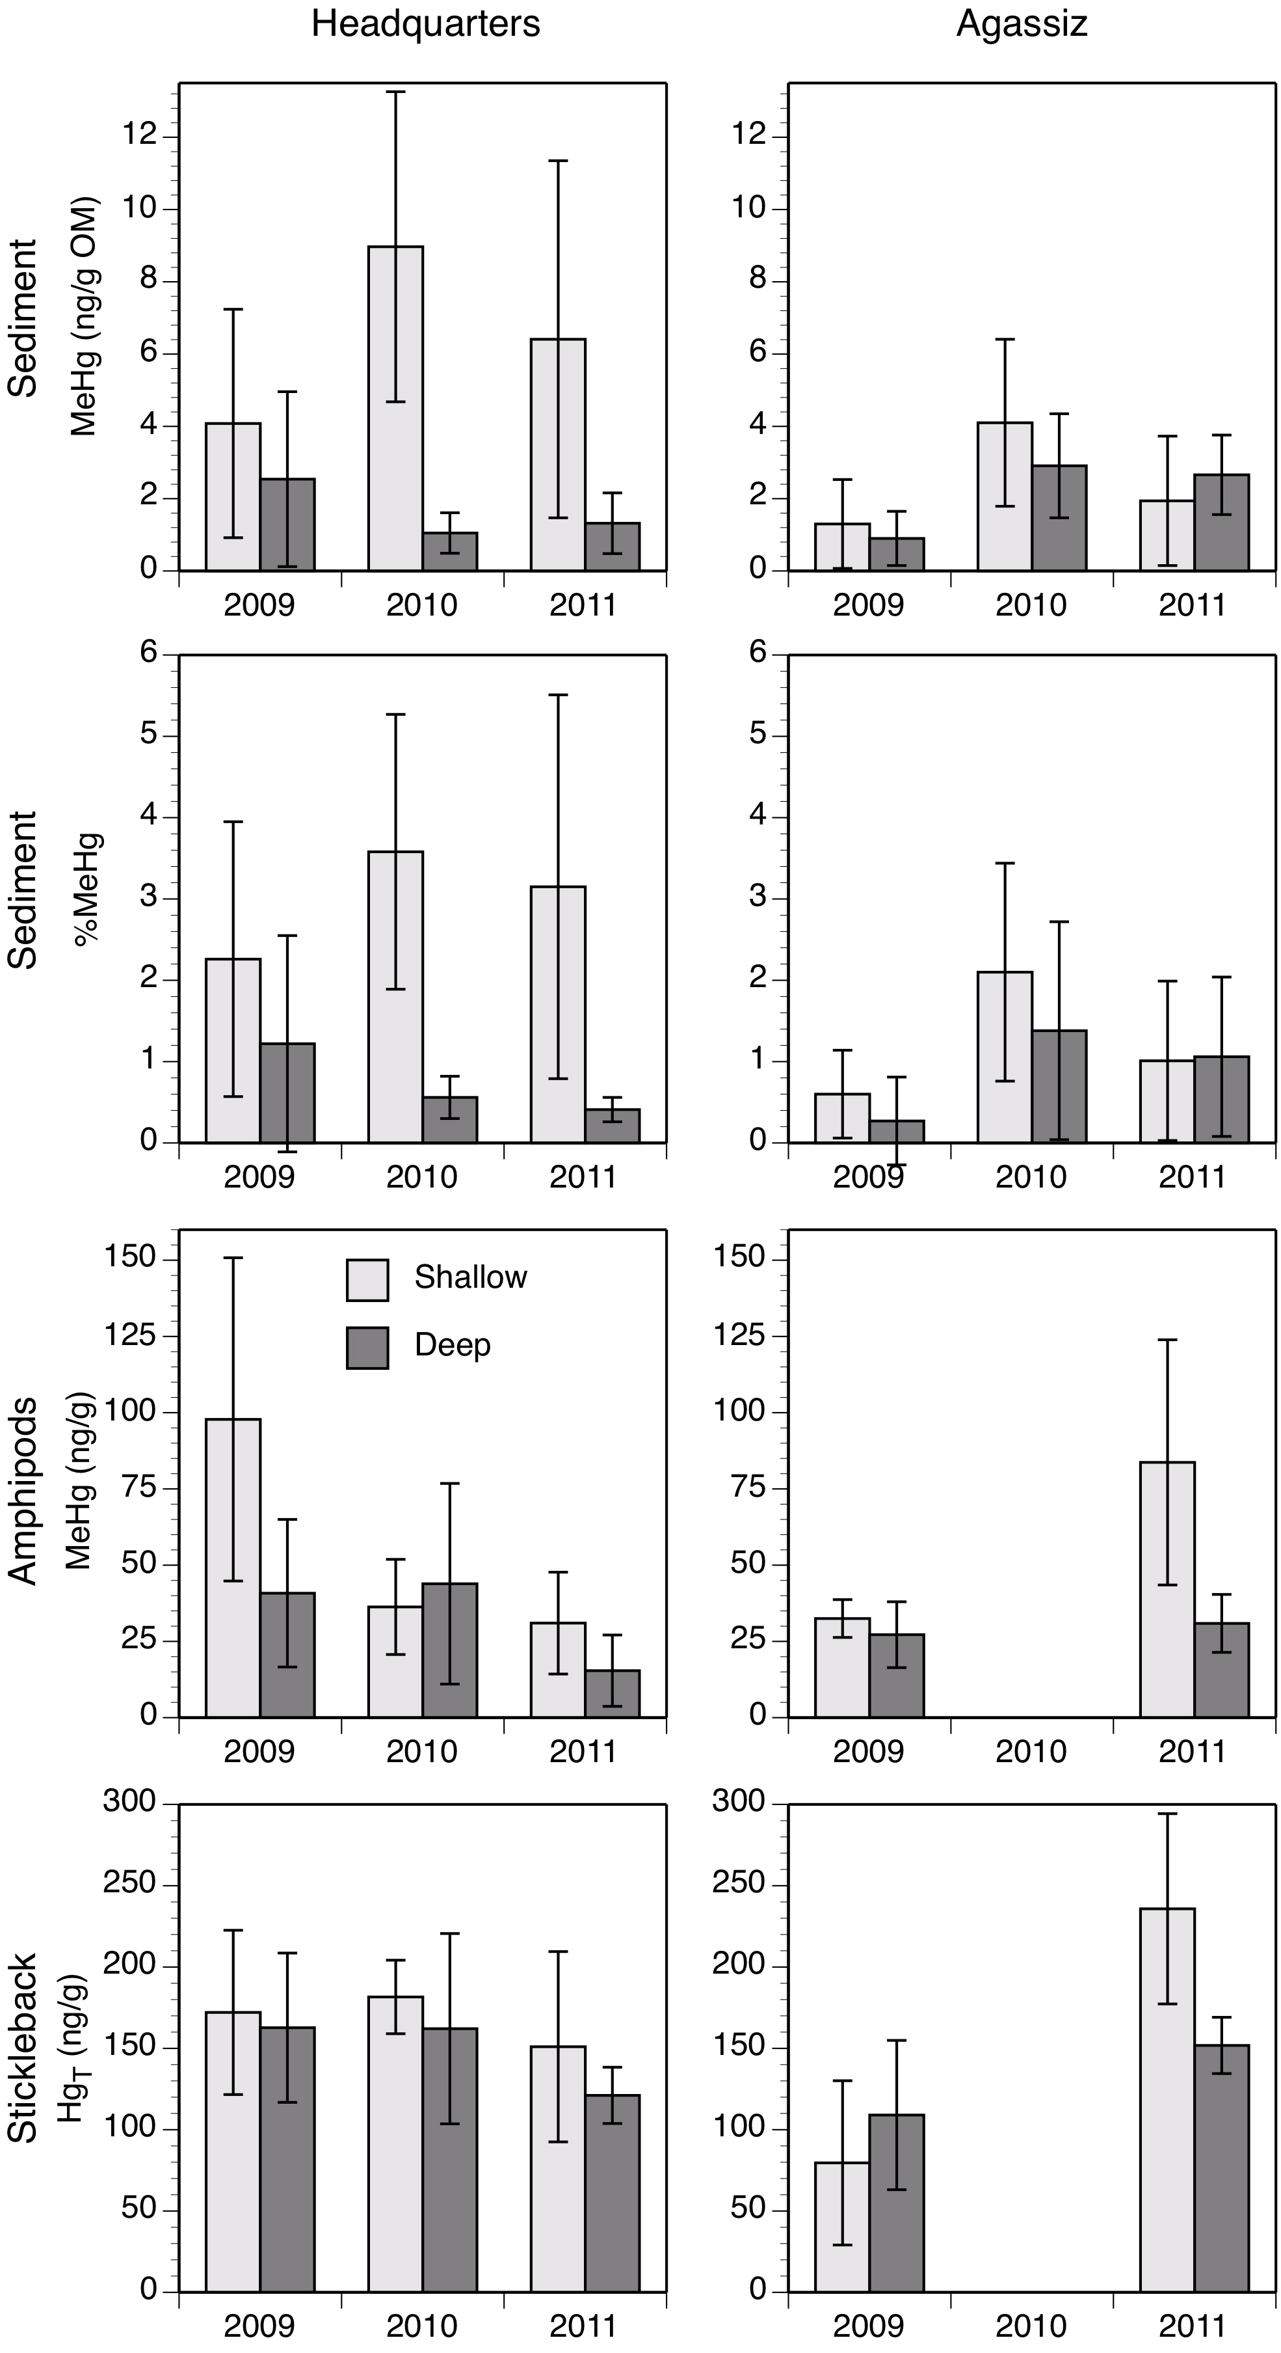

Figure 4. Average mercury concentrations and % methylmercury in sediments, amphipods (Gammarus), and fish (stickleback) in shallow and deep collection sites in each of the three study years. Error bars represent ± 1 s.d.

