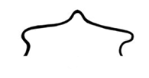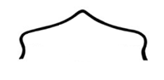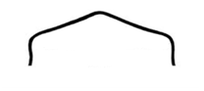Bison Body Condition Score *

If scoring with winter coat present, consider that features might appear more prominent without coat.

many ribs visible
no ribs visible
no ribs visible

Emaciated

a few ribs visible

a few ribs visible

a few ribs visible

some ribs visible

some ribs visible

late pregnancy
late pregnancy

Poor Excellent

late pregnancy

late pregnancy

Fair
Fair +
Good
Very Good

* Drawings adapted by USFWS Wildlife Health Office from “What’s the Score: Bison Body Condition Scoring (BCS) Guide” from the Alberta Ministry of Agriculture & Rural
Development. Please contact the FWS Wildlife Health Office for assistance at 406.587.2169 or lee_c_jones@fws.gov

